Lesson 10 Practice Problems
- This vase has a base of $B$ square inches and a height of $h$ inches. Which statement is true?
- 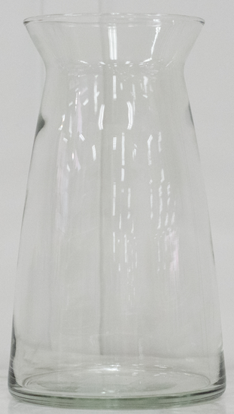
  - Its volume is less than $Bh$ cubic inches.
  - Its volume is equal to $Bh$ cubic inches.
  - Its volume is greater than $Bh$ cubic inches.
  - We cannot compare its volume to $Bh$ cubic inches.
- Noah is deciding which of 2 juice containers he should buy. One container is in the shape of a cylinder with radius 3.5 centimeters and height 12.5 centimeters. The second container is in the shape of a rectangular prism. The prism also has height 12.5 centimeters. Its length is 6.4 centimeters and its width is 4 centimeters.
- Which juice container has the larger volume?
- This zigzag crystal vase has a height of 10 inches. The cross sections parallel to the base are always rectangles that are 6 inches wide by 3 inches long.
- 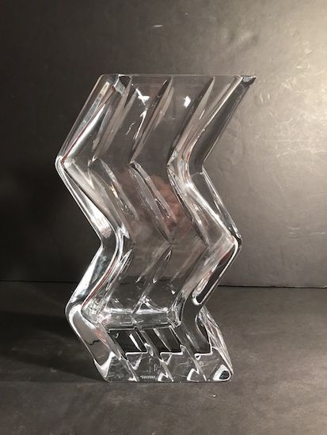
  - If we assume the crystal itself has no thickness, what would be the volume of the vase?
  - The crystal is actually half an inch thick on each of the sides and on the bottom. Approximately how much space is contained within the vase? Explain or show your reasoning.
- List two solids for which the formula $V=Bh$ applies and 2 for which $V=Bh$ does not apply.
- (From Unit 5, Lesson 9.)
- Each small square represents 1 square centimeter.
  - Sketch and label the solid formed by rotating this two-dimensional figure around the vertical axis shown.What is the volume of this solid?
  - 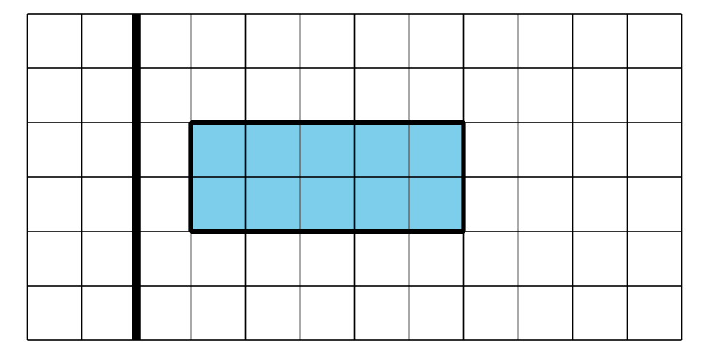
  - What is the volume of this solid?
- (From Unit 5, Lesson 9.)
- A solid has volume 2 cubic units and surface area 10 square units. The solid is dilated, and the image has volume 128 cubic units. What is the surface area of the image?
- (From Unit 5, Lesson 8.)
- A solid with surface area 50 square units is dilated by a scale factor of $k$ to obtain a solid with surface area 200 square units. Find the value of $k$.
  - 4
  - 2
  - $\frac{1}{2}$
  - $\frac{1}{4}$
- (From Unit 5, Lesson 7.)
- Name 2 figures for which all cross sections taken at a particular orientation are congruent.
- (From Unit 5, Lesson 2.)
© CC BY 2019 by Illustrative Mathematics®

