Lesson 5: Connecting Factors and Zeros
- Let’s investigate polynomials written in factored form.

5.1: Notice and Wonder: Factored Form
What do you notice? What do you wonder?

$f(x)=(x+5)(x+1)(x−3)$

$g(x)=(x+5)(x+1)(x−2)$

$h(x)=(x+4)(x+1)(x−2)$

5.2: What Values of $x$ Make These Equations True?
Find all values of $x$ that make the equation true.
- $(x+4)(x+2)(x−1)=0$
- $(x+4)(x+2)(x−1)(x−3)=0$
- $(x+4)^{2}(x+2)^{2}=0$
- $\text{-}2(x−4)(x−2)(x+1)(x+3)=0$
- $(2x+8)(7x−3)(x−10)=0$
- $x^{2}+3x−4=0$
- $x(3−x)(x−1)(x+0.75)=0$
- $(x^{2}−4)(x+9)=0$

Are you ready for more?
- Write an equation that is true when $x$ is equal to -5, 4, or 0 and for no other values of $x$.
- Write an equation that is true when $x$ is equal to -5, 4, or 0 and for no other values of $x$, and where one side of the equation is a 4th degree polynomial.

5.3: Factors, Intercepts, and Graphs
Your teacher will give you a set of cards. Match each equation to either a graph or a description.
Take turns with your partner to match an equation with a graph or a description of a graph.
- For each match that you find, explain to your partner how you know it’s a match.
- For each match that your partner finds, listen carefully to their explanation. If you disagree, discuss your thinking and work to reach an agreement.

Lesson 5 Summary
When a polynomial is written as a product of linear factors, we can identify several facts about it.
For example, the factored form of the polynomial shown in the graph is $P(x)=0.5(x−3)(x−2)(x+1)$.
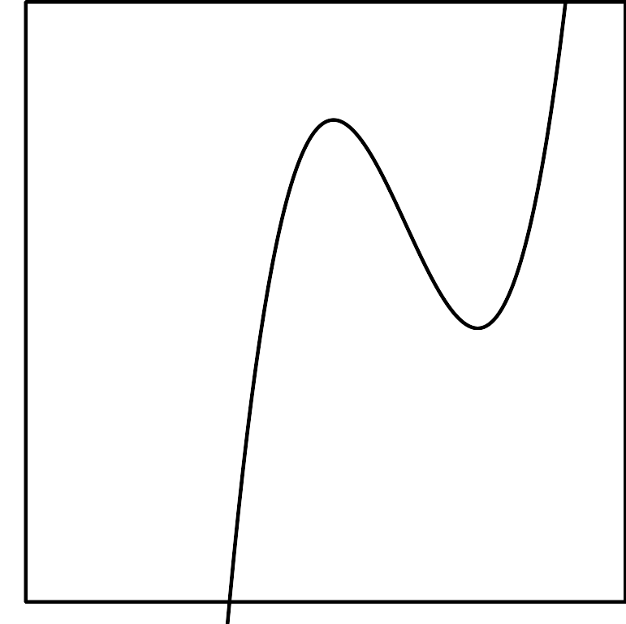
Looking back at the equation, can you see why the graph has $x$-intercepts at $x=$ 3, 2, and -1? Each of these $x$-values makes one of the factors in the expression $0.5(x−3)(x−2)(x+1)$ equal to zero, and so makes the equation $P(x)=0$ true. The numbers 3, 2, and -1 are known as the zeros of the function. When a polynomial is not written as the product of linear factors, identifying the zeros from the expression for the polynomial can be more challenging. We’ll learn how to do that in future lessons.
© CC BY 2019 by Illustrative Mathematics®

