Lesson 10: Center Day 2
- Let’s work with shapes.

Warm-up: How Many Do You See: Base-Ten Blocks
How many do you see? How do you see them?
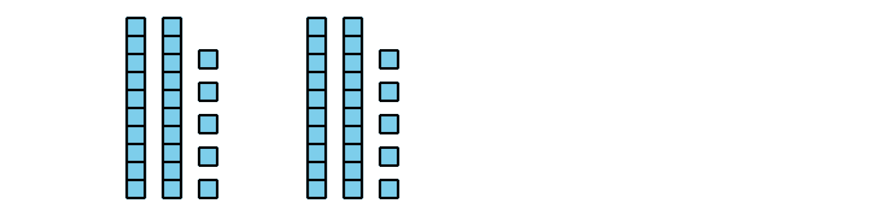
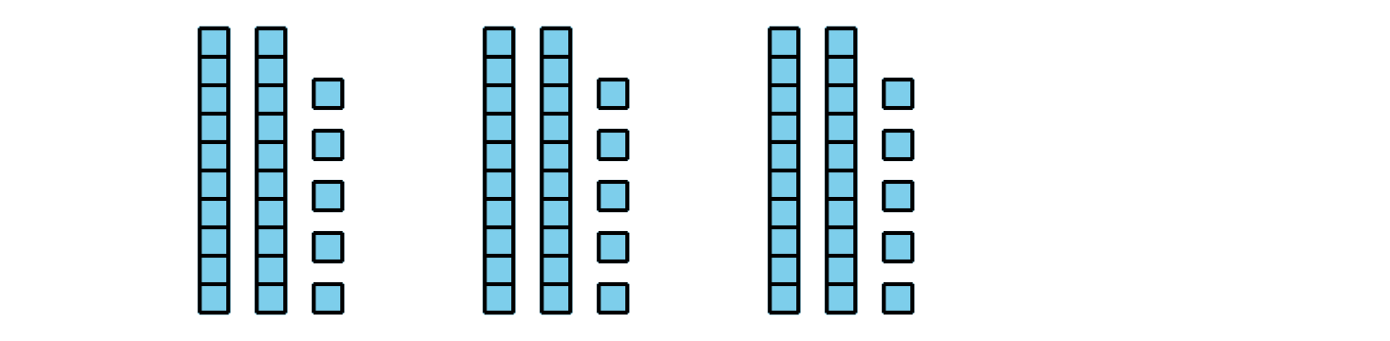
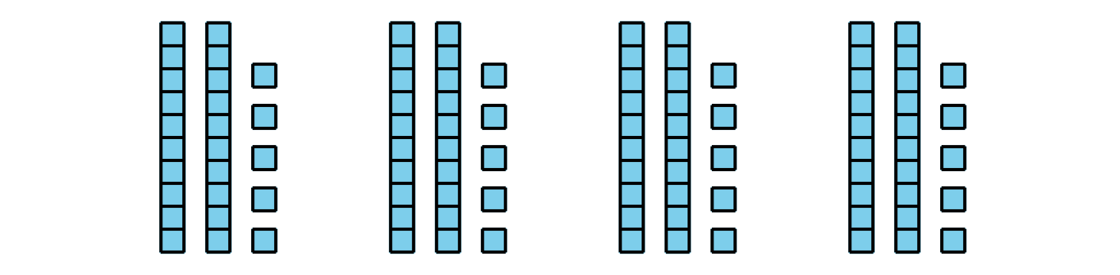

10.2: Centers: Choice Time
Choose a center:
How Are They the Same?
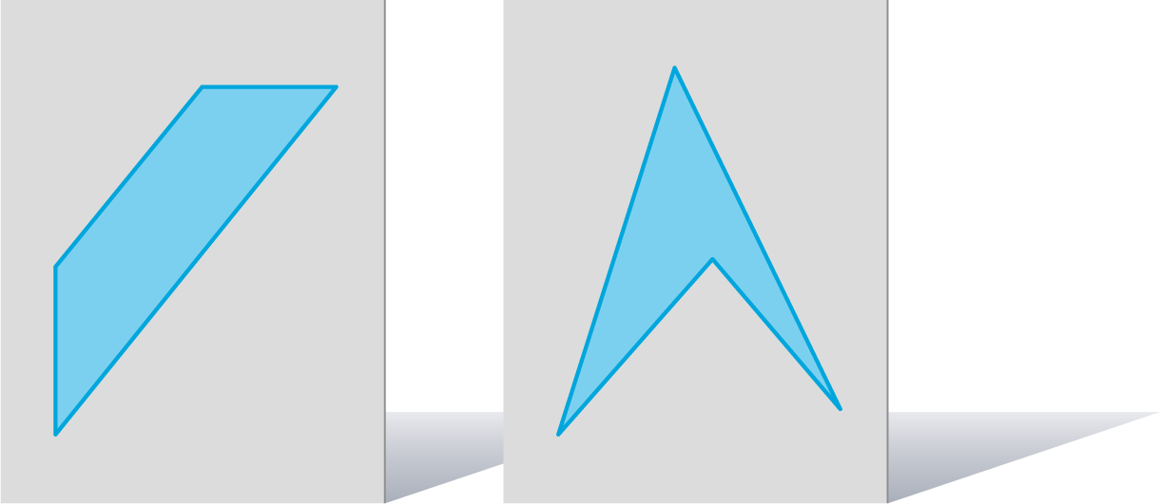
Which One?
Can You Draw It?
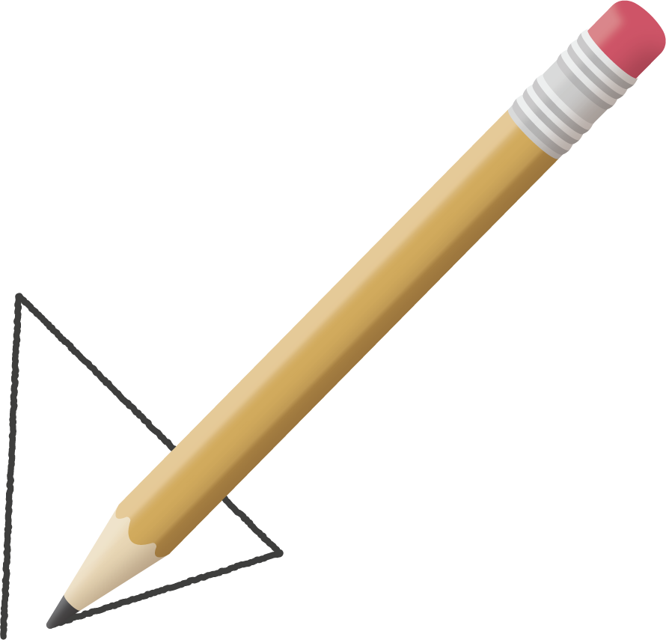
© CC BY 2021 Illustrative Mathematics®

