Unit 8 Lesson 2: Partners Make Pairs

WU Which One Doesn’t Belong: Laundry Day (Warm up)

Student Task Statement
Which one doesn’t belong?
A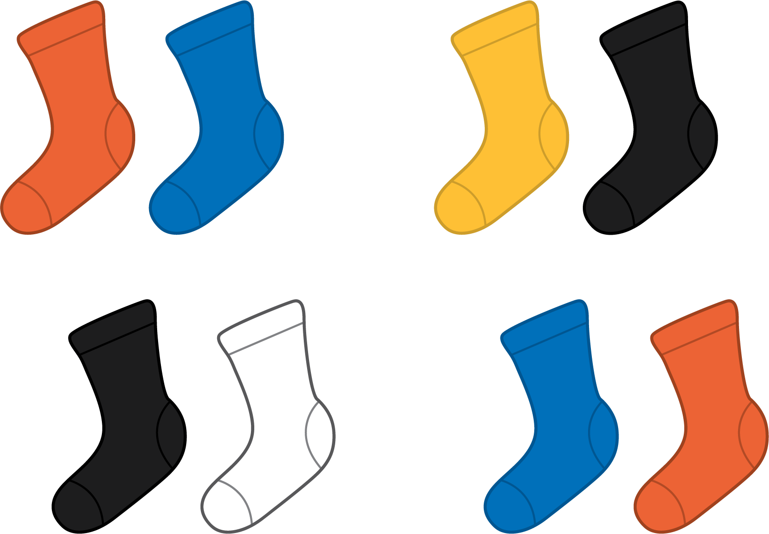
B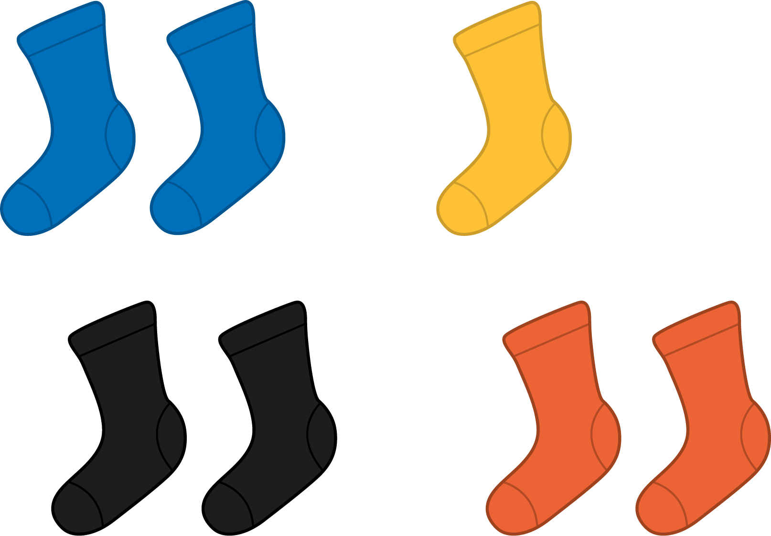
C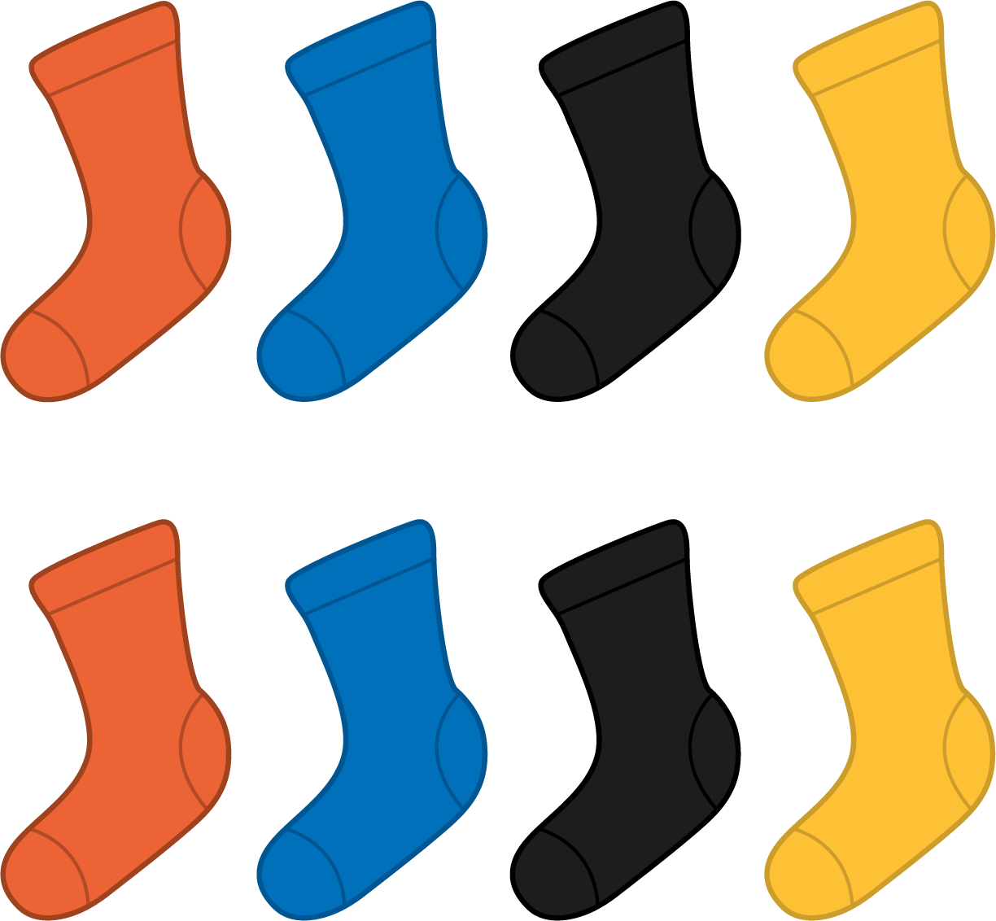
D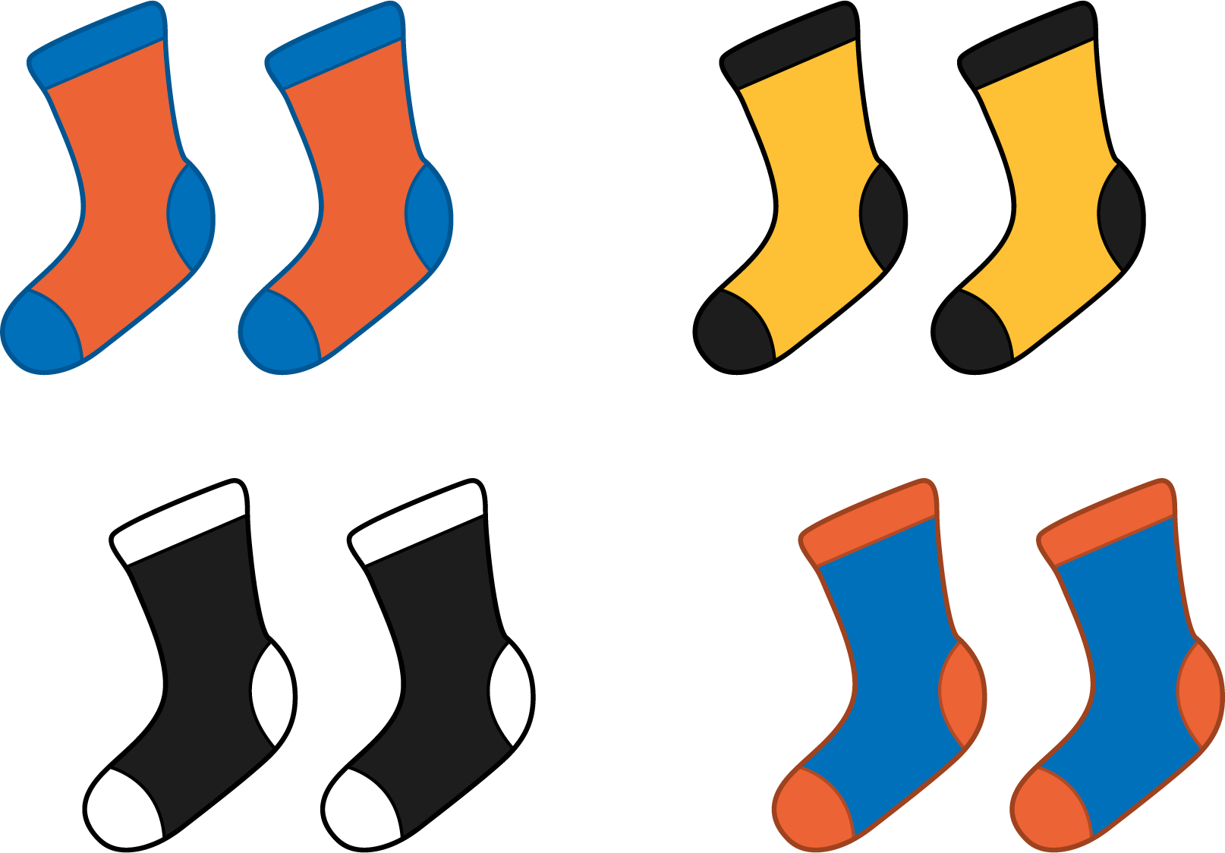

1 Pair Up

Student Task Statement
Make pairs with 1 yellow counter and 1 red counter.
my counters
total counters
leftover counters

Activity Synthesis
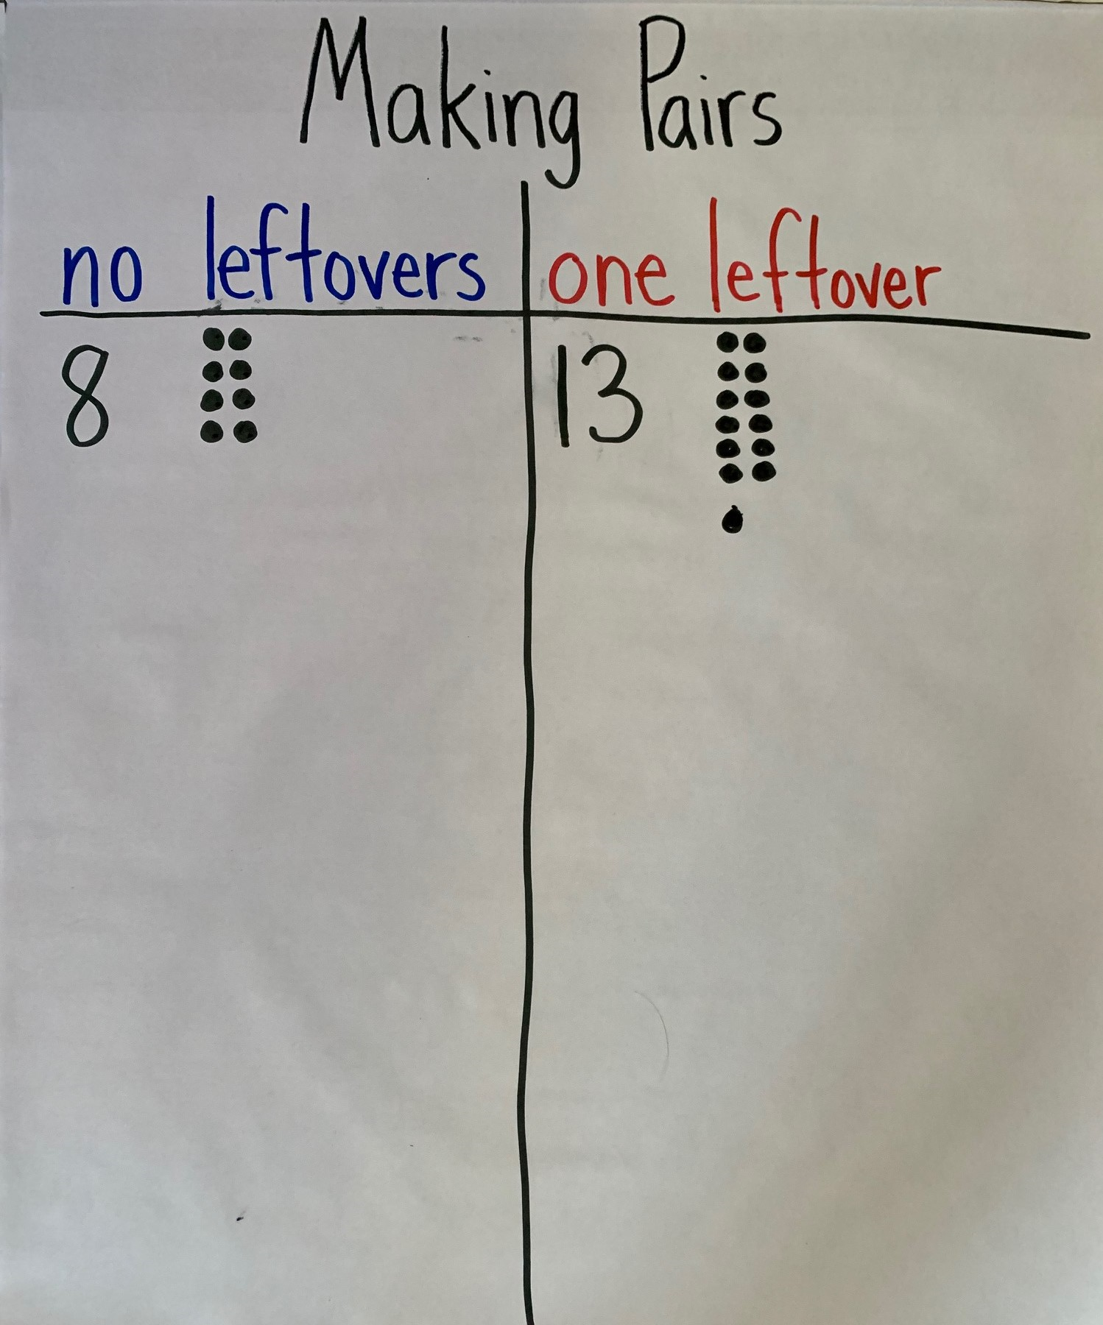

2 Are You Feeling Left Out?

Student Task Statement
Show your thinking using diagrams, symbols, or other representations. Use cubes or counters if it helps.
- There are 18 students in Clare’s class today. They will work in pairs. Will everyone be in a group of 2?
- There are 20 students in Priya’s class. Will everyone be in a group of 2?
- There are 19 students in Noah’s class. Will everyone be in a group of 2?

Activity Synthesis
© CC BY 2021 Illustrative Mathematics®

