Lesson 4: Draw Flat Shapes
- Let’s describe and draw shapes.

Warm-up: Notice and Wonder: Dot Paper
What do you notice?
What do you wonder?
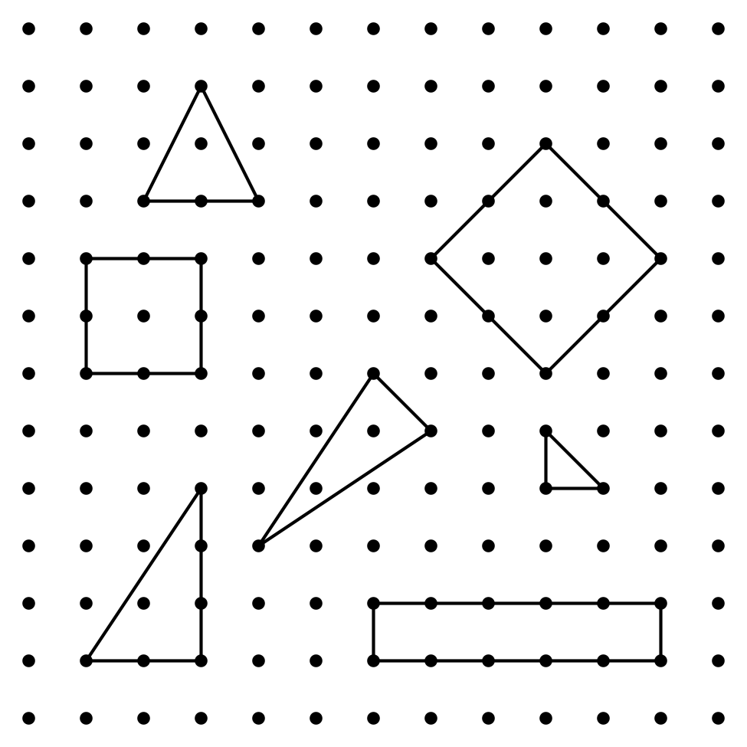

4.1: Draw Shapes on Dot Paper
- Pick a shape card.
- Each partner draws the shape on dot paper.
- Take turns describing the shape you drew.

4.3: Centers: Choice Time
Choose a center.
Capture Squares
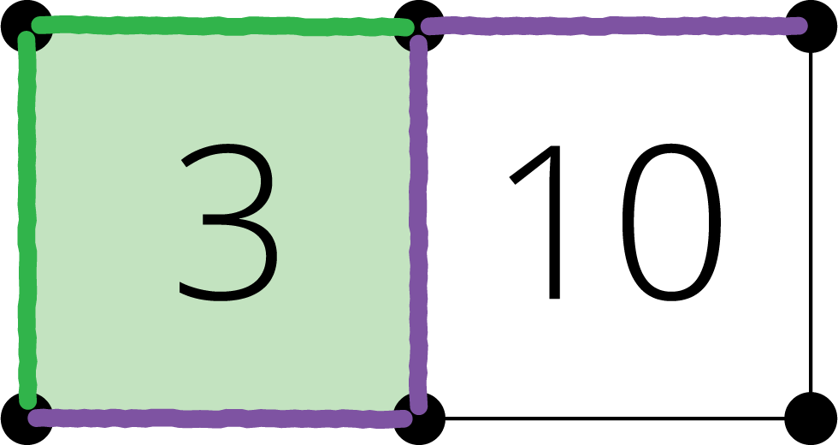
Compare
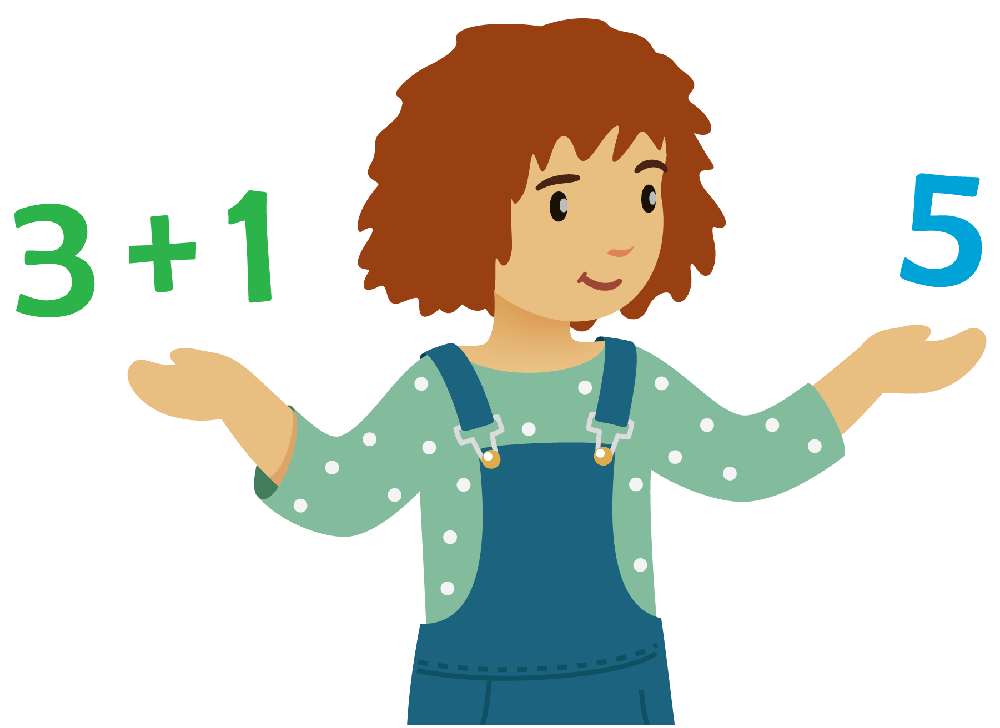
How Close?
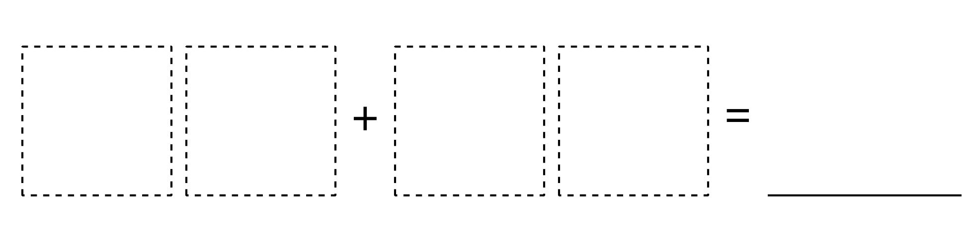
© CC BY 2021 Illustrative Mathematics®

