Unit 7 Lesson 17: Center Day 3

WU Number Talk: Simplify It (Warm up)

Student Task Statement
Find the value of each expression mentally.
- $34−9$
- $434−99$
- $367−98$
- $635−298$

1 Introduce Target Numbers, Add Hundreds, Tens, or Ones

Student Task Statement

2 More Target Numbers and Choice Time

Student Task Statement
Choose a center.
Target Numbers
Five in a Row: Addition and Subtraction
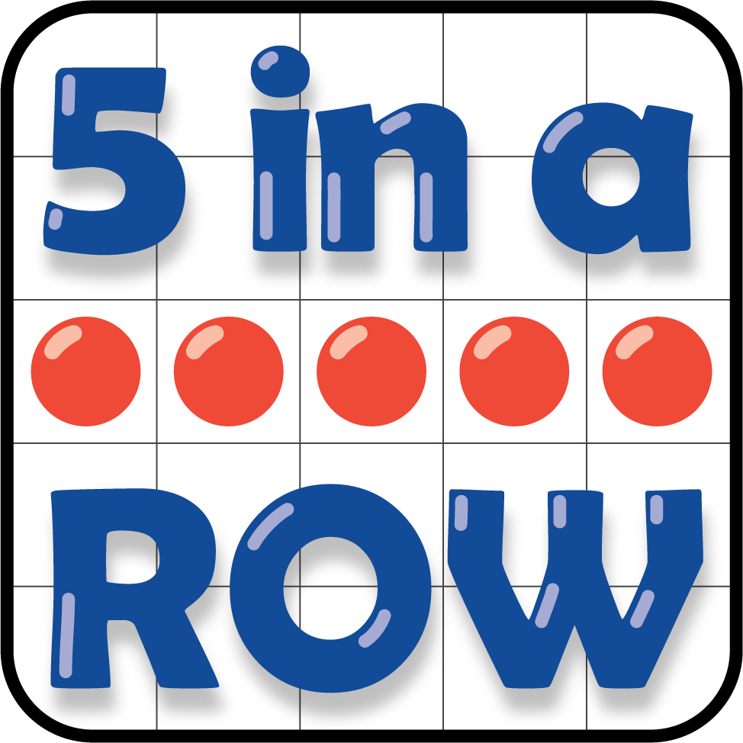
How Close?
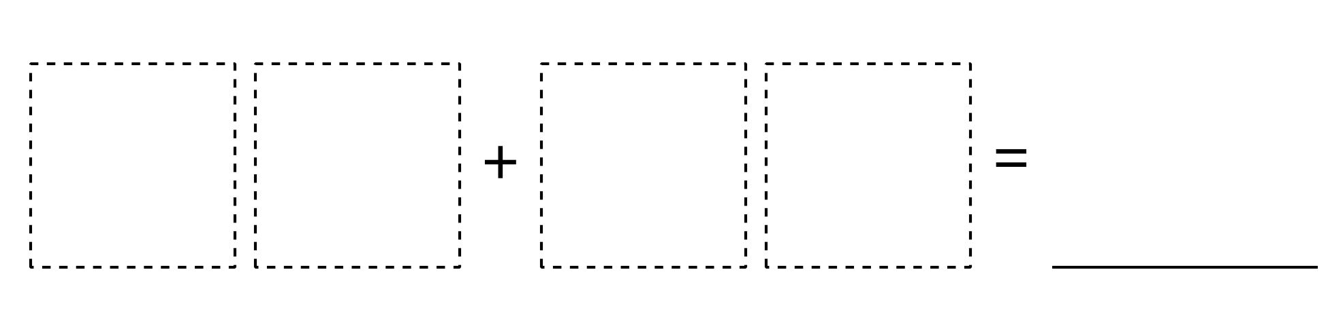
© CC BY 2021 Illustrative Mathematics®

