Lesson 1: Decimal Numbers
- Let’s learn about decimals.

Warm-up: Notice and Wonder: Shaded Grid
What do you notice? What do you wonder?
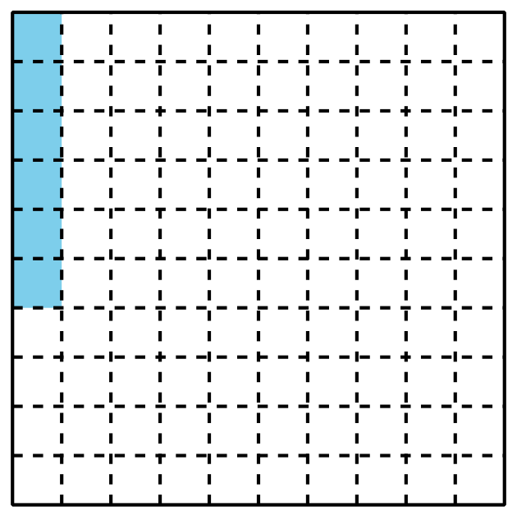

1.1: Shady Fractions
Each large square represents 1.
- What fraction do the shaded parts of each diagram represent? For the last square, shade in some parts and name the fraction it represents.
- a.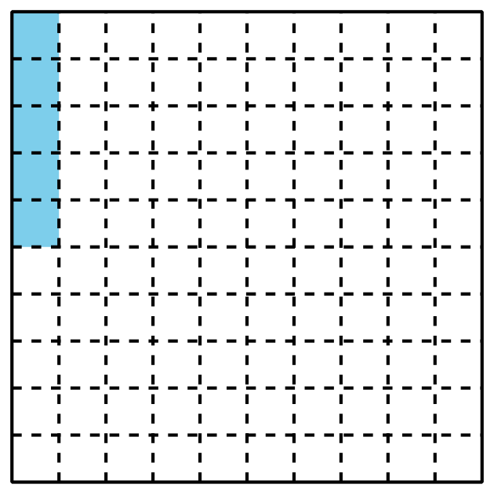
- b.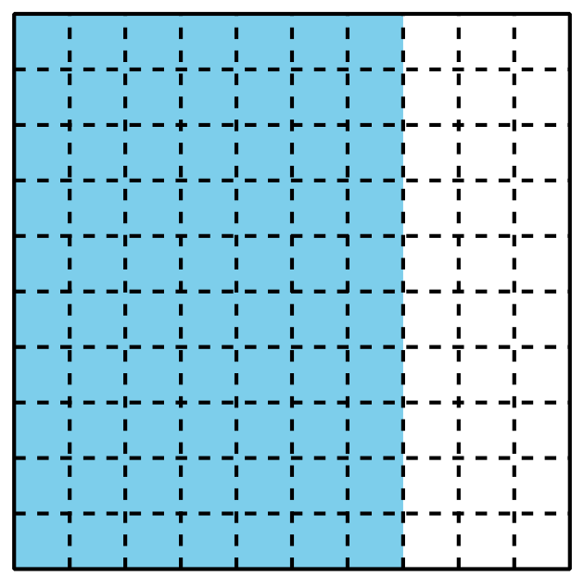
- c.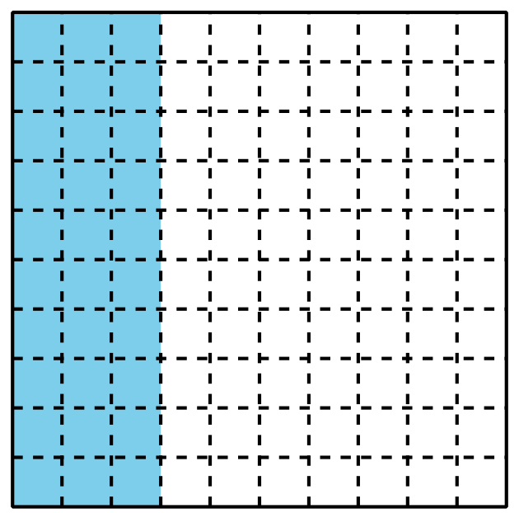
- d.
- e.
- f.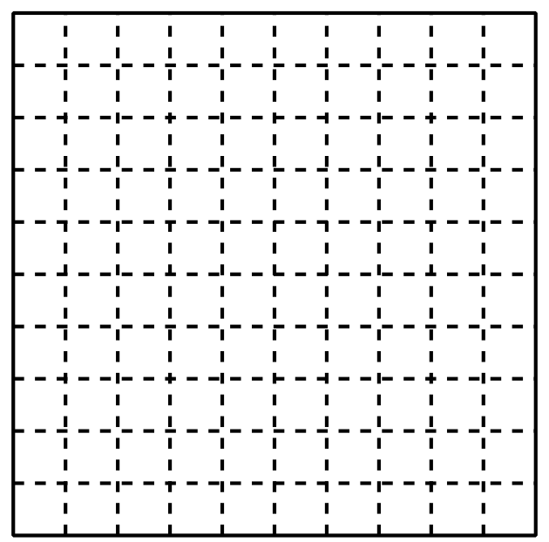
- The shaded part of this diagram represents 0.01 or “1 hundredth.”
- 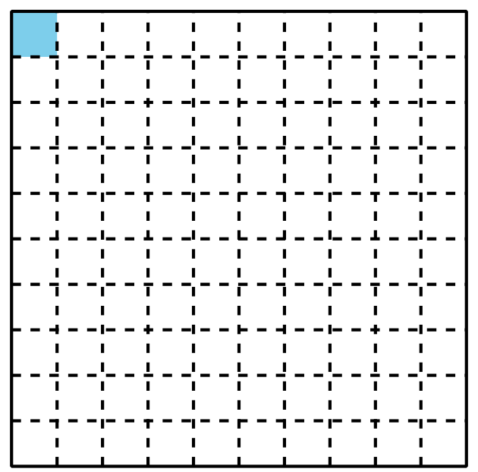
- The shaded parts of this diagram represent 0.10 or “10 hundredths.”
They also represent 0.1 or “1 tenth.”
- 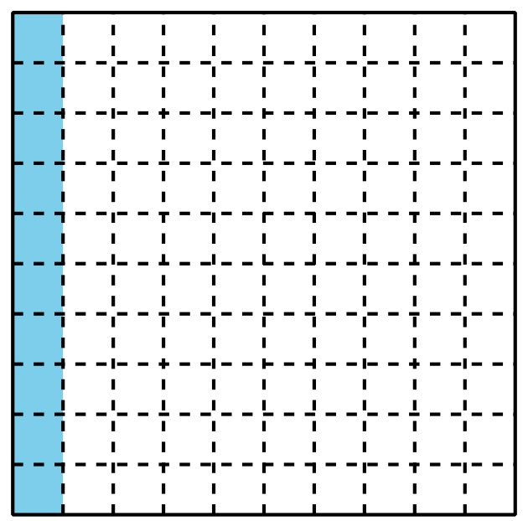
- Numbers like 0.01, 0.10, and 0.1 are written as decimals.
- Look at the shaded parts of each diagram in the first problem. Write the numbers they represent as decimals.
- What fraction and decimal do the shaded parts of each diagram represent?
- a.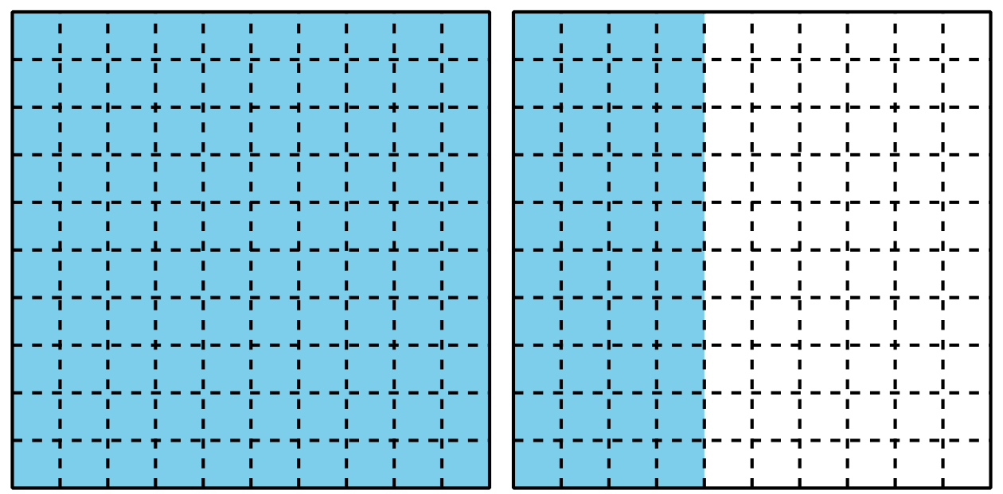
- ​​​​​
- b.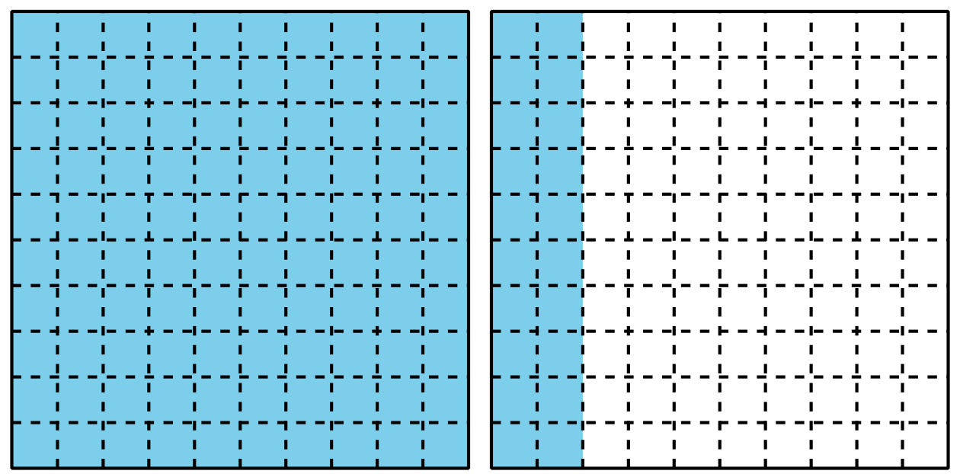

1.2: Ways to Express a Number
Each large square represents 1.
- Write a fraction and a decimal that represent the shaded parts of each diagram. Then, write each amount in words.
- a.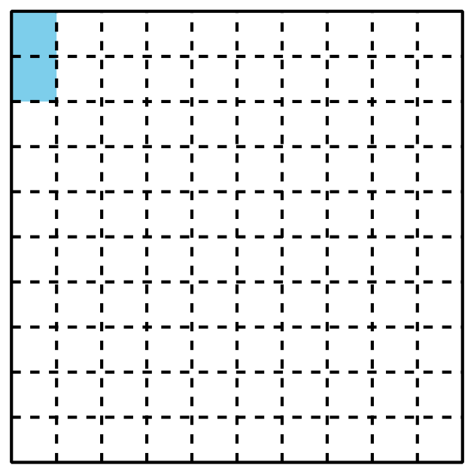
- b.
- c.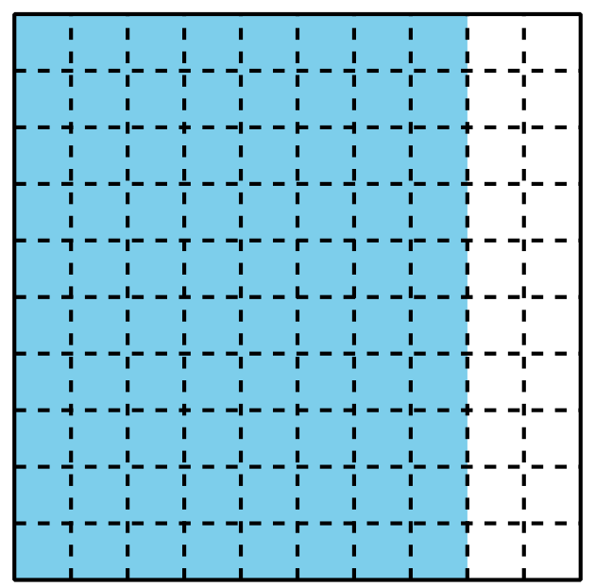
- Shade each diagram to represent each given fraction or decimal.
- a.
- Fraction: ________
- Decimal: 0.78
- b.
- Fraction: $\frac{8}{10}$
- Decimal: ________
- c.
- Fraction: $\frac{55}{100}$
- Decimal: ________
- d.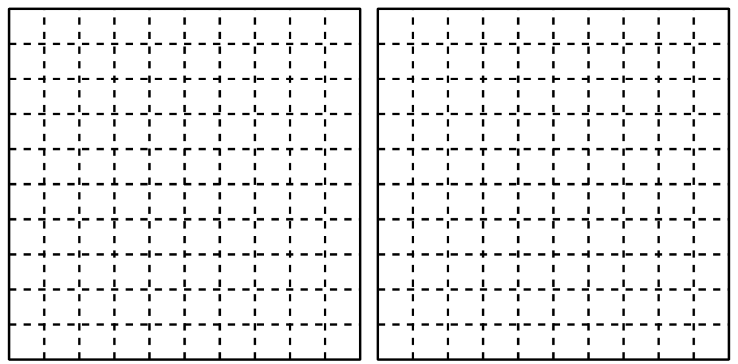
- Fraction: $\frac{107}{100}$
- Decimal: ________
- e.
- Fraction: ________
- Decimal: 1.6
- Han and Elena disagree about what number the shaded portion represents.
- Han says that it represents 0.60 and Elena says it represents 0.6.
- Explain why both Han and Elena are correct.
- 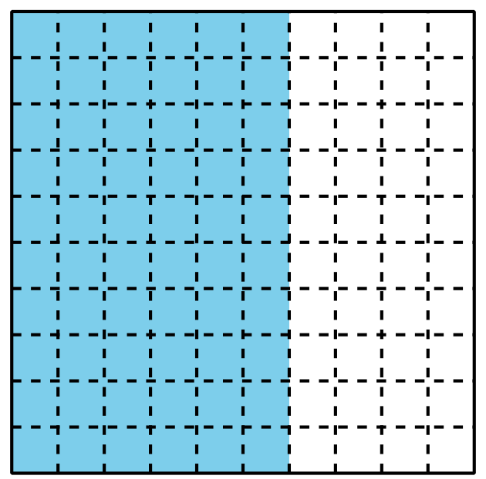
© CC BY 2021 Illustrative Mathematics®

