Lesson 11: Tell Time with Halves and Quarters
- Let’s tell time with halves and quarters.

Warm-up: What Do You Know About Ways to Tell Time?
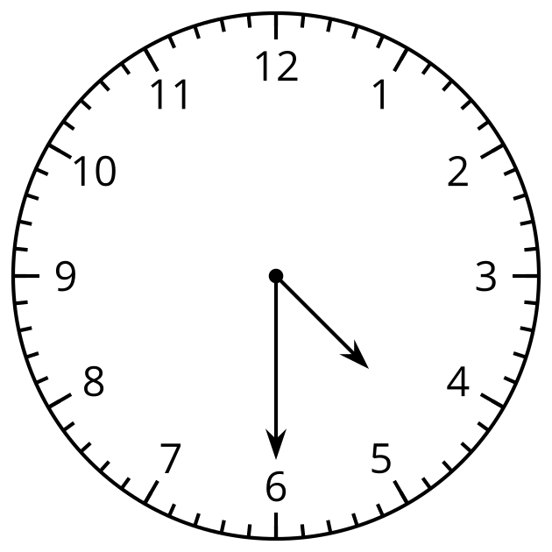
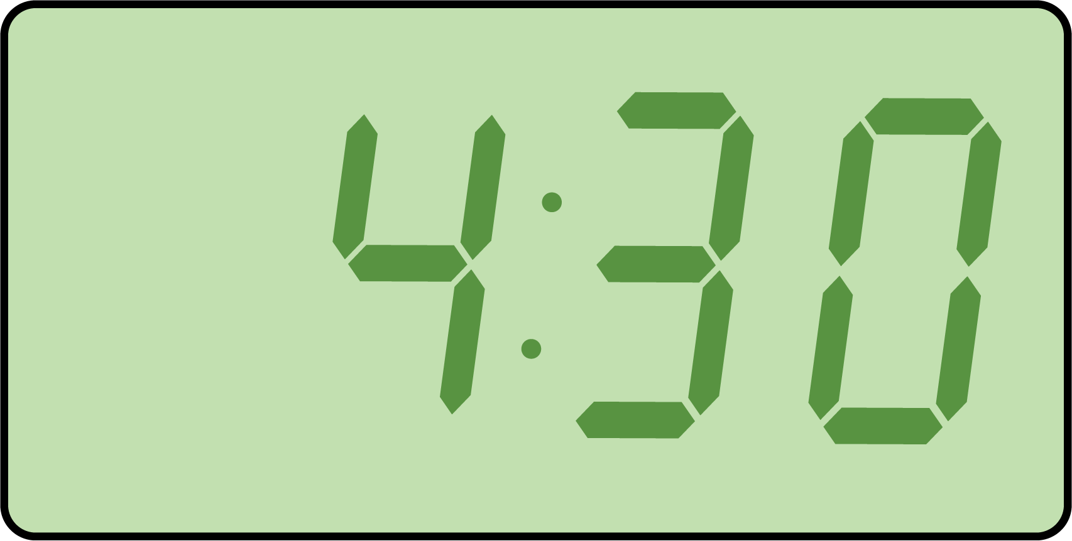
What do you know about ways to tell time? What words do you use to talk about time?

11.1: Tell Time to the Hour and Half-hour
- Circle the clock that shows 4 o’clock.
- 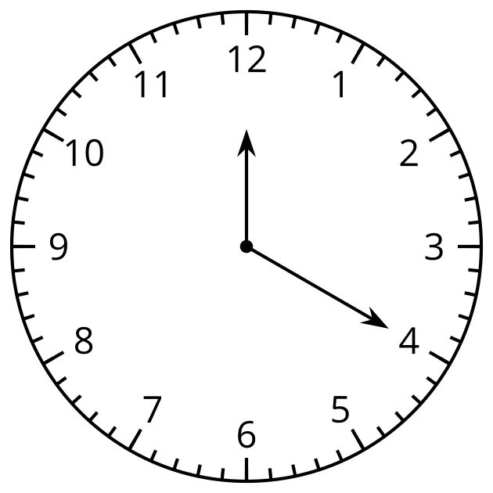
- 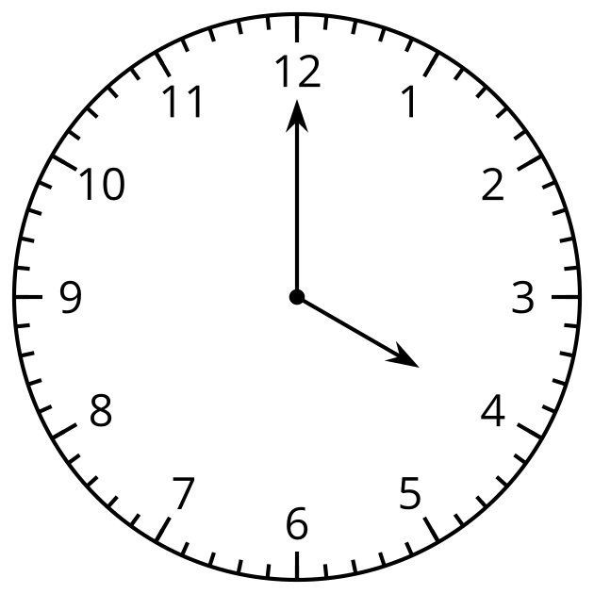
- Why doesn’t the other clock show 4 o’clock?
- Circle the clock that shows half past 7.
- 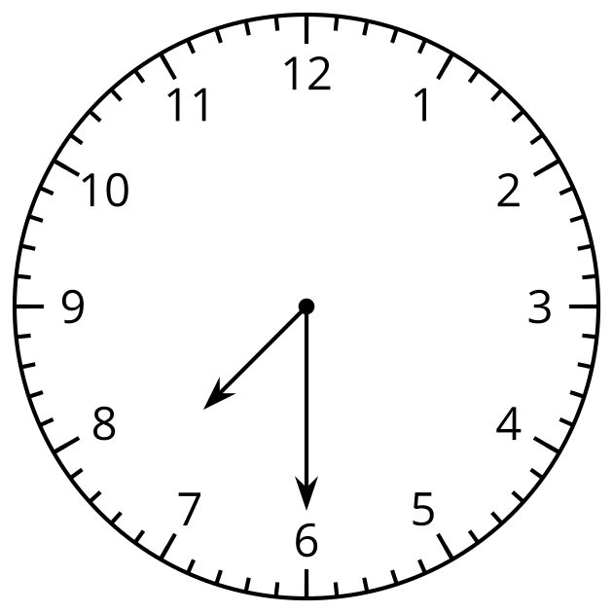
- 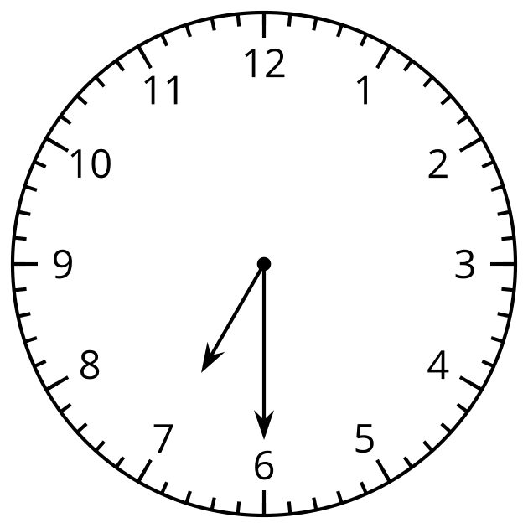
- Why doesn’t the other clock show half past 7?
- Draw the hands on the clock to show 10:00.
- 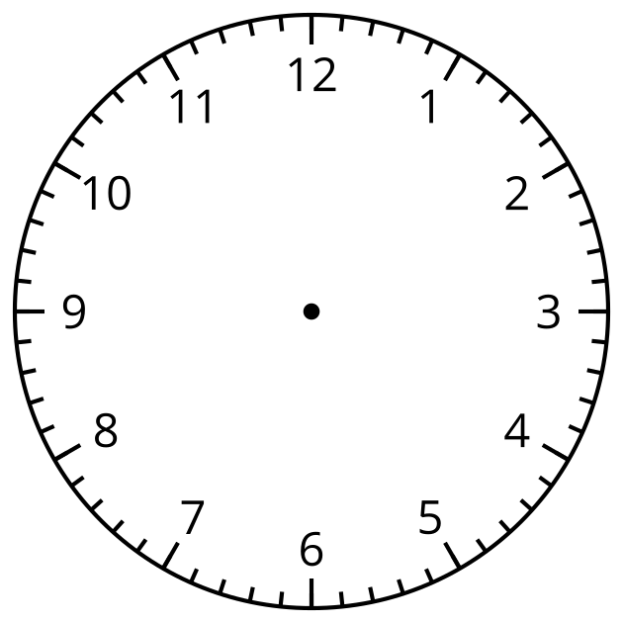
- Draw the hands on the clock to show 1:30.

11.2: Card Sort: Halves and Quarters
- Find matching sets of cards. Each set should have 3 cards. Be prepared to explain why they match.
- Write the time shown on each clock using the words half past, quarter past, or quarter till.

  - 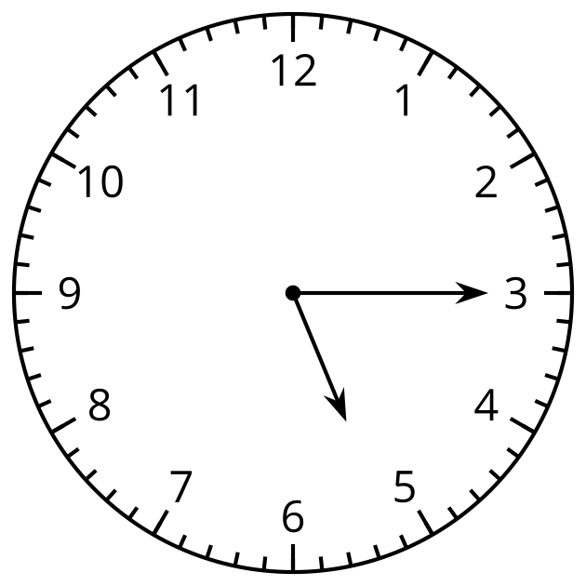

  - 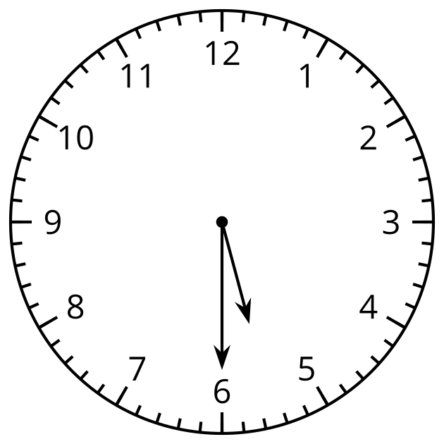

  - 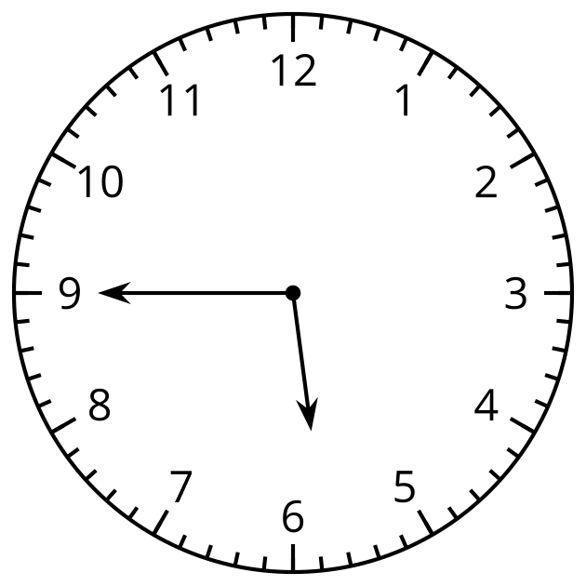

  - 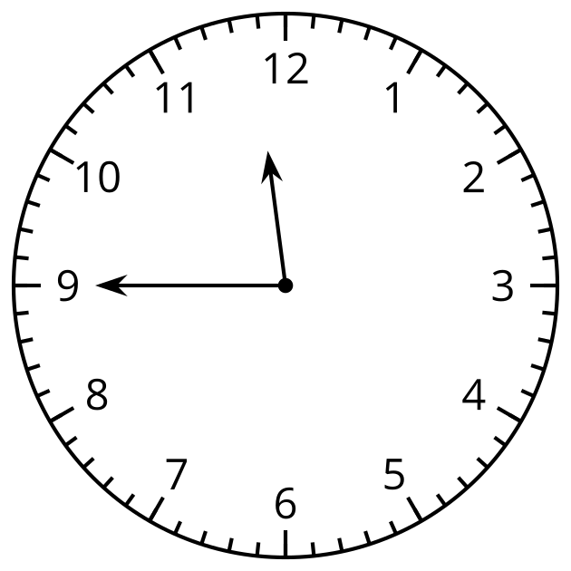

  - 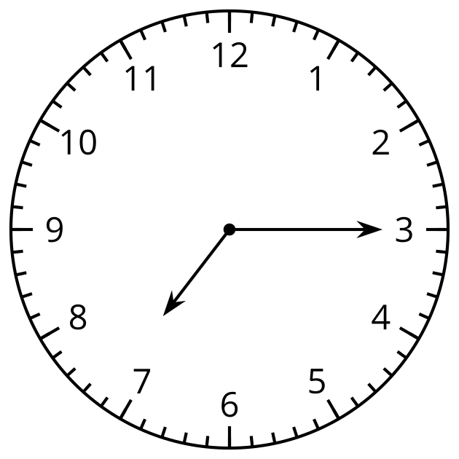
© CC BY 2021 Illustrative Mathematics®

