Unit 8 Lesson 3: Is it Odd or Even?

WU Choral Count: Skip Count by 2 (Warm up)

Student Task Statement

1 Color by Number

Images for Launch

Student Task Statement
Han wants to color a design with the same number of yellow and blue shapes.
A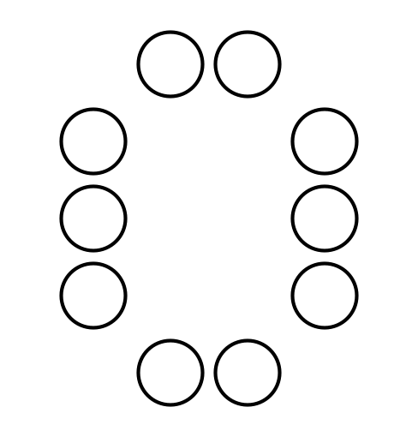
B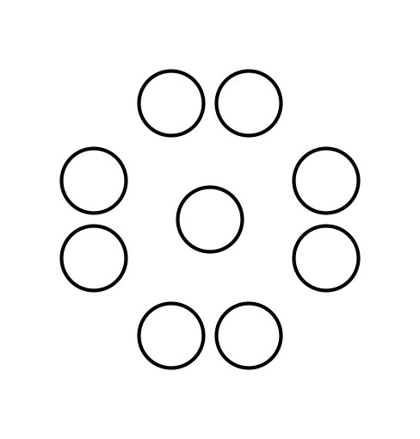
C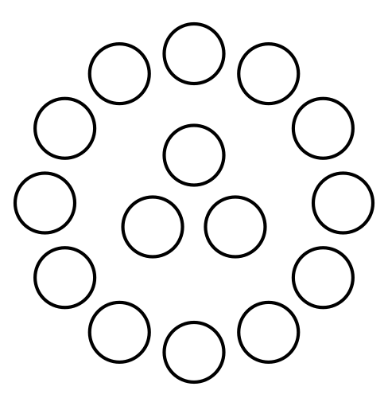
D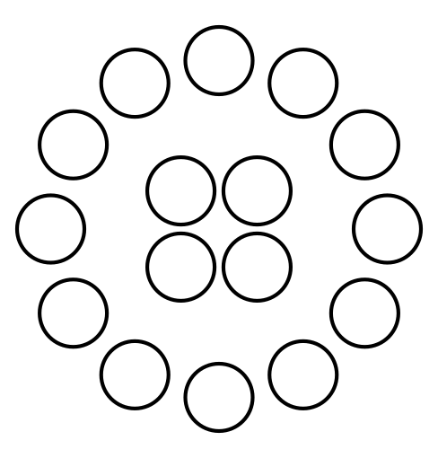
- Which designs could Han choose? Show your thinking using diagrams, symbols, or other representations. Use counters if it helps.
- Draw a circle design that would work for Han and a circle design that would not work.
- Priya drew a design that has 6 circles, 3 triangles, and 3 squares. Would Han be able to color it the way he wants? Show your thinking using diagrams, symbols, or other representations. Use counters if it helps.

2 Card Sort: Even or Odd

Student Task Statement
- Sort your cards into a group that shows an even number and a group that shows an odd number.
- Explain your thinking to your partner.
- Find 3 cards that show the same number. Explain to your partner how each card shows whether the number is even or odd in a different way.
© CC BY 2021 Illustrative Mathematics®

