Lesson 14: Wax Prints

Standards Alignments
Addressing | 3.G.A.1, 3.MD.D.8

Teacher-facing Learning Goals
- Apply geometric understanding to solve problems about wax prints.

Student-facing Learning Goals
- Let’s analyze and make wax prints.

Lesson Purpose
The purpose of this lesson is for students to consider how geometric attributes, perimeter, and area are used to design and use wax print fabric.
In previous lessons, students learned how to identify different types of quadrilaterals and solve problems involving area and perimeter. In this lesson students put all of their learning together to analyze geometric attributes of wax prints, then design a wax print of their own with specific constraints about the shapes they need to use. Then, students use what they know about area and perimeter to solve problems that involve wax print fabric.

Access for:

Students with Disabilities
- Action and Expression (Activity 1)

English Learners
- MLR8 (Activity 1)

Instructional Routines
MLR4 Information Gap (Activity 2), Notice and Wonder (Warm-up)

Materials to Gather
- Colored pencils, crayons, or markers: Activity 1

Materials to Copy
- Square Dot Paper Standard (groups of 1): Activity 1
- Info Gap: The Bundle (groups of 2): Activity 2

Lesson Timeline
Warm-up | 10 min
Activity 1 | 20 min
Activity 2 | 20 min
Lesson Synthesis | 5 min
Cool-down | 5 min

Teacher Reflection Question
What do your students think it means to be good at math? How are you helping them change negative impressions they might have about their ability to reason mathematically?

Cool-down
(to be completed at the end of the lesson) 5min
Quadrilaterals in a Pattern

Standards Alignments
Addressing | 3.G.A.1, 3.MD.D.8

Student-facing Task Statement
- Describe the quadrilaterals that were used in this pattern.
- 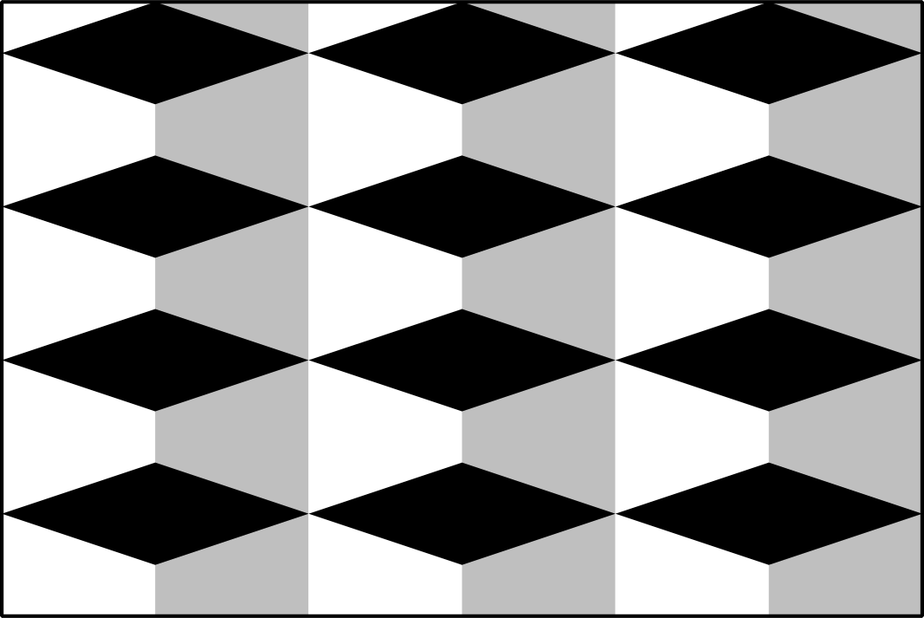
- If the image of the pattern is a rectangle with side lengths of 9 inches by 6 inches, what is the perimeter? Explain your reasoning.

Student Responses
- Samples responses: There are quadrilaterals in white and gray that don’t have any right angles. The black quadrilaterals are rhombuses. The grey shapes and the white shapes are quadrilaterals that have 2 equal sides. They are not rectangles, rhombuses, or squares. It looks like there are tall skinny rectangles that are shaded white and gray behind the black rhombuses.
- 30 inches. I added 9 plus 6 to get 15, then multiplied by 2 since there would be another set of sides that were 9 inches and 6 inches.

