Lesson 5: Some Triangles, All Triangles
- Let’s explore what makes a shape a triangle.

Warm-up: Which One Doesn’t Belong: Shapes
Which one doesn’t belong?
A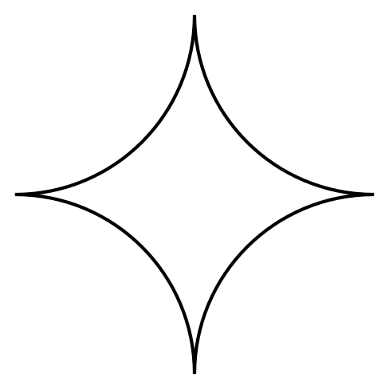
B
C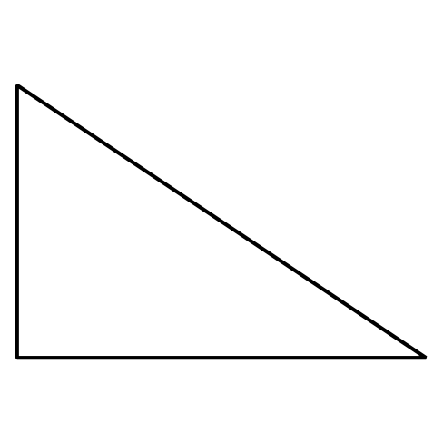
D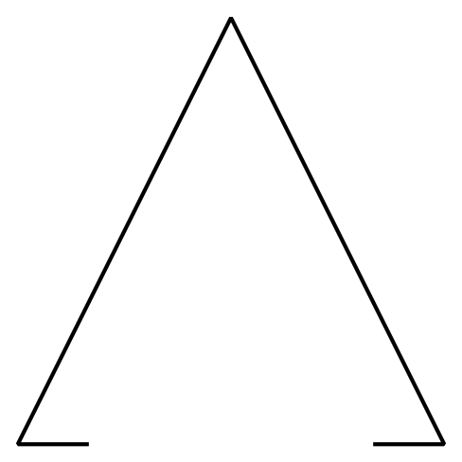

5.1: Triangles and “Not Triangles”
- These are triangles.
- 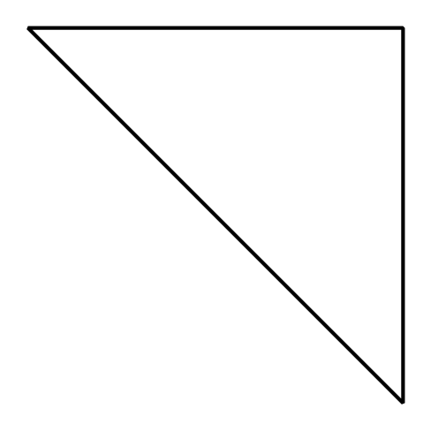
- 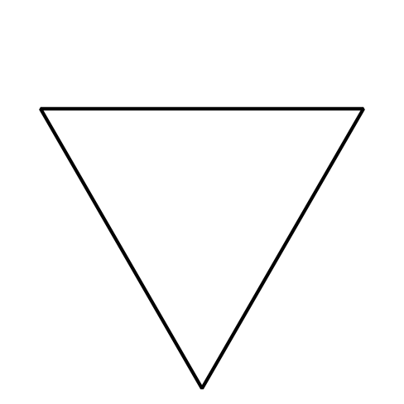
- What is the same about all these triangles?
- These are not triangles.
- 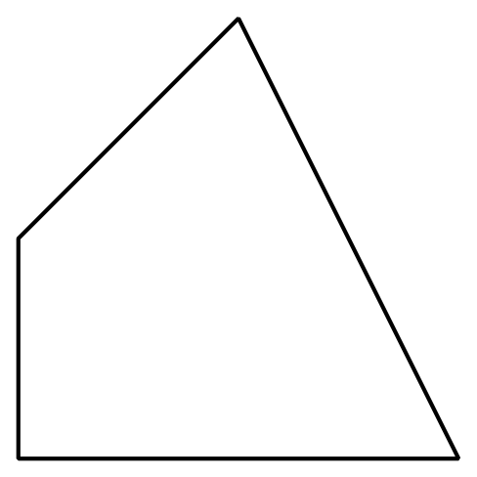
- 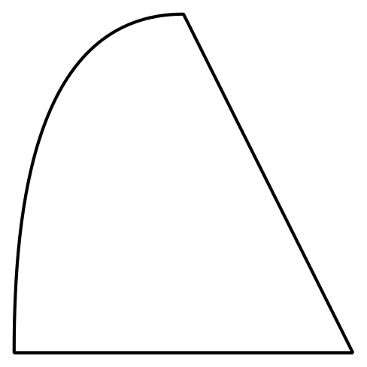
- What makes these shapes different from the triangles?

5.2: Draw Triangles
- Draw 3 different triangles.
- Draw 3 different shapes that are not triangles.

5.3: Centers: Choice Time
Choose a center.
Geoblocks
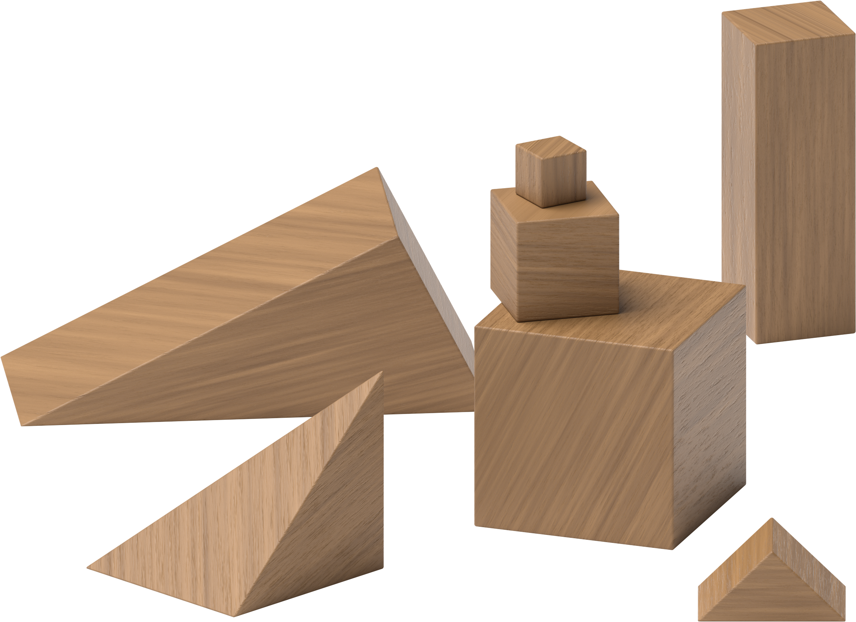
How Are They the Same?
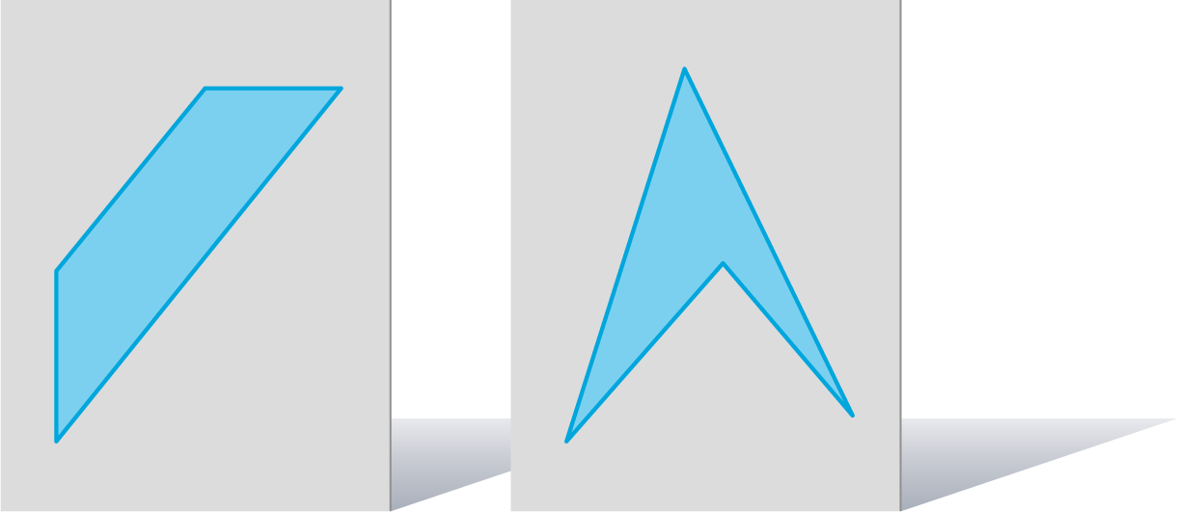
Compare
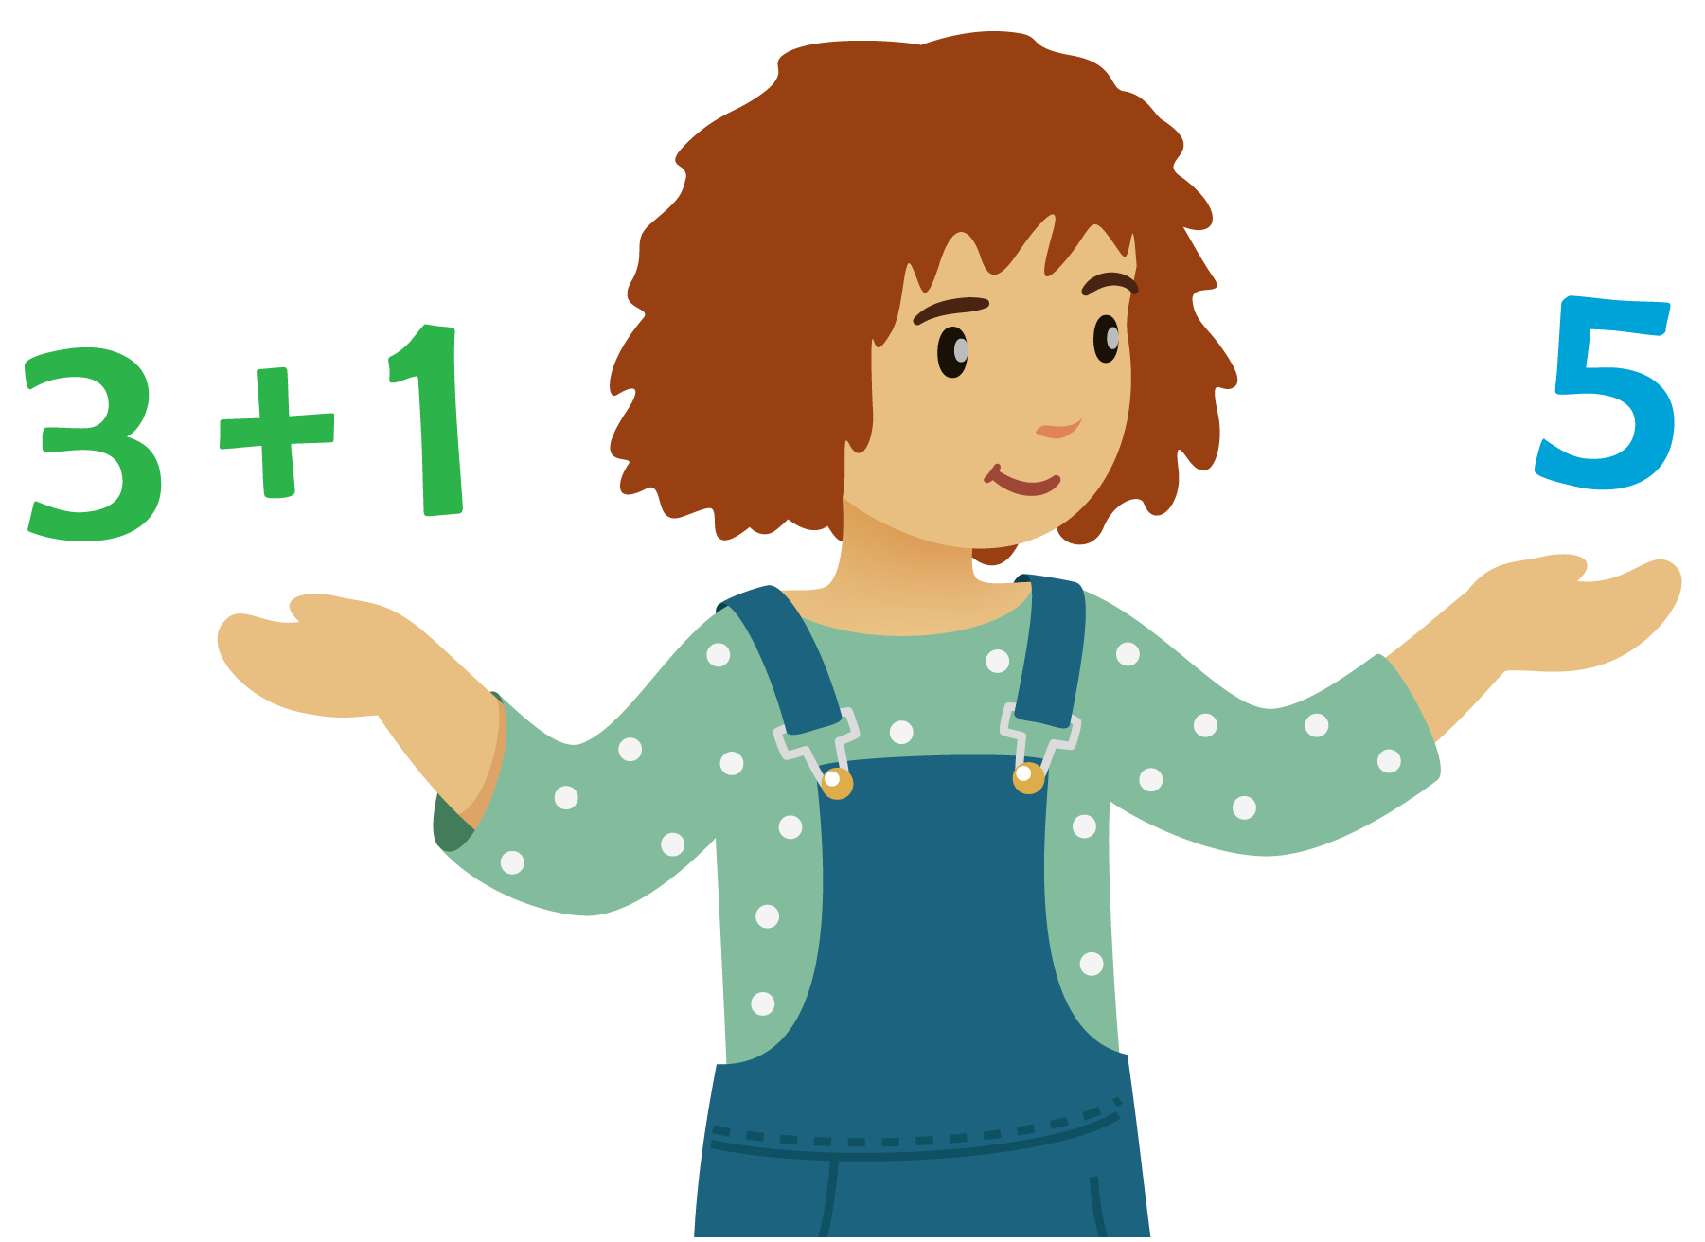
How Close?
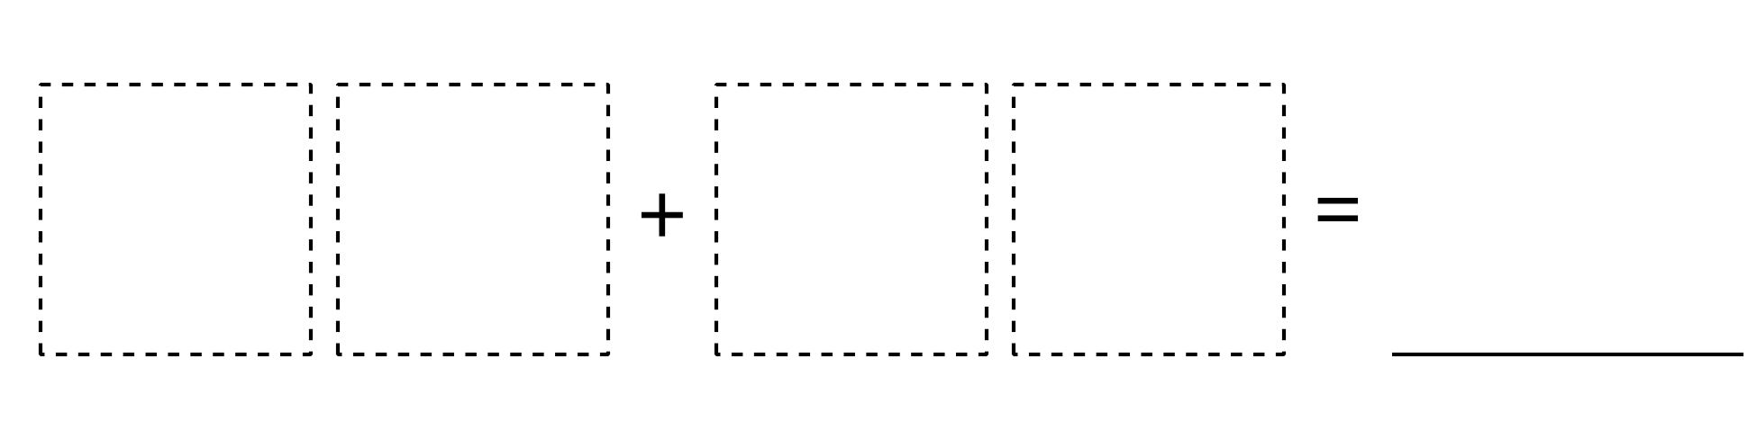
© CC BY 2021 Illustrative Mathematics®

