Lesson 14: Solve It Your Way
- Let’s solve story problems and share our thinking with others.

Warm-up: Number Talk: Multiple Addends
Find the value of each expression mentally.
- $5+9+5$
- $25+9+5$
- $25+15+19$
- $25+30+15+19$

14.1: Put It All Together
- Andre gathered seeds. He has 25 sunflower seeds and 17 squash seeds. How many seeds does he have? Show your thinking.
- Andre gathered more seeds. He has 35 cucumber seeds. How many seeds does Andre have altogether? Show your thinking.
- Compare your thinking with your partner.
- 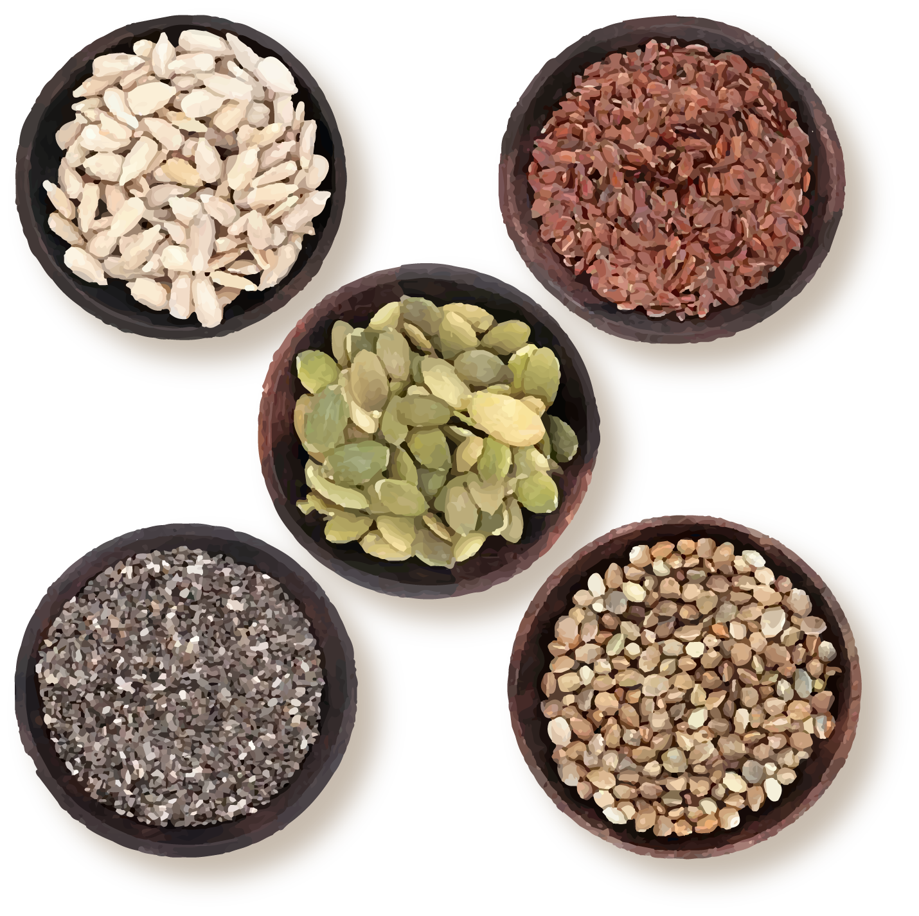

14.2: Select, Solve, and Share
- Decide which problem each member of your group will solve.
  - Priya has 24 fewer seeds than Tyler. Tyler has 53 seeds. How many seeds does Priya have?
  - Jada and Mai have 61 seeds. Jada has 39 seeds. How many seeds does Mai have?
  - Kiran started the game with 24 seeds. He won 17 seeds on his turn. How many seeds does he have now?
- Solve the problem. Show your thinking.
- Share your thinking with your group. After everyone has shared, complete the sentences with your answers. Then solve the story problem together.
  - Priya has ____________ seeds.
  - Mai has ____________ seeds.
  - Kiran has ____________ seeds.
  - How many seeds do they have in all?

Section Summary
Section Summary
In this section, we solved many different kinds of story problems. We used diagrams and equations to make sense of problems.
Jada started with some seeds. Then she won 28 seeds from Elena. Now she has 65 seeds.
How many seeds did Jada have at the start?
$?+28=65$
We shared how we make sense of story problems, how we solve them, and what we learned from each other.
© CC BY 2021 Illustrative Mathematics®

