Unit 7 Lesson 18: Paint Splattered Bar Graph

WU Number Talk: Subtract within 1,000 (Warm up)

Student Task Statement
Find the value of each expression mentally.
- $530−420$
- $530−426$
- $535−420$
- $535−426$

1 Student Population

Student Task Statement
Oh no! Paint fell on the poster of the bar graph Clare and Priya created.
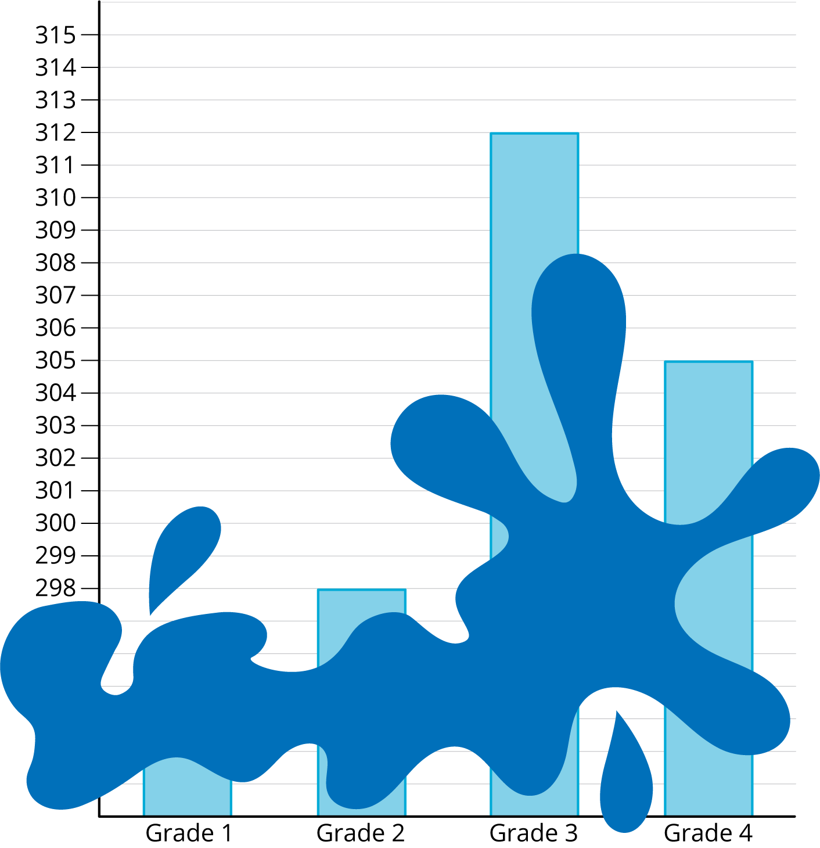
Answer the questions that you can with the graph. If a question cannot be answered, explain how you know.
- What is the total number of students in grades 3 and 4?
- How many more students are in grade 2 than in grade 1?
- How many more students are in grade 3 than grade 2?
- Write at least 2 mathematical questions that can be answered using the bar graph.

2 Asked and Answered

Student Task Statement
For each round:
- Trade one question you came up with in the last activity with a partner.
- Answer the question. Show or explain your reasoning.
- If you have time, trade another question with a different partner.
Round 1:
Round 2:
Round 3:
© CC BY 2021 Illustrative Mathematics®

