Unit 5 Lesson 2: Representing Proportional Relationships

1 An Unknown Situation (Warm up)

Student Task Statement
Here is a graph that could represent a variety of different situations.
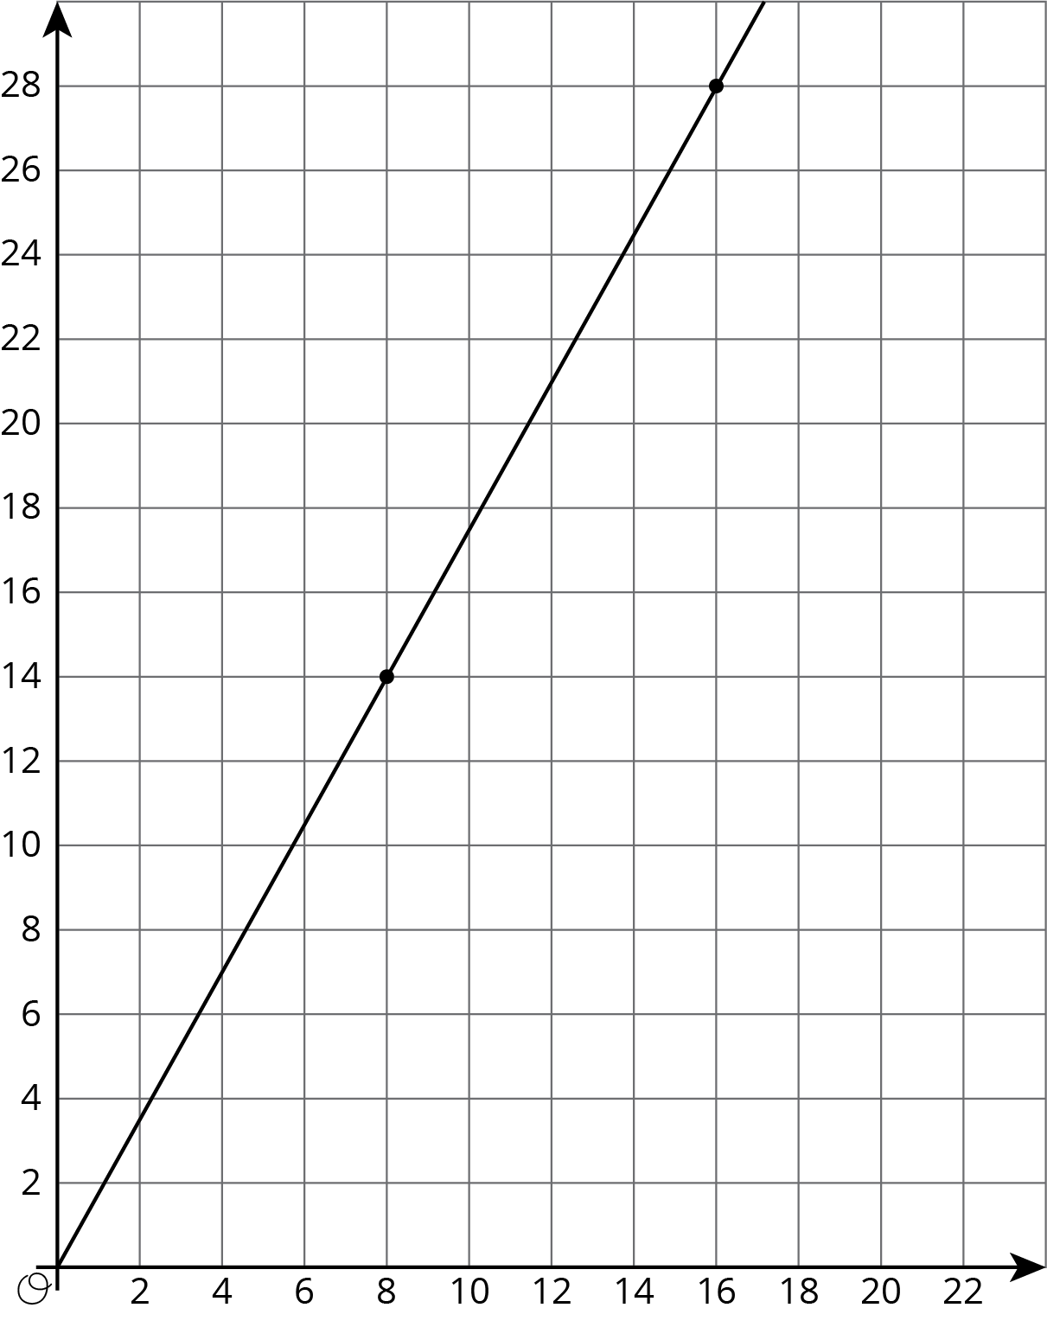
- Write an equation for the graph.
- Sketch a new graph of this relationship.
- 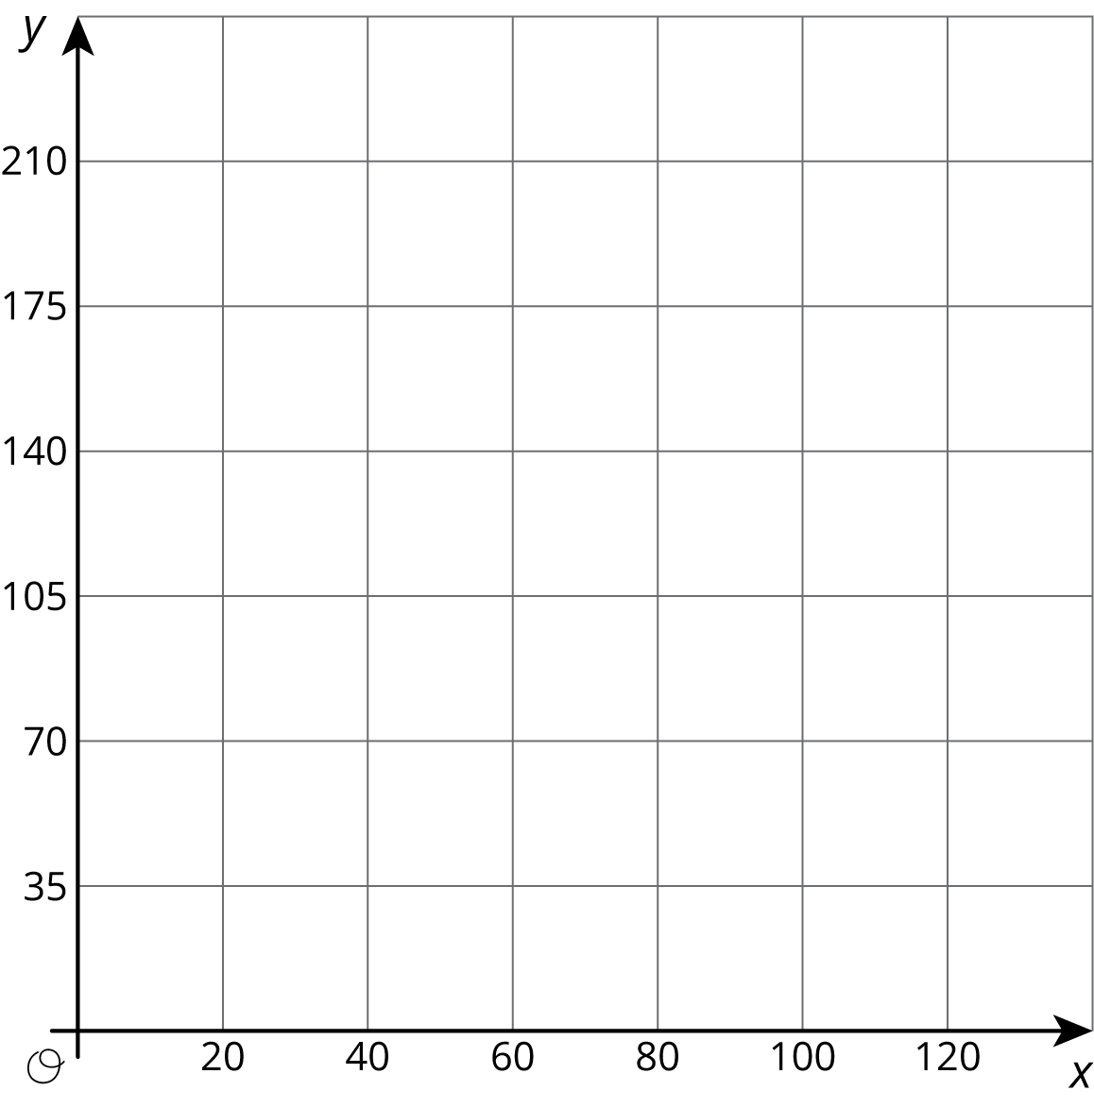

2 Card Sort: Proportional Relationships

Student Task Statement
Your teacher will give you 12 graphs of proportional relationships.
- Sort the graphs into groups based on what proportional relationship they represent.
- Write an equation for each different proportional relationship you find.

3 Different Scales

Student Task Statement
Two large water tanks are filling with water. Tank A is not filled at a constant rate, and the relationship between its volume of water and time is graphed on each set of axes. Tank B is filled at a constant rate of $\frac{1}{2}$ liters per minute. The relationship between its volume of water and time can be described by the equation $v=\frac{1}{2}t$, where $t$ is the time in minutes and $v$ is the total volume in liters of water in the tank.
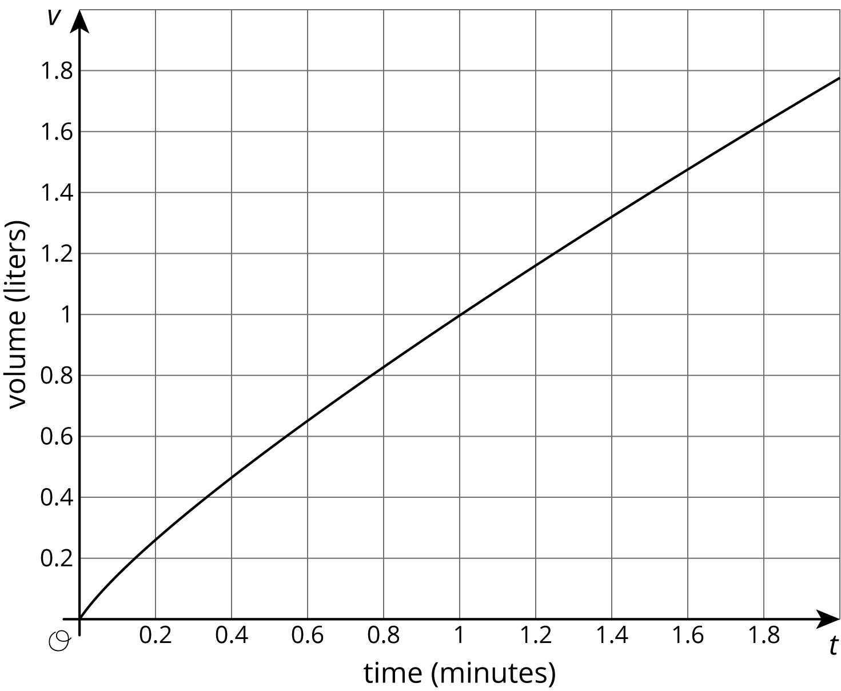
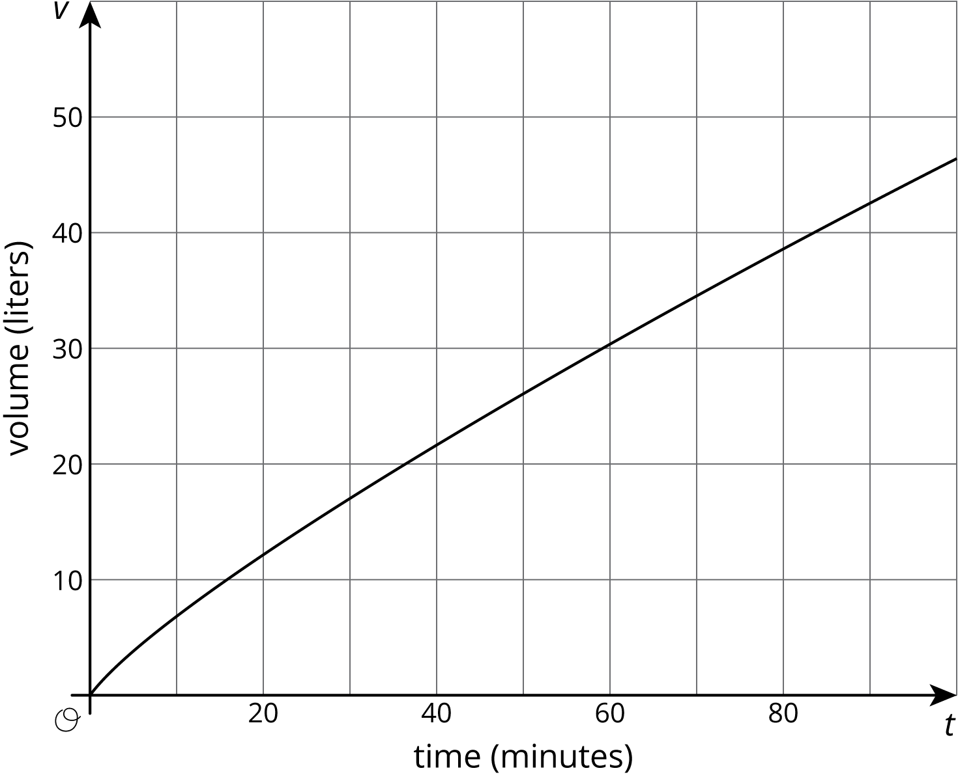
- Sketch and label a graph of the relationship between the volume of water $v$ and time $t$ for Tank B on each of the axes.
- Answer the following questions and say which graph you used to find your answer.
  - After 30 seconds, which tank has the most water?
  - At approximately what times do both tanks have the same amount of water?
  - At approximately what times do both tanks contain 1 liter of water? 20 liters?

4 Representations of Proportional Relationships

Student Task Statement
- Here are two ways to represent a situation.
- Description:
- Jada and Noah counted the number of steps they took to walk a set distance. To walk the same distance, Jada took 8 steps while Noah took 10 steps. Then they found that when Noah took 15 steps, Jada took 12 steps.
- Equation:
- Let $x$ represent the number of steps Jada takes and let $y$ represent the number of steps Noah takes. $y=\frac{5}{4}x$
  - Create a table that represents this situation with at least 3 pairs of values.
  - Graph this relationship and label the axes.
  - How can you see or calculate the constant of proportionality in each representation? What does it mean?
  - Explain how you can tell that the equation, description, graph, and table all represent the same situation.
- Here are two ways to represent a situation.
- Description:
- The Origami Club is doing a car wash fundraiser to raise money for a trip. They charge the same price for every car. After 11 cars, they raised a total of $93.50. After 23 cars, they raised a total of $195.50.
- Table:
- number of  cars | - amount raised  in dollars
- 11 | - 93.50
- 23 | - 195.50
  - Write an equation that represents this situation. (Use $c$ to represent number of cars and use $m$ to represent amount raised in dollars.)
  - Create a graph that represents this situation.
  - How can you see or calculate the constant of proportionality in each representation? What does it mean?
  - Explain how you can tell that the equation, description, graph, and table all represent the same situation.

5 Info Gap: Proportional Relationships

Student Task Statement
Your teacher will give you either a problem card or a data card. Do not show or read your card to your partner.
If your teacher gives you the problem card:
- Silently read your card and think about what information you need to be able to answer the question.
- Ask your partner for the specific information that you need.
- Explain how you are using the information to solve the problem.
- Continue to ask questions until you have enough information to solve the problem.
- Share the problem card and solve the problem independently.
- Read the data card and discuss your reasoning.
If your teacher gives you the data card:
- Silently read your card.
- Ask your partner “What specific information do you need?” and wait for them to ask for information.
- If your partner asks for information that is not on the card, do not do the calculations for them. Tell them you don’t have that information.
- Before sharing the information, ask “Why do you need that information?” Listen to your partner’s reasoning and ask clarifying questions.
- Read the problem card and solve the problem independently.
- Share the data card and discuss your reasoning.
Pause here so your teacher can review your work. Ask your teacher for a new set of cards and repeat the activity, trading roles with your partner.

Images for Activity Synthesis
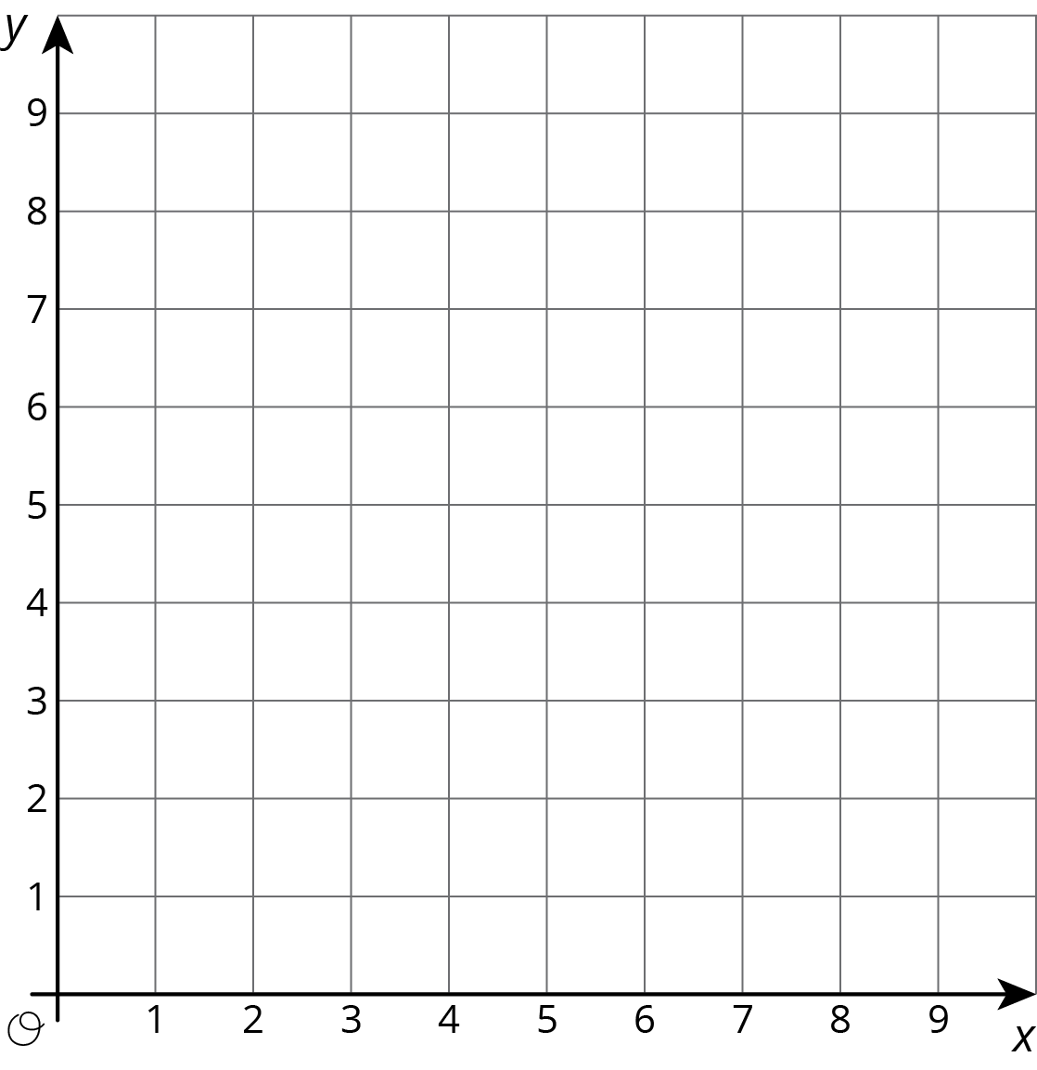
© CC BY Open Up Resources. Adaptations CC BY IM.

