Unit 6 Lesson 3: Staying in Balance

1 Hanging Around (Warm up)

Images for Launch
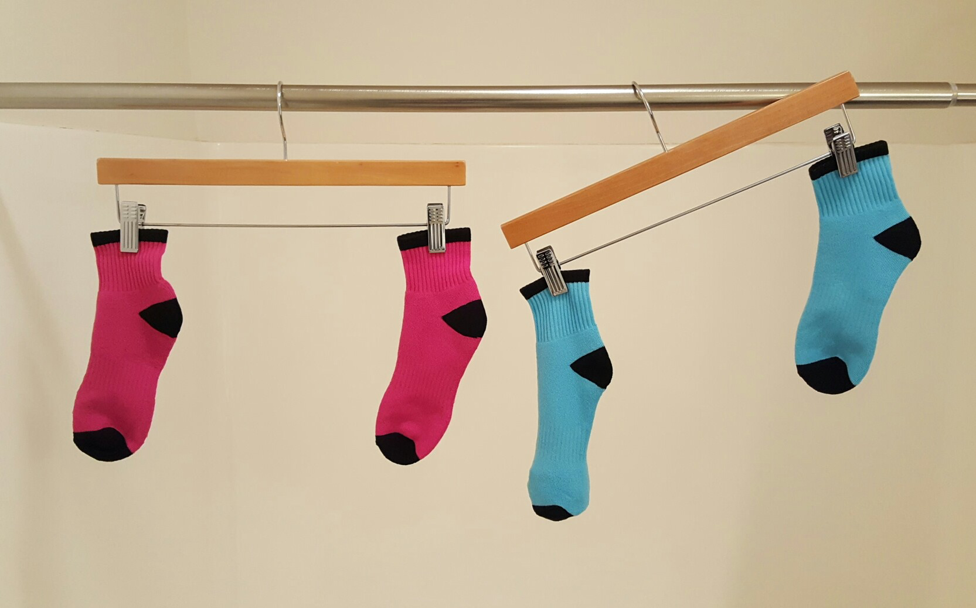

Student Task Statement
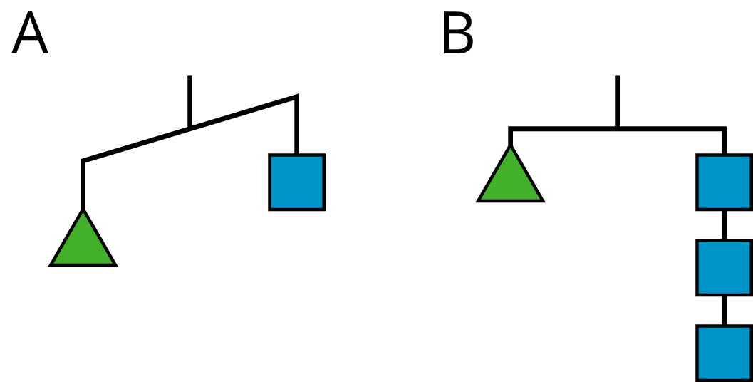
For diagram A, find:
- One thing that must be true
- One thing that could be true or false
- One thing that cannot possibly be true
For diagram B, find:
- One thing that must be true
- One thing that could be true or false
- One thing that cannot possibly be true

2 Match Equations and Hangers

Student Task Statement
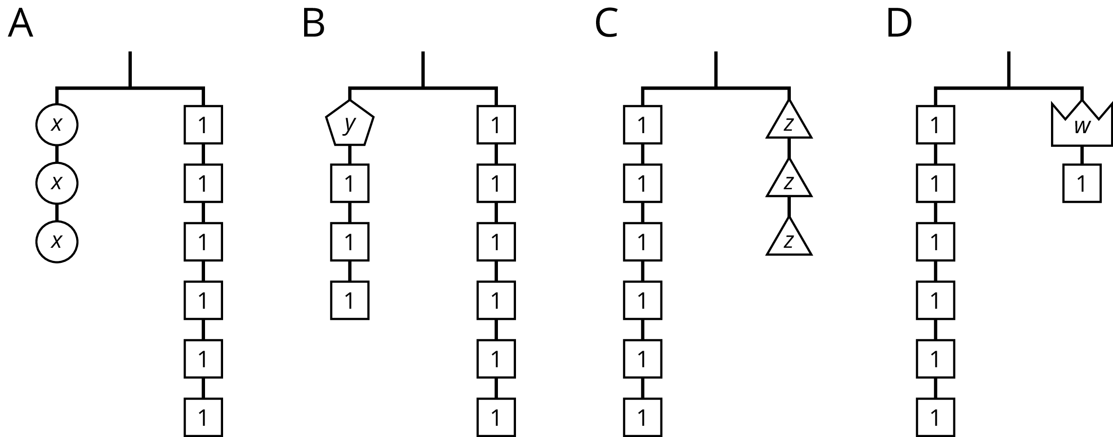
- Match each hanger to an equation. Complete the equation by writing $x$, $y$, $z$, or $w$ in the empty box.
- 3+3=6
- 3⋅3=6
- 6=3+1
- 6=3⋅3
- ​​Find a solution to each equation. Use the hangers to explain what each solution means.

Activity Synthesis
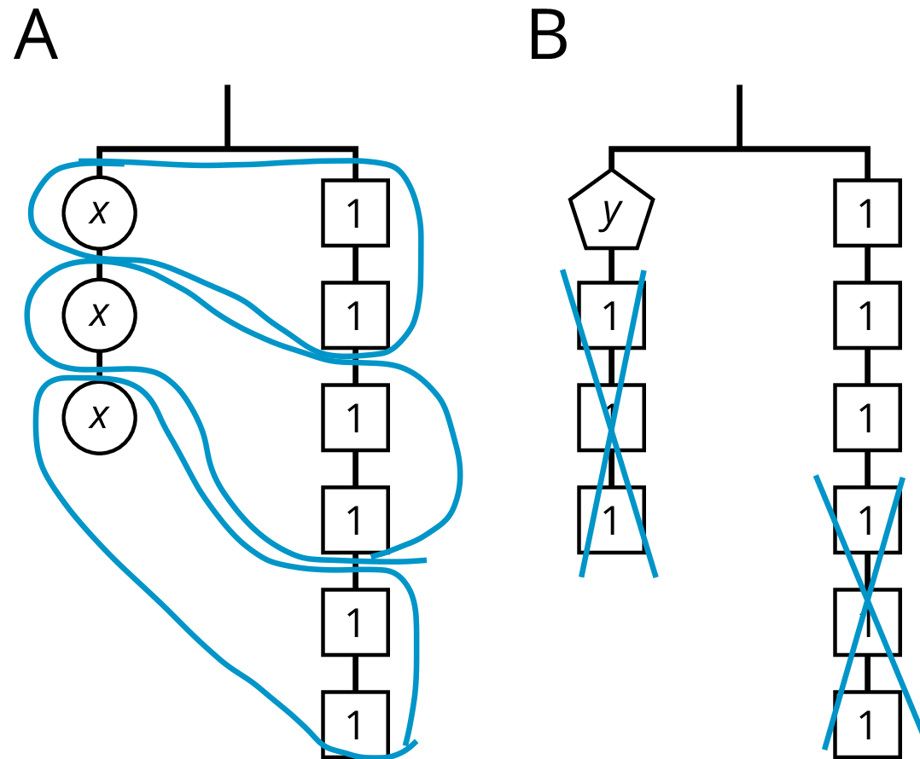

3 Connecting Diagrams to Equations and Solutions

Student Task Statement
Here are some balanced hangers. Each piece is labeled with its weight.
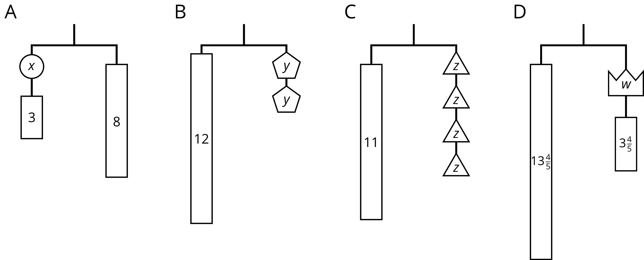
For each diagram:
- Write an equation.
- Explain how to reason with the diagram to find the weight of a piece with a letter.
- Explain how to reason with the equation to find the weight of a piece with a letter.
© CC BY Open Up Resources. Adaptations CC BY IM.

