## Unit 5 Lesson 5: Representing Subtraction

### 1 Equivalent Equations (Warm up)

#### Student Task Statement

Consider the equation . Here are some more equations, using the same numbers, that express the same relationship in a different way:

For each equation, write two more equations, using the same numbers, that express the same relationship in a different way.

### 2 Subtraction with Number Lines

#### Student Task Statement

1. Here is an unfinished number line diagram that represents a sum of 8.

* 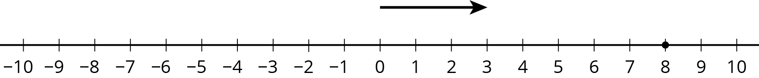
  1. How long should the other arrow be?
  2. For an equation that goes with this diagram, Mai writes .  
     Tyler writes . Do you agree with either of them?
  3. What is the unknown number? How do you know?

1. Here are two more unfinished diagrams that represent sums.

* 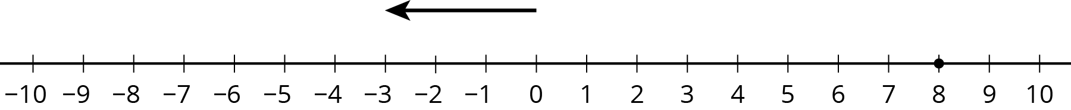
* 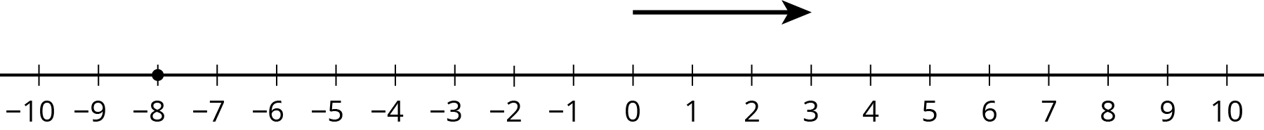
* For each diagram:
  1. What equation would Mai write if she used the same reasoning as before?
  2. What equation would Tyler write if he used the same reasoning as before?
  3. How long should the other arrow be?
  4. What number would complete each equation? Be prepared to explain your reasoning.

1. Draw a number line diagram for What is the unknown number? How do you know?

### 3 We Can Add Instead

#### Student Task Statement

1. Match each diagram to one of these expressions:

* 1. 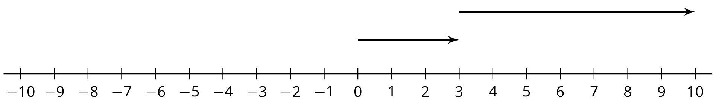
  2. 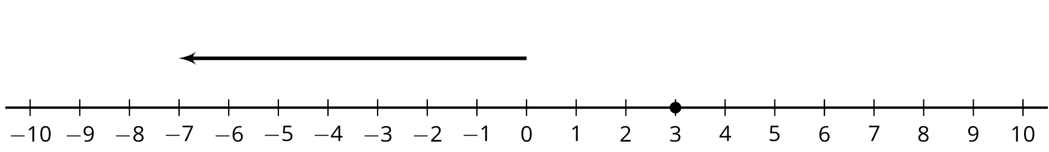
  3. 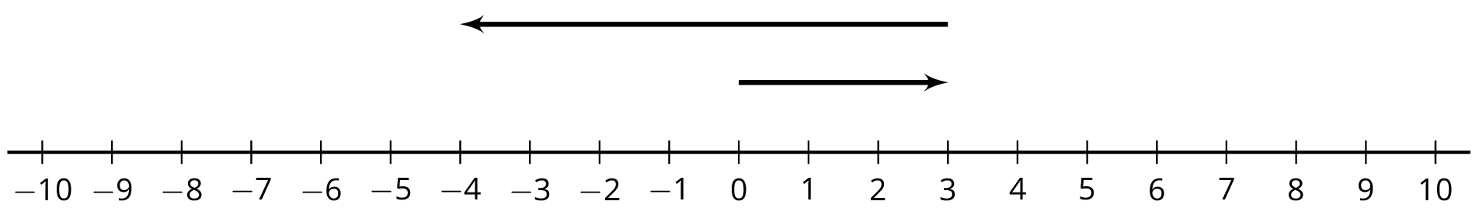
  4. 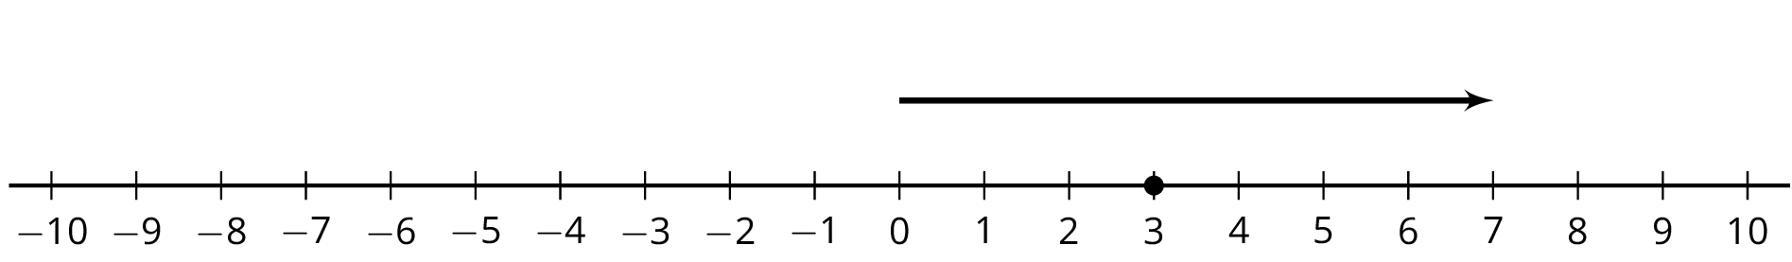

1. Which expressions in the first question have the same value? What do you notice?
2. Complete each of these tables. What do you notice?

|  |  |
| --- | --- |
| * expression | * value |
|  |  |
|  |  |
|  |  |
|  |  |
|  |  |
|  |  |

|  |  |
| --- | --- |
| * expression | * value |
|  |  |
|  |  |
|  |  |
|  |  |
|  |  |
|  |  |



© CC BY Open Up Resources. Adaptations CC BY IM.