Unit 4 Lesson 17: Two Related Quantities, Part 1

1 Which One Would You Choose? (Warm up)

Student Task Statement
Which one would you choose? Be prepared to explain your reasoning.
- A 5-pound jug of honey for $15.35
- Three 1.5-pound jars of honey for $13.05
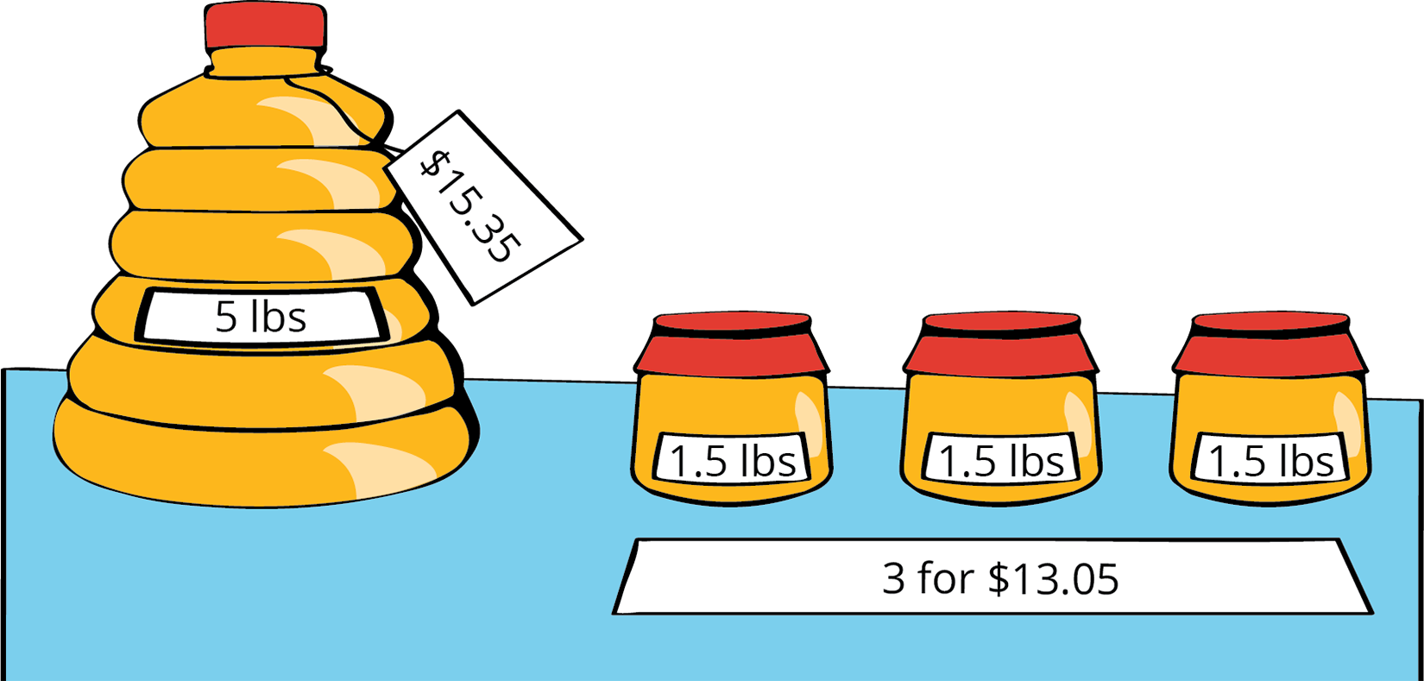

2 Painting the Set

Student Task Statement
Lin needs to mix a specific shade of orange paint for the set of the school play. The color uses 3 parts yellow for every 2 parts red.
- Complete the table to show different combinations of red and yellow paint that will make the shade of orange Lin needs.
- cups of red paint $\left(r\right)$ | - cups of yellow paint $\left(y\right)$ | - total cups of paint $\left(t\right)$
- 2 | - 3
- 6
 |  | - 20
 | - 18
- 14
- 16
 |  | - 50
 | - 42
- Lin notices that the number of cups of red paint is always $\frac{2}{5}$ of the total number of cups. She writes the equation $r=\frac{2}{5}t$ to describe the relationship. Which is the independent variable? Which is the dependent variable? Explain how you know.
- Write an equation that describes the relationship between $r$ and $y$ where $y$ is the independent variable.
- Write an equation that describes the relationship between $y$ and $r$ where $r$ is the independent variable.
- Use the points in the table to create two graphs that show the relationship between $r$ and $y$. Match each relationship to one of the equations you wrote.
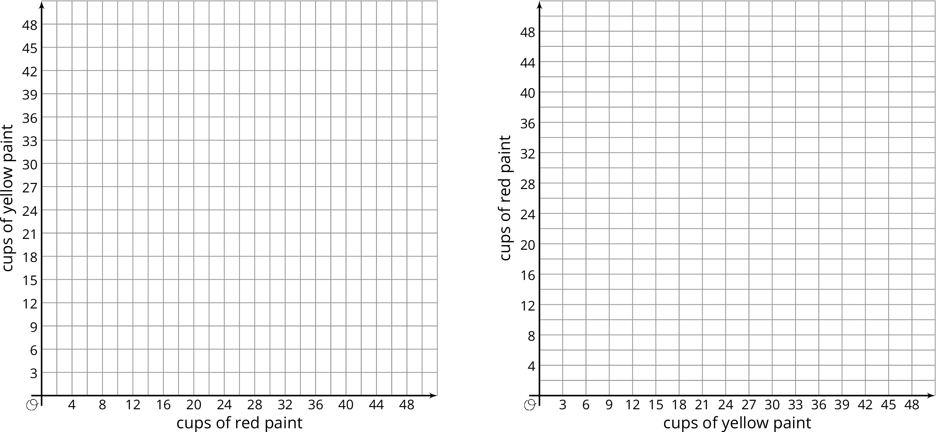
© CC BY Open Up Resources. Adaptations CC BY IM.

