Lesson 13: Make 10
- Let’s make 10.

Warm-up: How Many Do You See: Fingers Up and Down
How many do you see?
How do you see them?
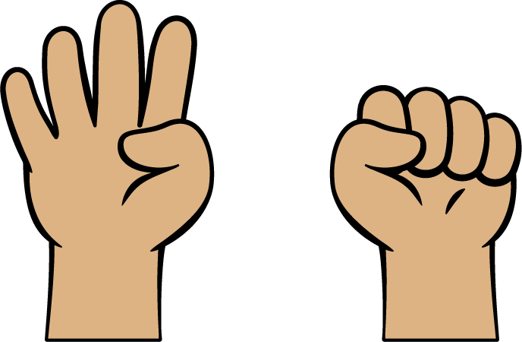
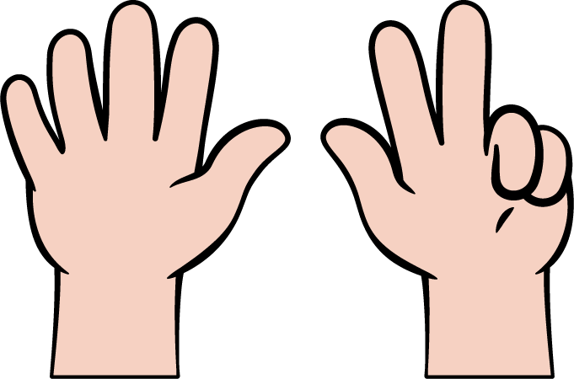

13.2: Make 10
3
_______________
$10=\underset{_}{}+\underset{_}{}$
9
_______________
$10=\underset{_}{}+\underset{_}{}$
2
_______________
$10=\underset{_}{}+\underset{_}{}$
5
_______________
$10=\underset{_}{}+\underset{_}{}$
7
_______________
$10=\underset{_}{}+\underset{_}{}$
6
_______________
$10=\underset{_}{}+\underset{_}{}$
8
_______________
$10=\underset{_}{}+\underset{_}{}$
4
_______________
$10=\underset{_}{}+\underset{_}{}$

13.3: Centers: Choice Time
Choose a center.
Math Fingers
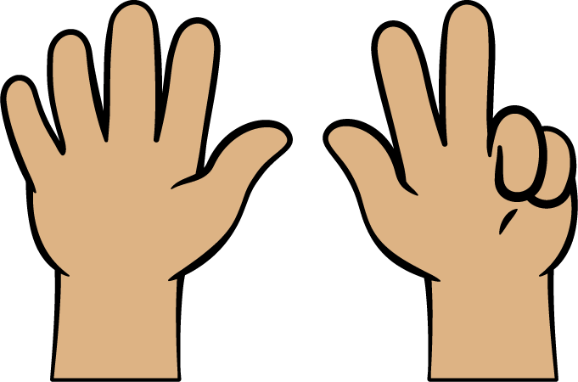
Shake and Spill
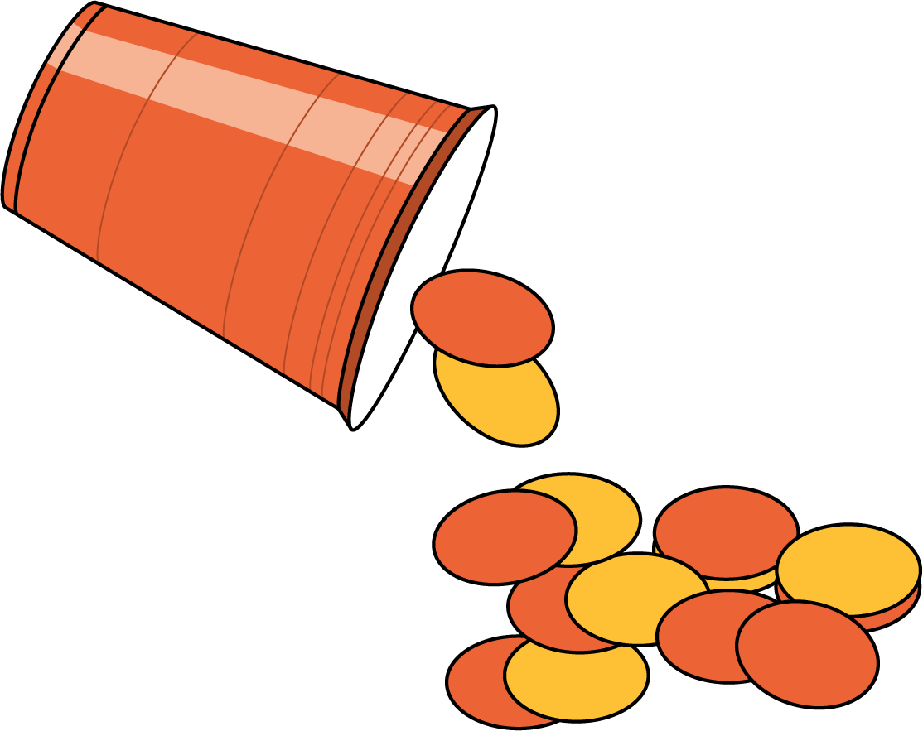
Counting Collections
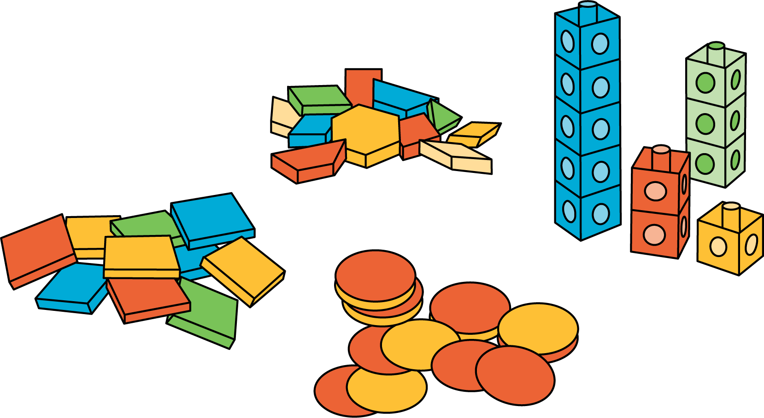
Roll and Add
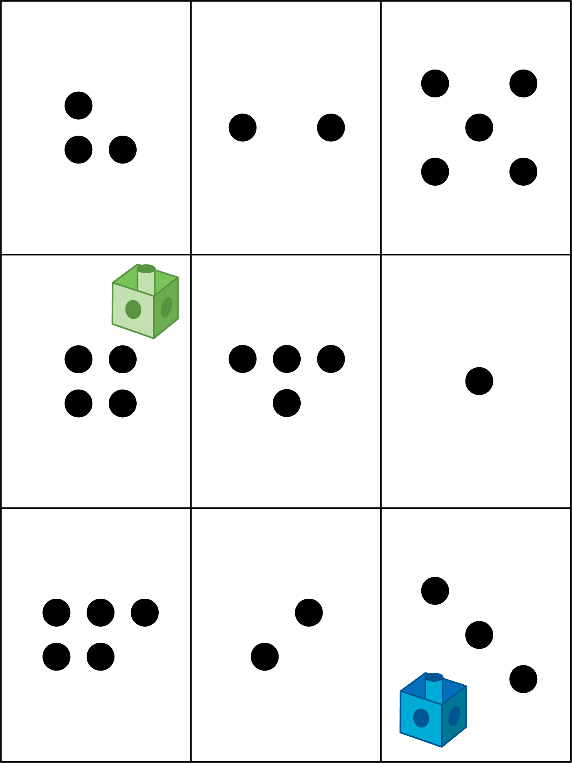
© CC BY 2021 Illustrative Mathematics®

