Lesson 4: Pattern Block Puzzles and Equations
- Let’s use equations to show how many of each shape there are.

Warm-up: Which One Doesn’t Belong: Equations
Which one doesn’t belong?
A
$3+3=6$
B
$6=4+2$
C
$4+3=7$
D
$4+2=6$

4.1: Match Equations to Pattern Block Puzzles
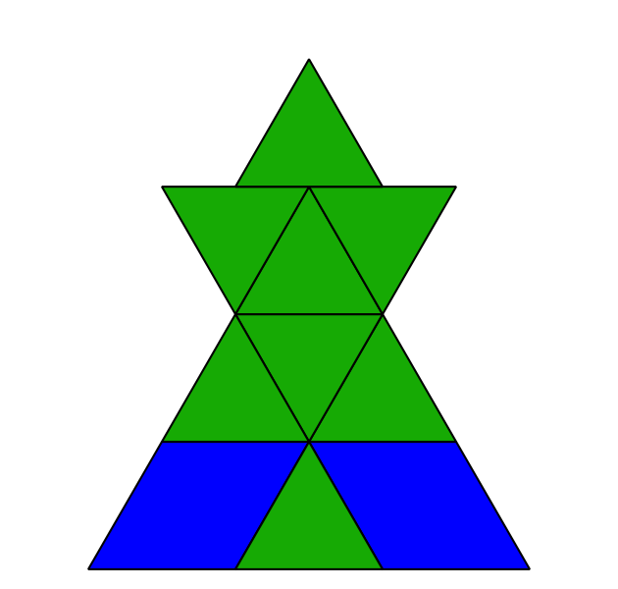
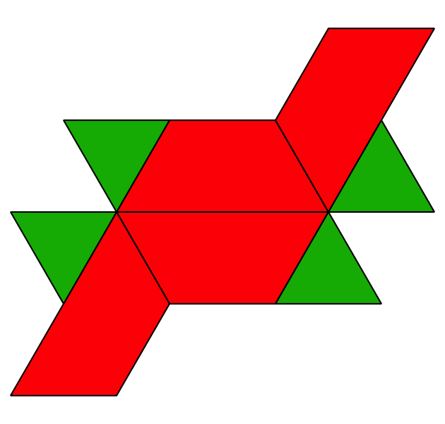
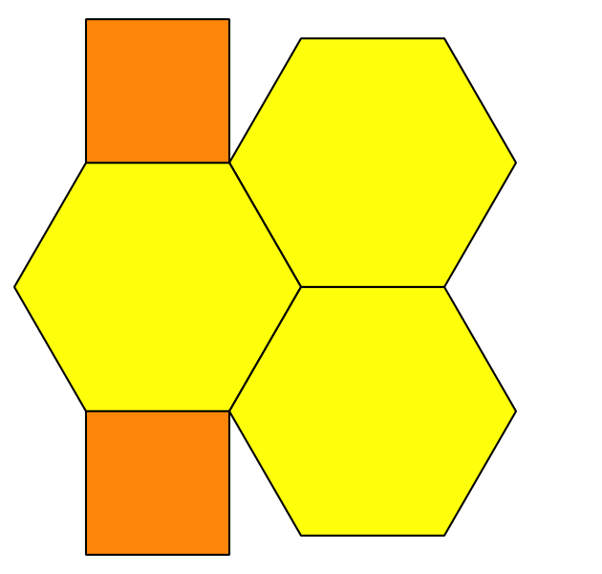
$8=4+4$
$6+1=7$
$10=2+8$
$7=6+1$
$2+3=5$
​$9=6+3$
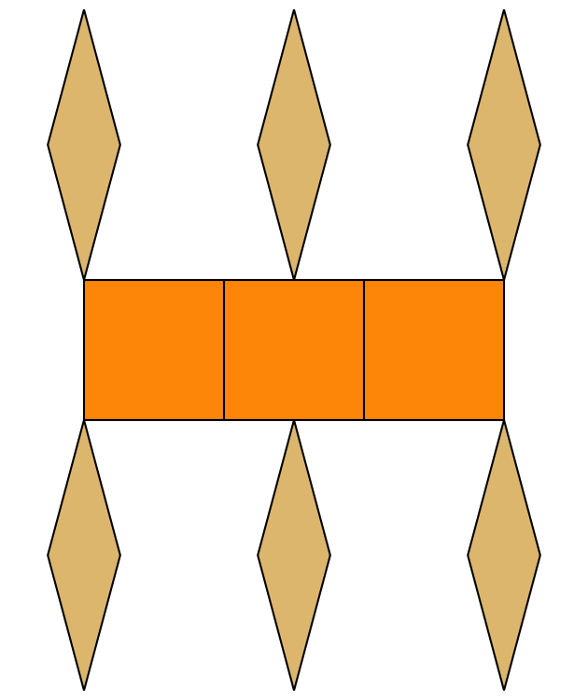
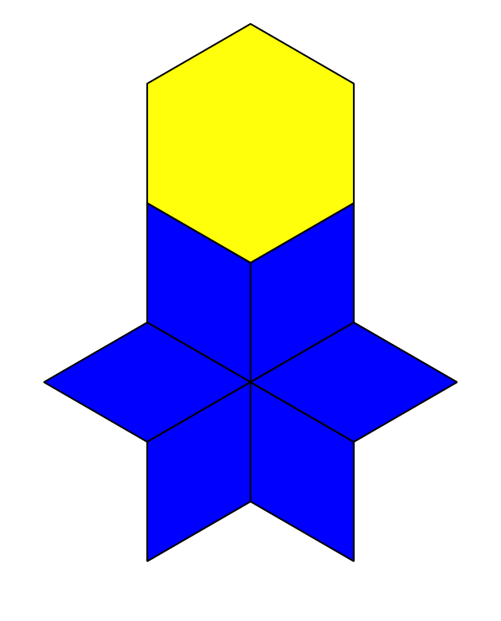

4.2: Make Shapes to Represent Equations
$4=1+3$
$10+0=10$
$5+4=9$
$8=2+6$
$3+3=6$
$7=2+5$

4.3: Centers: Choice Time
Choose a center.
Pattern Blocks
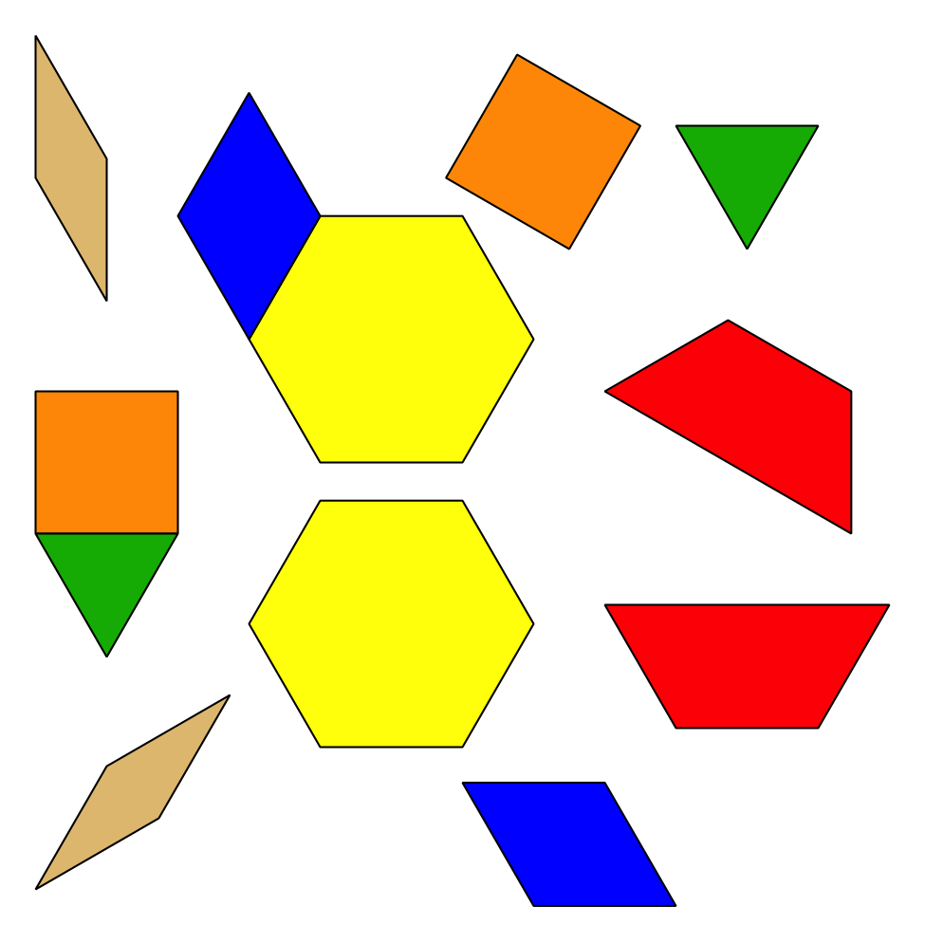
Geoblocks
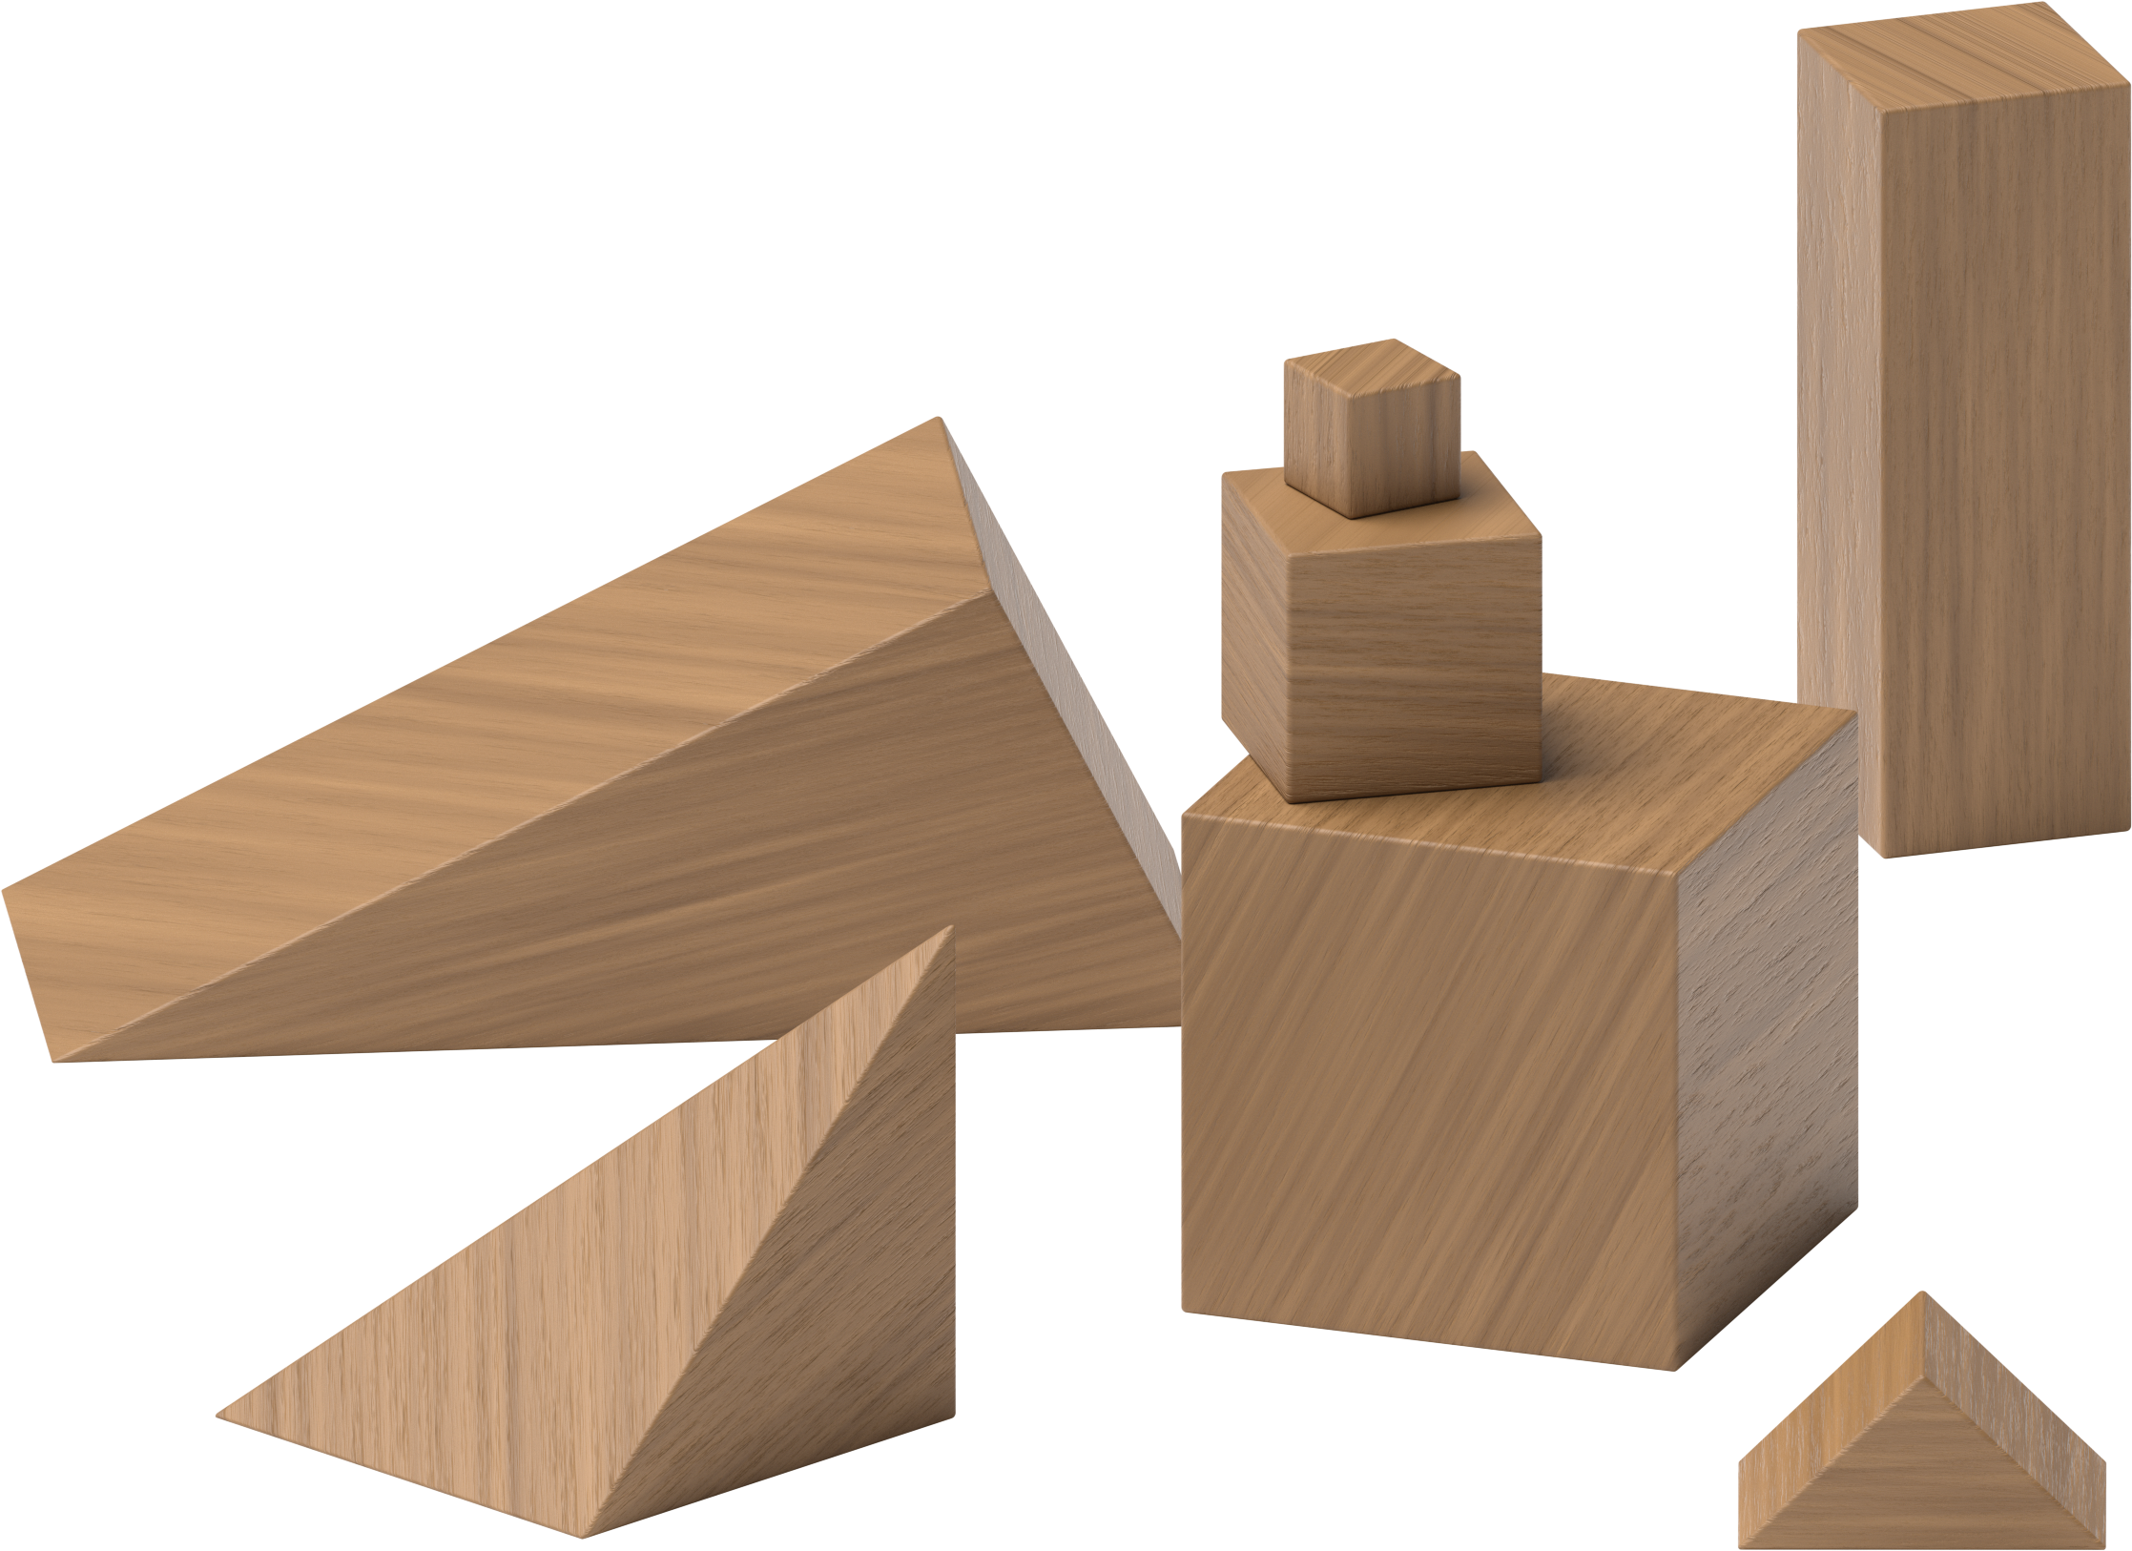
Grab and Count
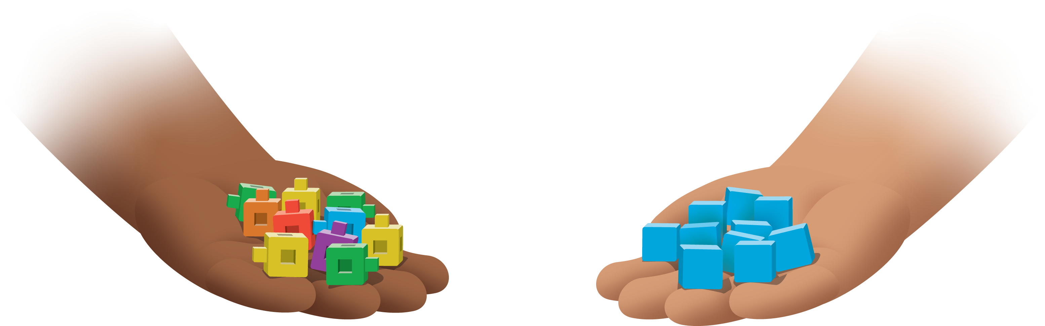
Find the Pair
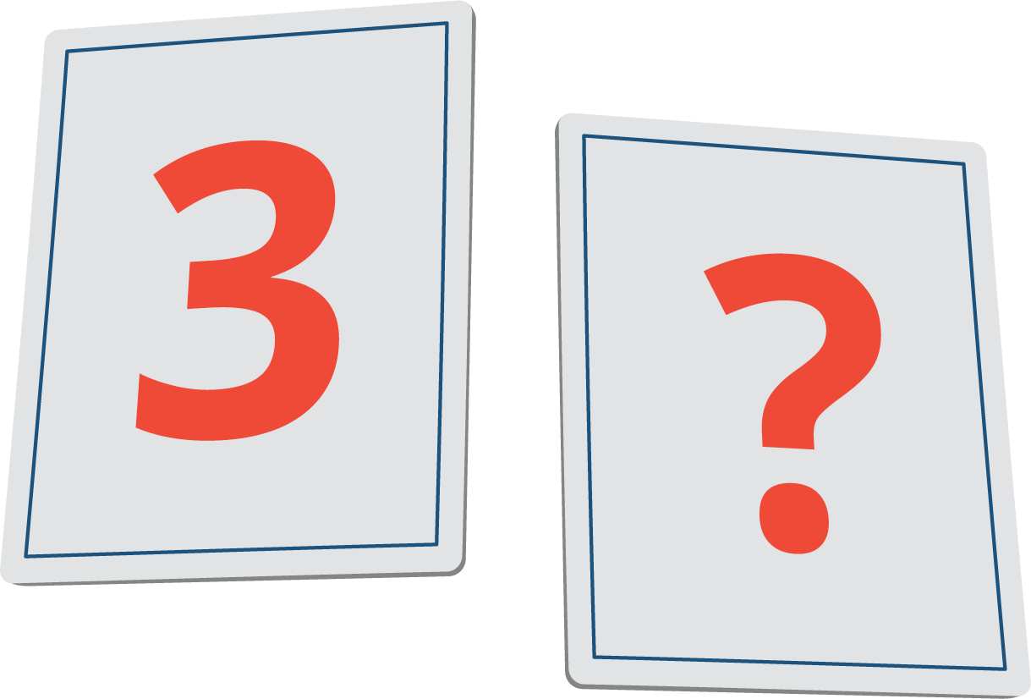
© CC BY 2021 Illustrative Mathematics®

