Unit 1 Lesson 13 Cumulative Practice Problems
- Which of these four figures are congruent to the top figure?
- 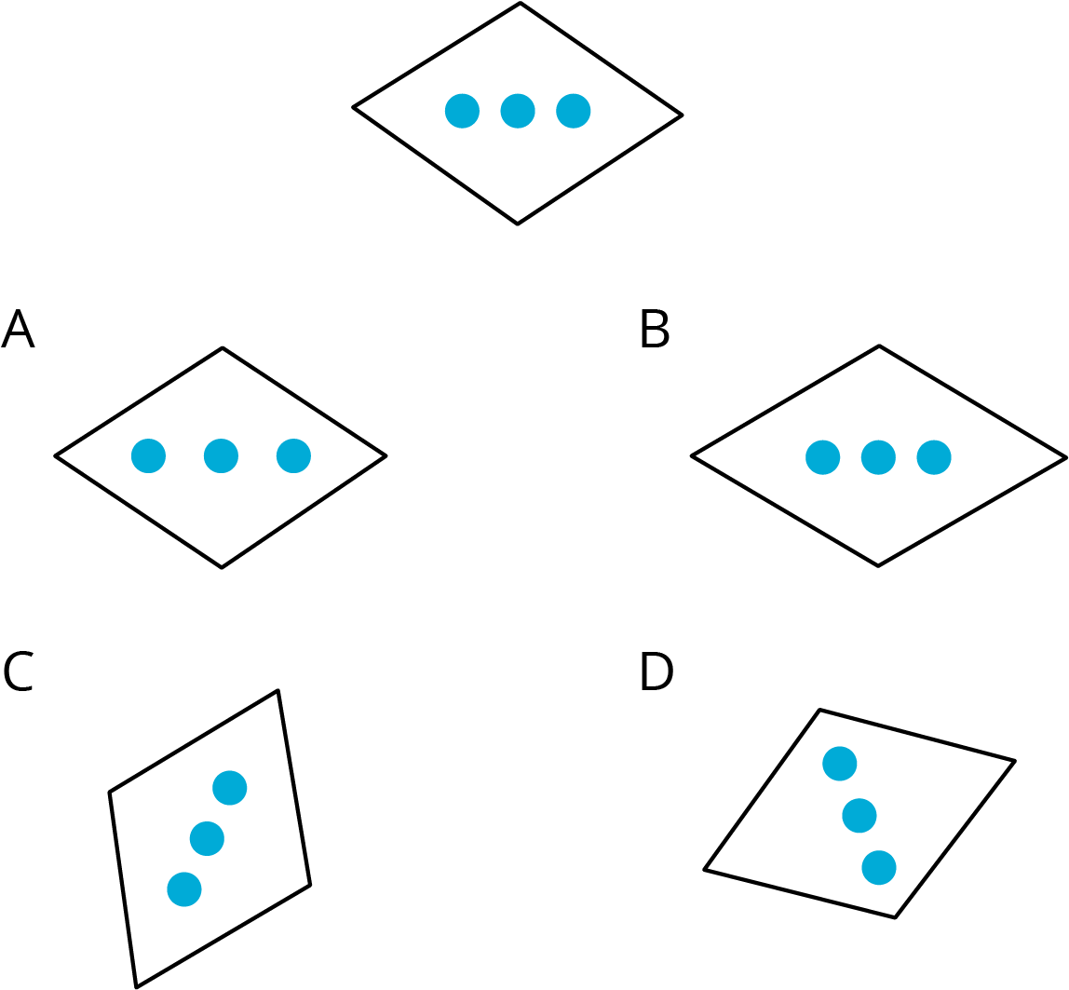
  - A
  - B
  - C
  - D
- These two figures are congruent, with corresponding points marked.
- 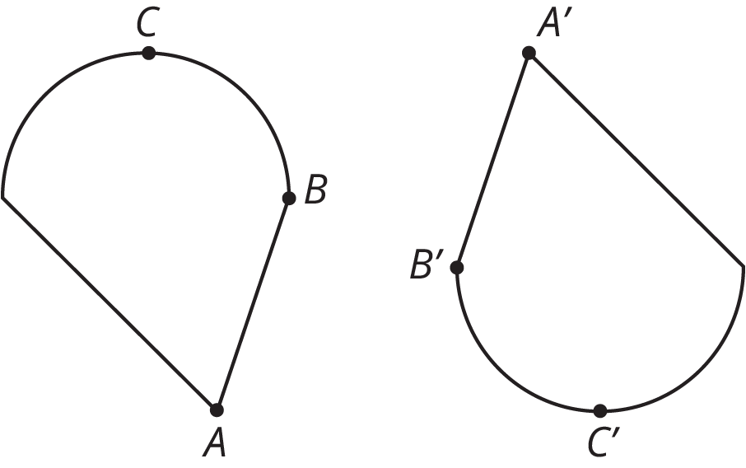
  - Are angles $ABC$ and $A^{′}B^{′}C^{′}$ congruent? Explain your reasoning.
  - Measure angles $ABC$ and $A^{′}B^{′}C^{′}$ to check your answer.
- Here are two figures.
- 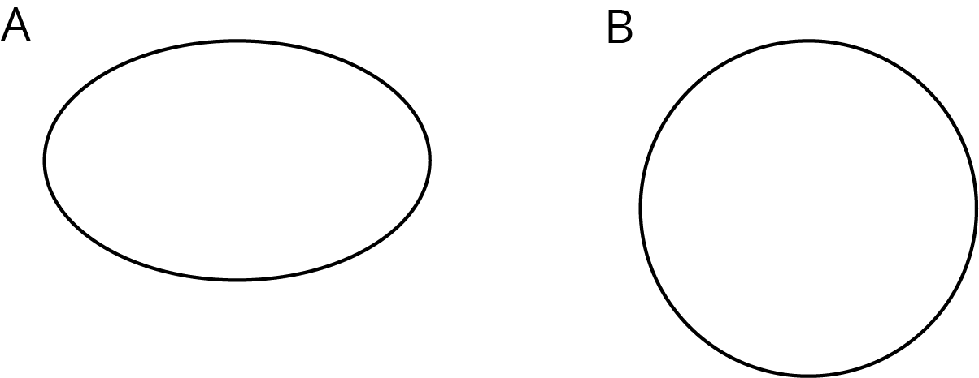
- Show, using measurement, that these two figures are not congruent.
- Each picture shows two polygons, one labeled Polygon A and one labeled Polygon B. Describe how to move Polygon A into the position of Polygon B using a transformation.

  - 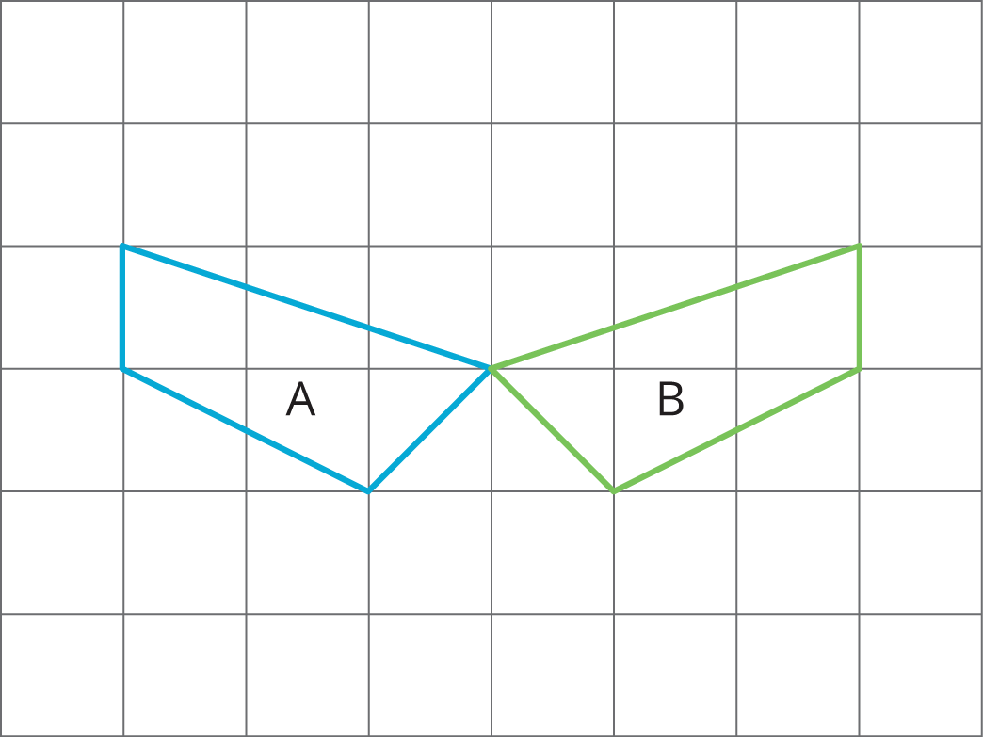

  - 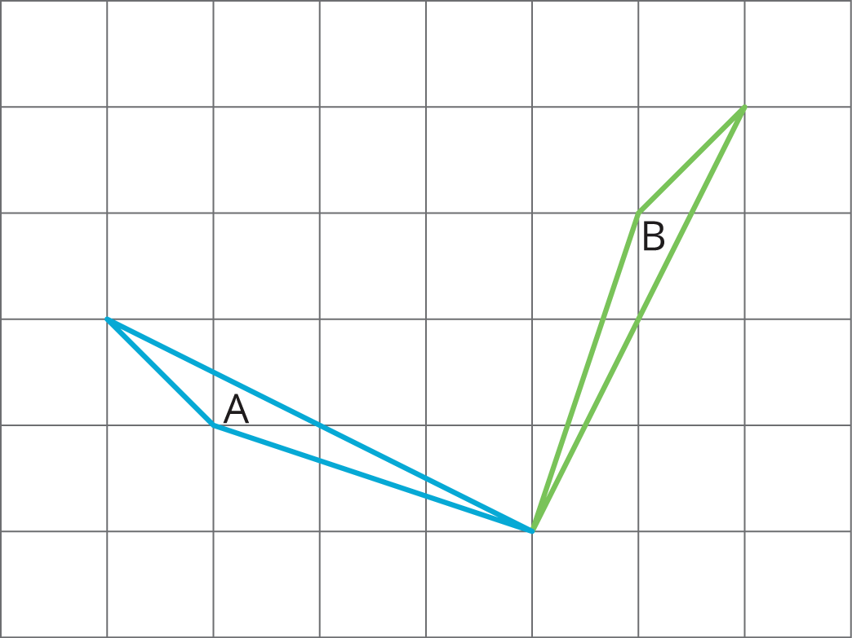

  - 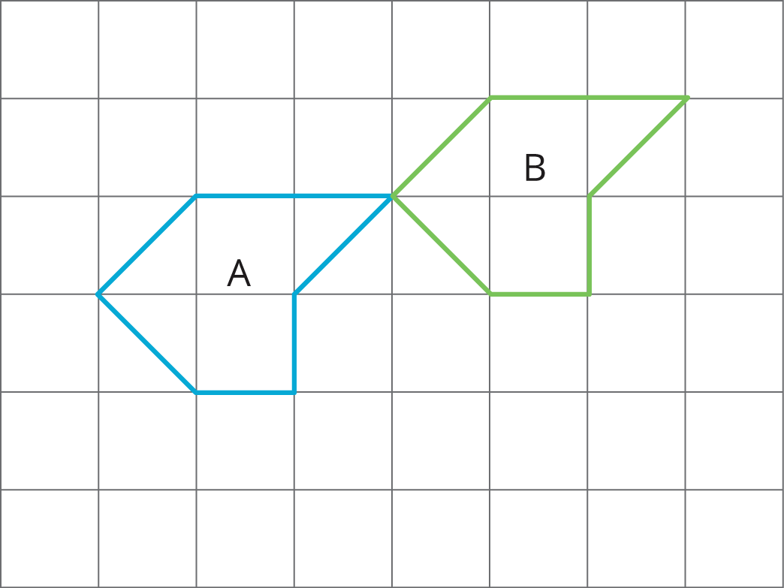
- (From Unit 1, Lesson 3.)
© CC BY Open Up Resources. Adaptations CC BY IM.

