Unit 3 Lesson 14: Solving Percentage Problems

1 Number Talk: Multiplication with Decimals (Warm up)

Student Task Statement
Find the products mentally.
$6⋅\left(0.8\right)⋅2$
$\left(4.5\right)⋅\left(0.6\right)⋅4$

2 Coupons

Images for Launch
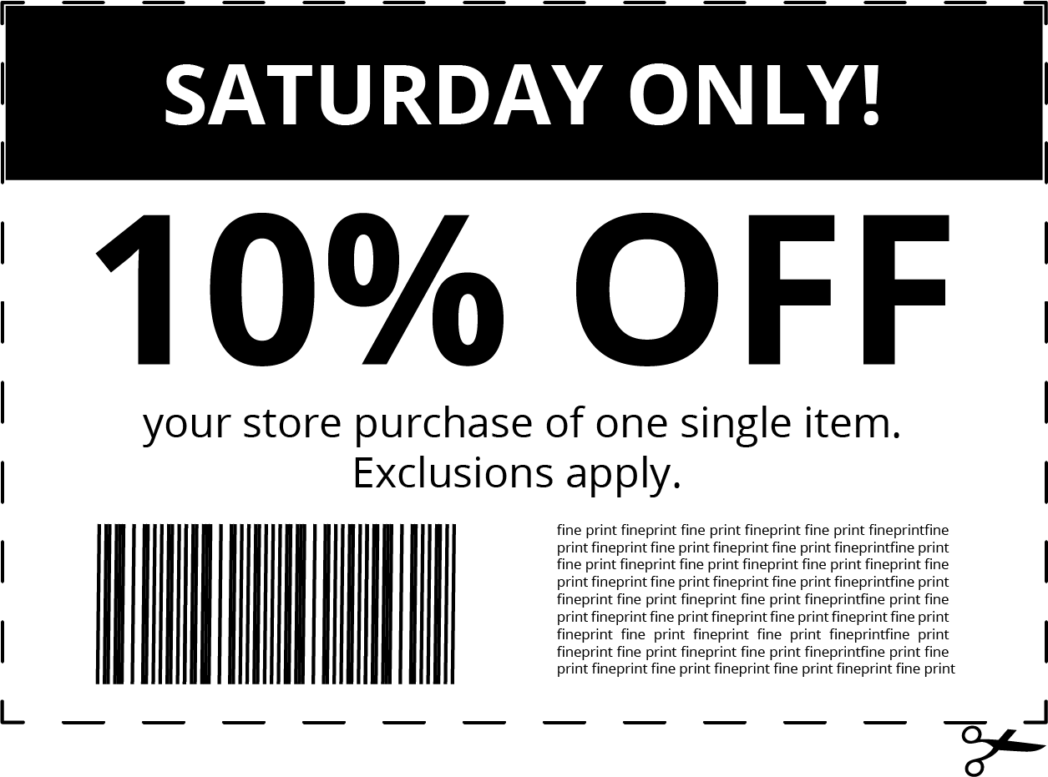

Student Task Statement
Han and Clare go shopping, and they each have a coupon. Answer each question and show your reasoning.
- Han buys an item with a normal price of $15, and uses a 10% off coupon. How much does he save by using the coupon?
- 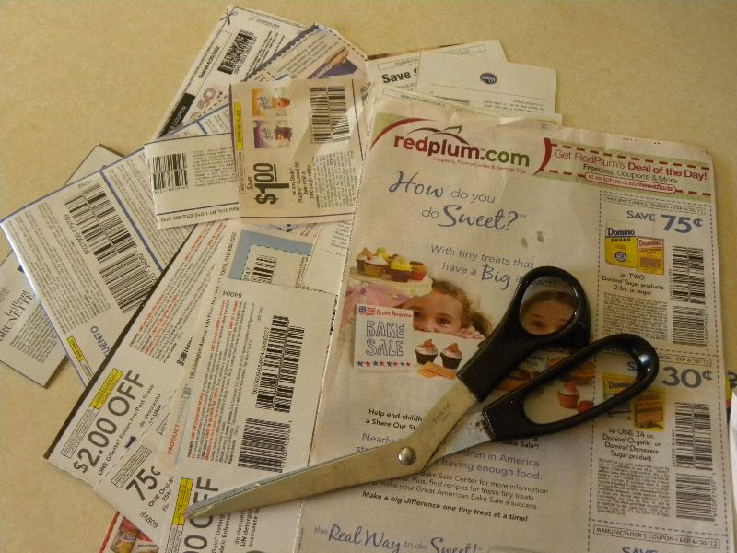
- Clare buys an item with a normal price of $24, but saves $6 by using a coupon. For what percentage off is this coupon?

3 Info Gap: Music Devices

Student Task Statement
Your teacher will give you either a problem card or a data card. Do not show or read your card to your partner.
If your teacher gives you the problem card:
- Silently read your card and think about what information you need to be able to answer the question.
- Ask your partner for the specific information that you need.
- Explain how you are using the information to solve the problem.
- Continue to ask questions until you have enough information to solve the problem.
- Share the problem card and solve the problem independently.
- Read the data card and discuss your reasoning.
If your teacher gives you the data card:
- Silently read your card.
- Ask your partner “What specific information do you need?” and wait for them to ask for information.
- If your partner asks for information that is not on the card, do not do the calculations for them. Tell them you don’t have that information.
- Before sharing the information, ask “Why do you need that information?” Listen to your partner’s reasoning and ask clarifying questions.
- Read the problem card and solve the problem independently.
- Share the data card and discuss your reasoning.

Images for Activity Synthesis
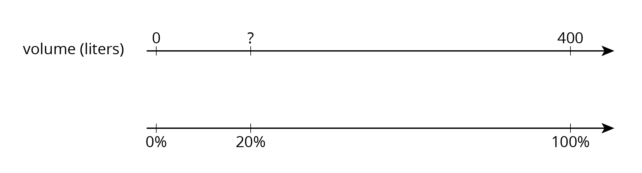
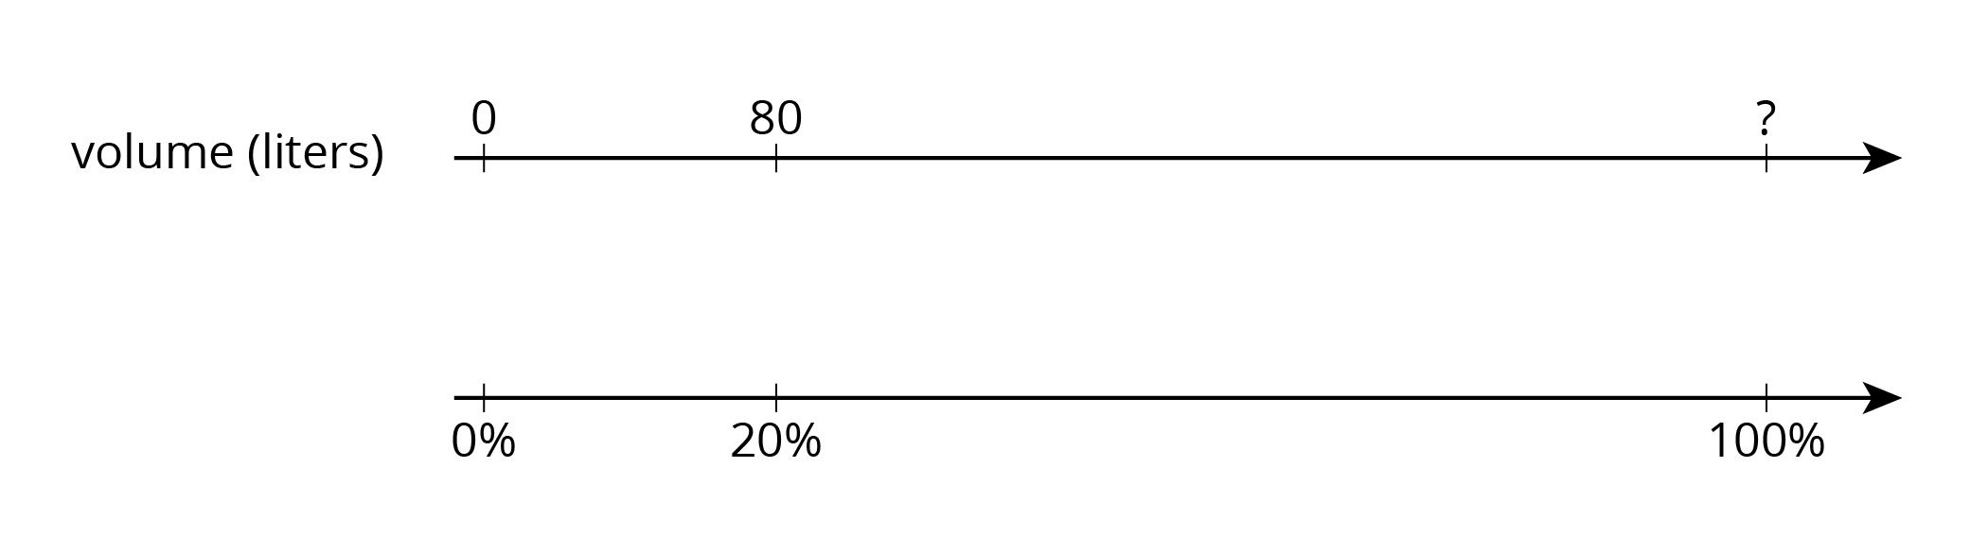
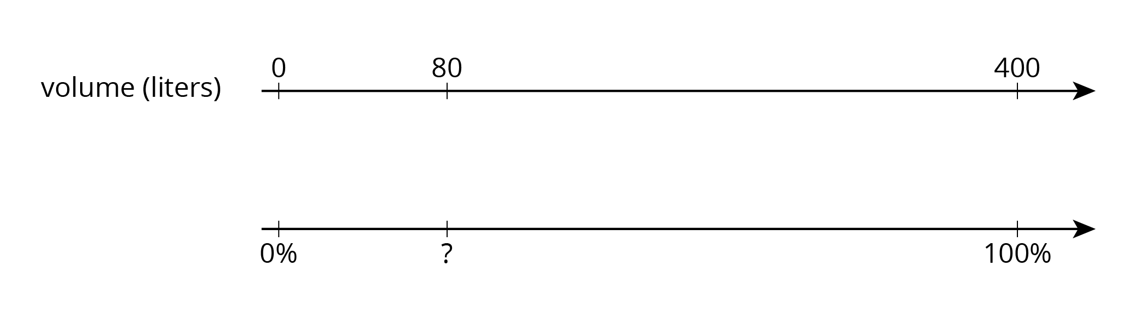
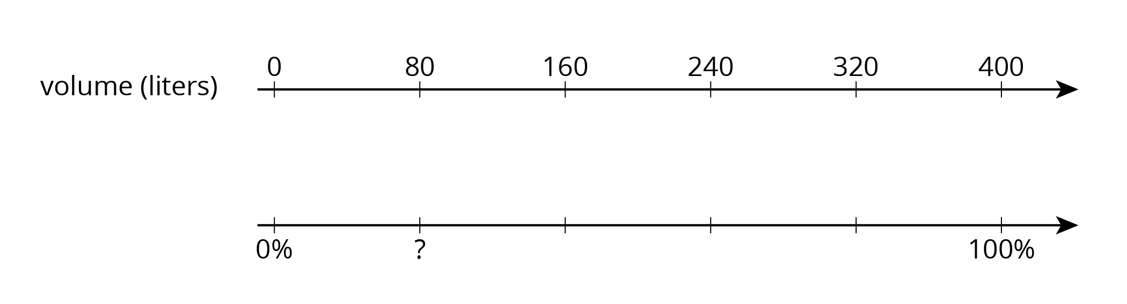
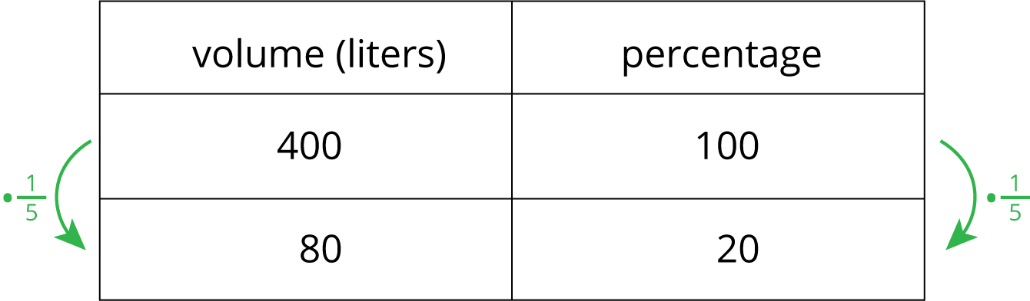
© CC BY Open Up Resources. Adaptations CC BY IM.

