Lesson 7: Using Factors and Zeros
- Let’s write some polynomials.

7.1: More Than Factors
$M$ and $K$ are both polynomial functions of $x$ where $M(x)=(x+3)(2x−5)$ and $K(x)=3(x+3)(2x−5)$.
- How are the two functions alike? How are they different?
- If a graphing window of $\text{-}5≤x≤5$ and $\text{-}20≤y≤20$ shows all intercepts of a graph of $y=M(x)$, what graphing window would show all intercepts of $y=K(x)$?

7.2: Choosing Windows
Mai graphs the function $p$ given by $p(x)=(x+1)(x−2)(x+15)$ and sees this graph.
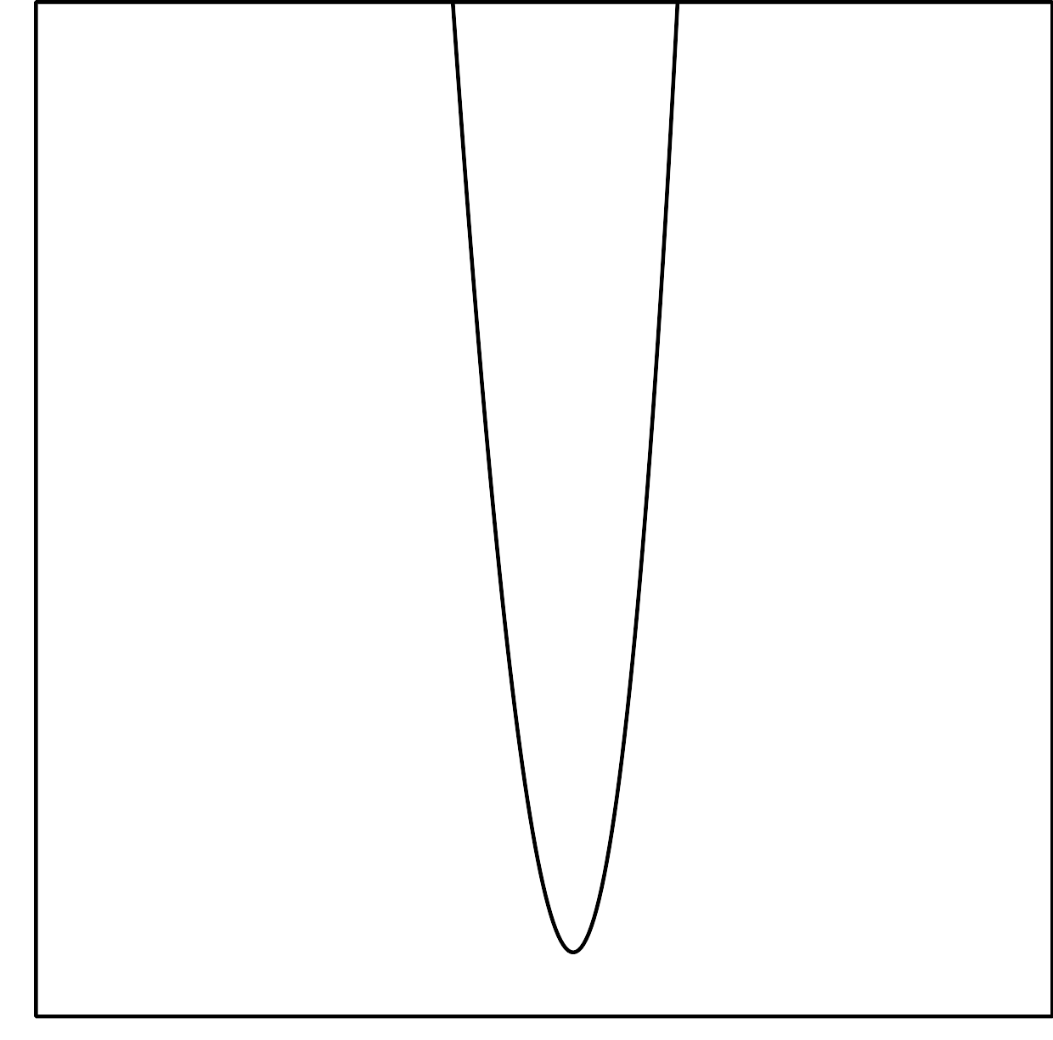
She says, “This graph looks like a parabola, so it must be a quadratic.”
- Is Mai correct? Use graphing technology to check.
- Explain how you could select a viewing window before graphing an expression like $p(x)$ that would show the main features of a graph.
- Using your explanation, what viewing window would you choose for graphing $f(x)=(x+1)(x−1)(x−2)(x−28)$?

Are you ready for more?
Select some different windows for graphing the function $q(x)=23(x−53)(x−18)(x+111)$. What is challenging about graphing this function?

7.3: What’s the Equation?
Write a possible equation for a polynomial whose graph has the following horizontal intercepts. Check your equation using graphing technology.
- $(4,0)$
- $(0,0)$ and $(4,0)$
- $(\text{-}2,0)$, $(0,0)$ and $(4,0)$
- $(\text{-}4,0),(0,0)$, and $(2,0)$
- $(\text{-}5,0)$, $\left(\frac{1}{2},0\right)$, and $(3,0)$

Lesson 7 Summary
We can use the zeros of a polynomial function to figure out what an expression for the polynomial might be.
Let’s say we want a polynomial function $Z$ that satisfies $Z(x)=0$ when $x$ is -1, 2, or 4. We know that one way to write a polynomial expression is as a product of linear factors. We could write a possible expression for $Z(x)$ by multiplying together a factor that is zero when $x=\text{-}1$, a factor that is zero when $x=2$, and a factor that is zero when $x=4$. Can you think of what these three factors could be?
It turns out that there are many possible expressions for $Z(x)$. Using linear factors, one possibility is $Z(x)=(x+1)(x−2)(x−4)$. Another possibility is $Z(x)=2(x+1)(x−2)(x−4)$, since the 2 (or any other rational number) does not change what values of $x$ make the function equal to zero.
To check that these expressions match what we know about $Z$, we can test the three values -1, 2, and 4 to make sure that $Z(x)$ is 0 for those values. Alternatively, we can graph both possible versions of $Z$ and see that the graphs intercept the horizontal axis at -1, 2, and 4, as shown here.
© CC BY 2019 by Illustrative Mathematics®

