Unit 8 Lesson 15: Addition and Subtraction Expressions within 5

WU Which One Doesn’t Belong: Expressions and Equations (Warm up)

Student Task Statement
Which one doesn’t belong?
A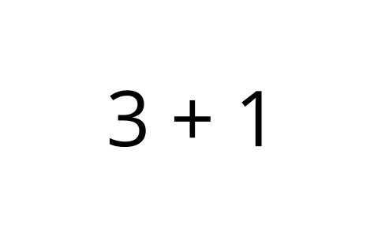
B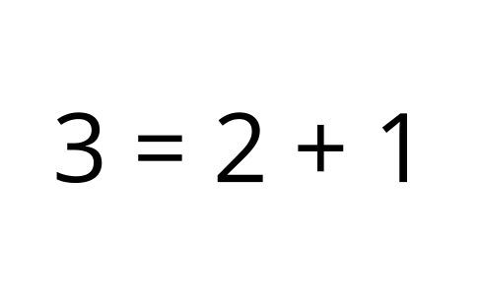
C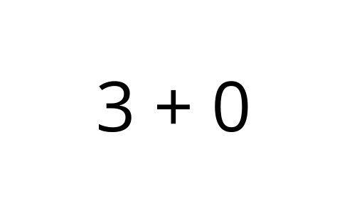
D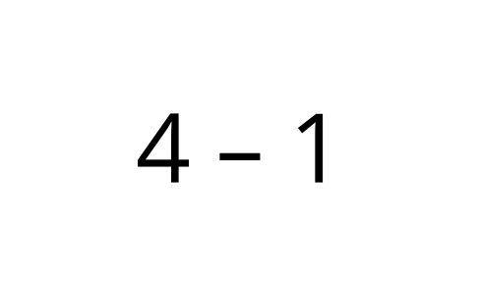

1 Four Corners: Totals and Differences

Student Task Statement

2 Compare Expressions

Student Task Statement

3 Centers: Choice Time

Student Task Statement
Choose a center.
5-frames
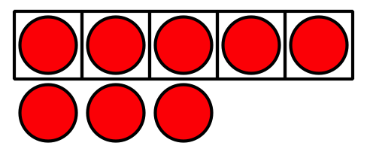
Roll and Add
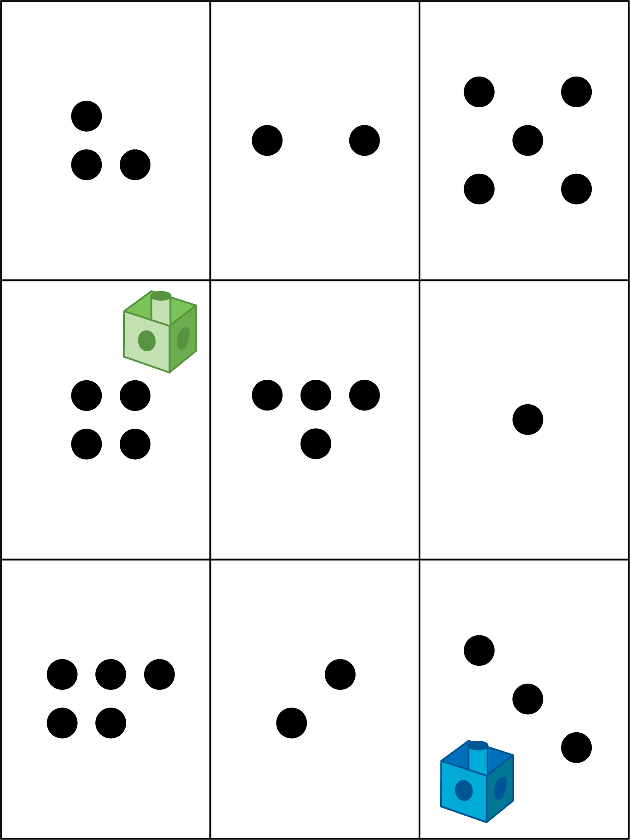
Bingo
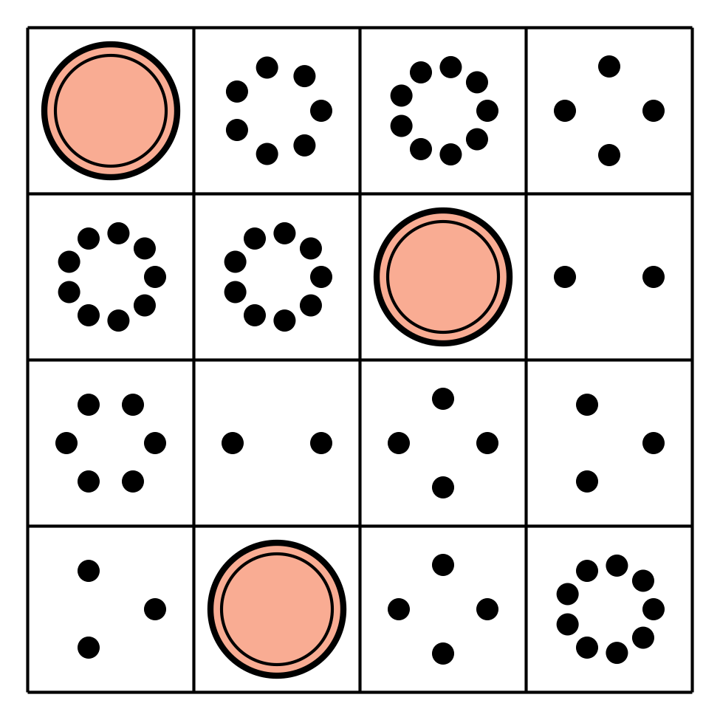
Geoblocks
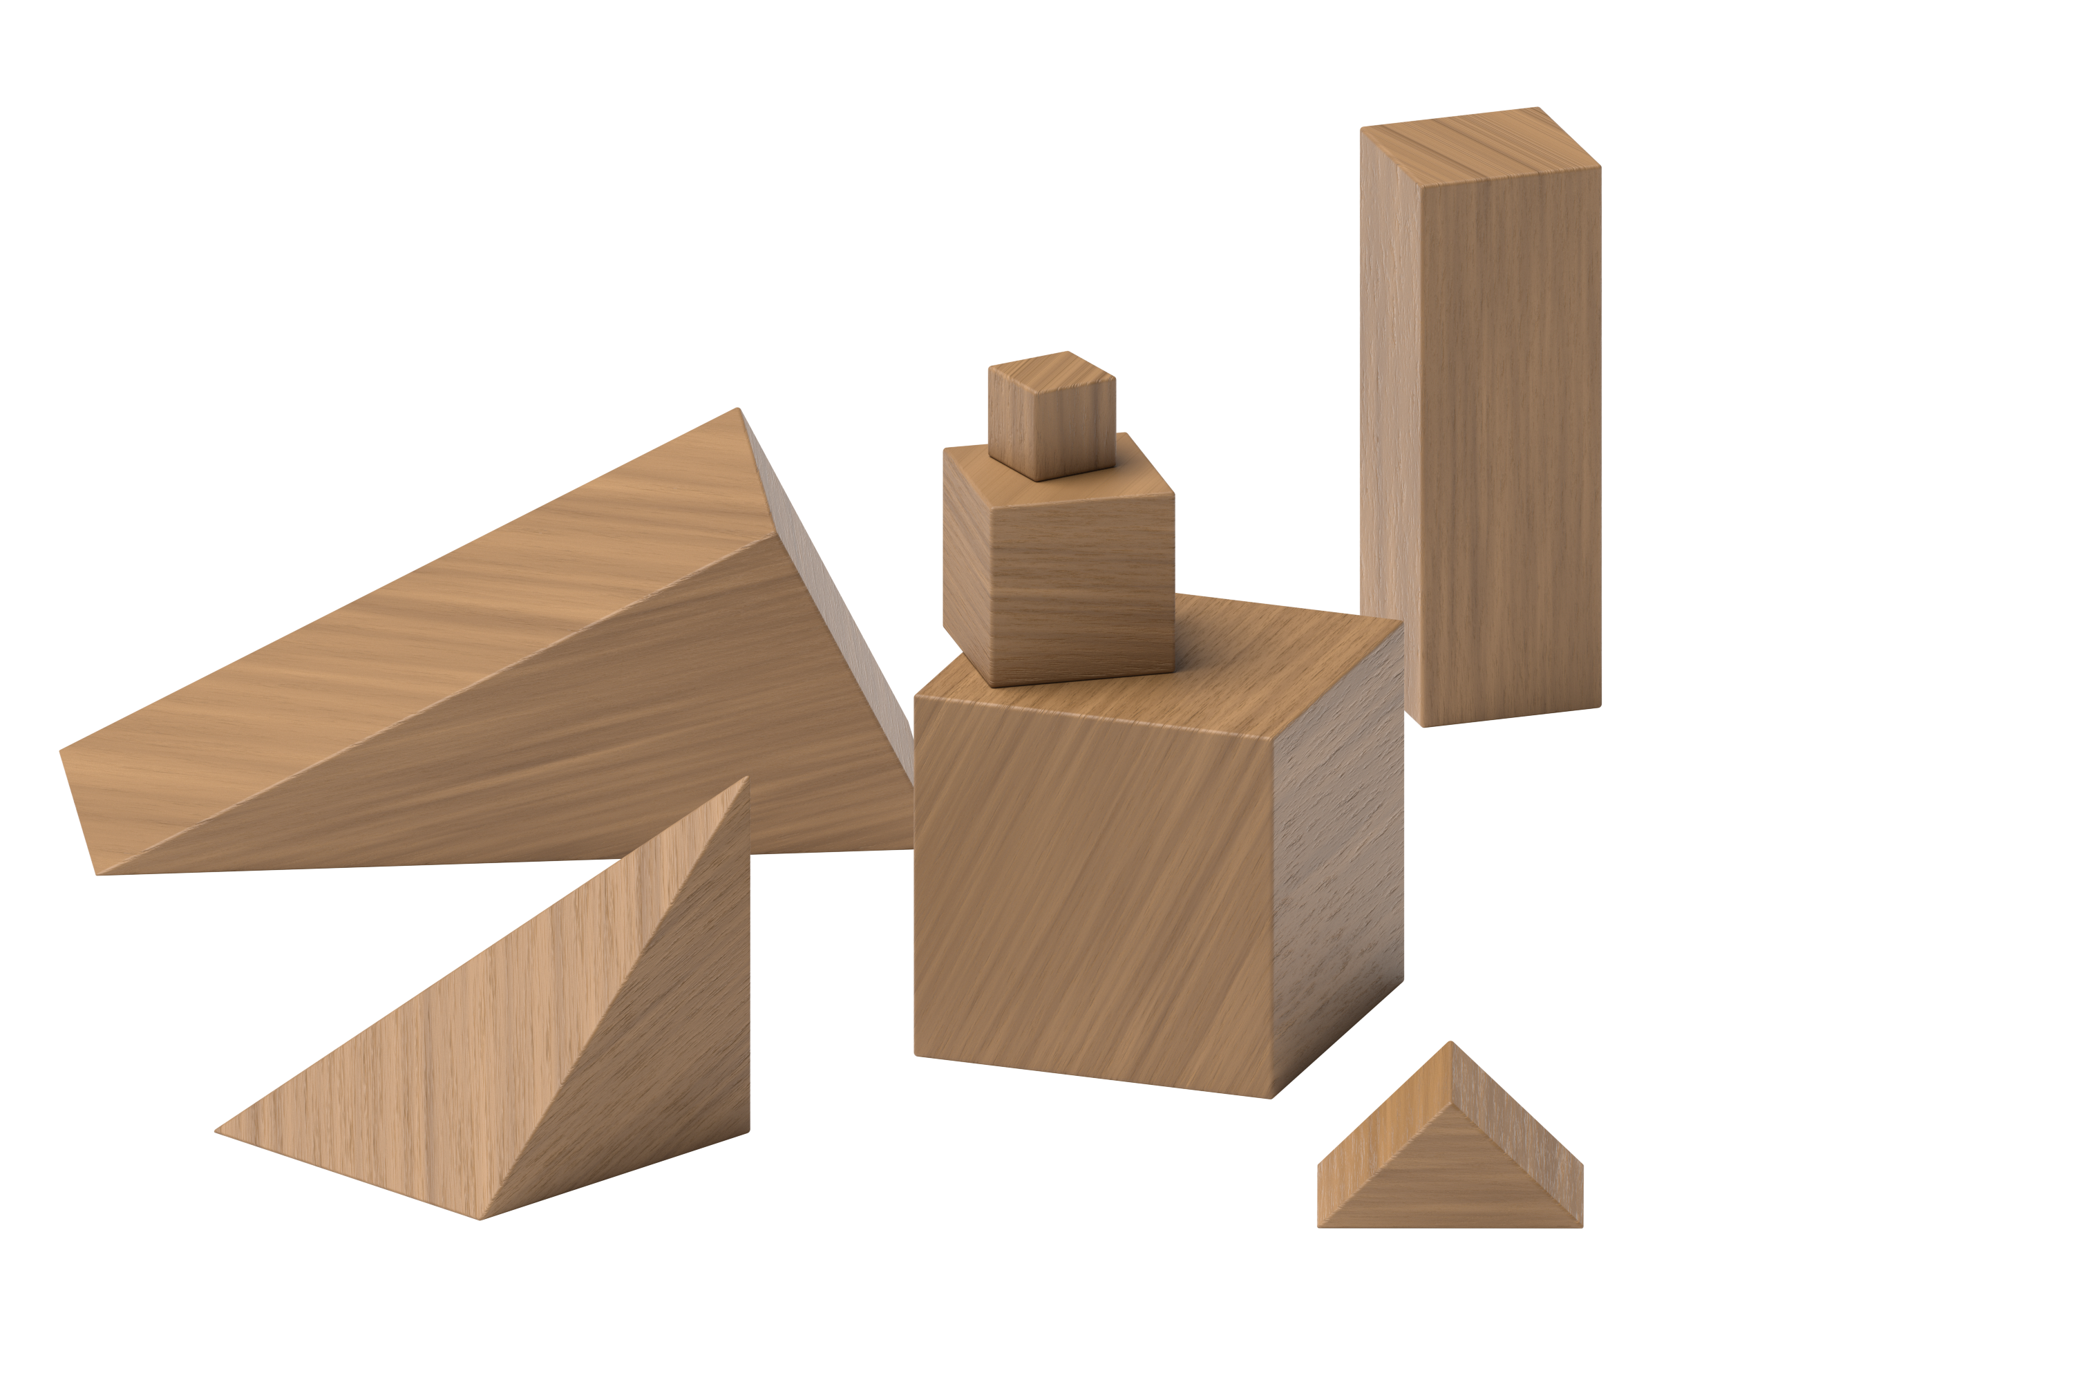
Find the Value of Expressions
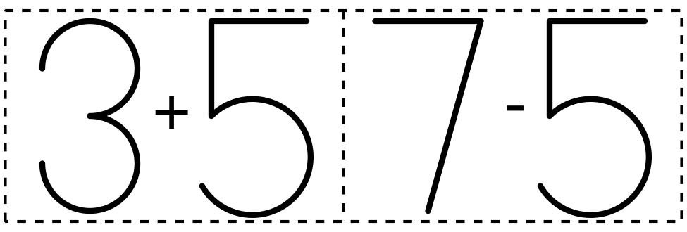
© CC BY 2021 Illustrative Mathematics®

