Lesson 12: Count by 5 to Tell Time
- Let’s tell time.

Warm-up: Notice and Wonder: Number Line and Clock
What do you notice? What do you wonder?
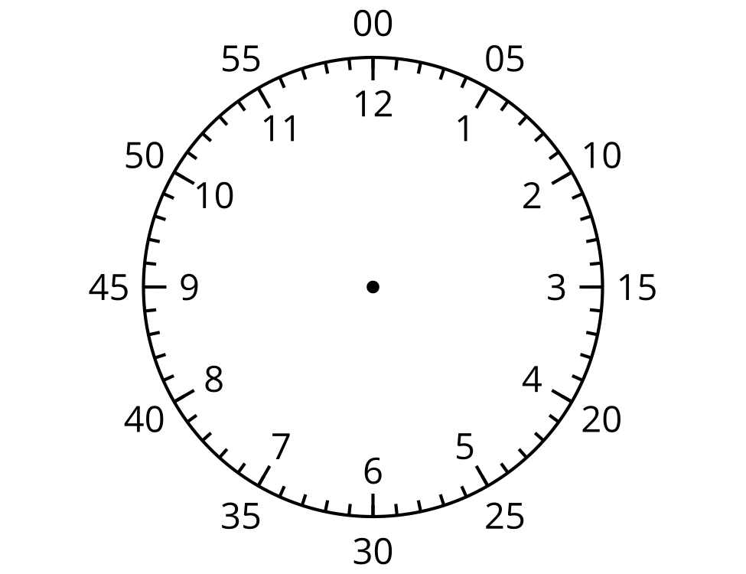

12.1: Count by 5 on the Clock
- Discuss 2 ways to read the time on this clock.
- 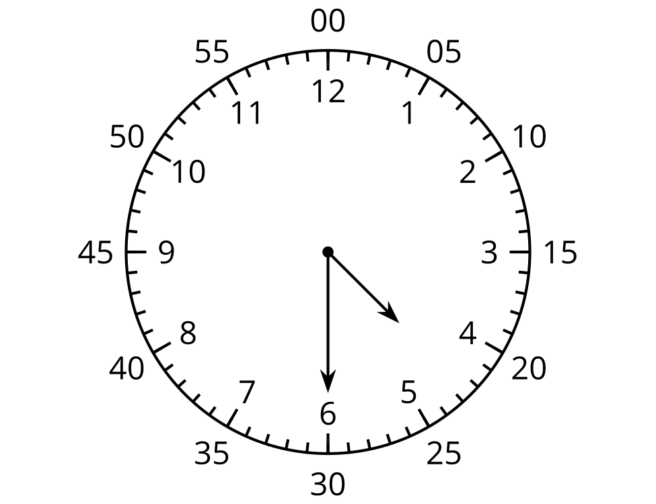
- What time does this clock show?
- 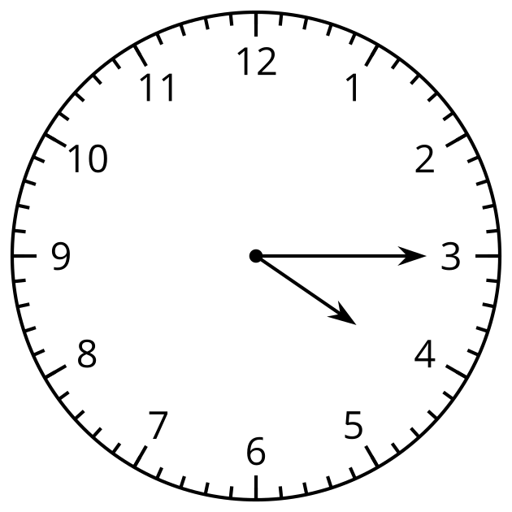
- Read the time on each clock card with your partner. Put the clocks in order based on the times they show.

12.2: Write the Time
Write the time shown on each clock.
- 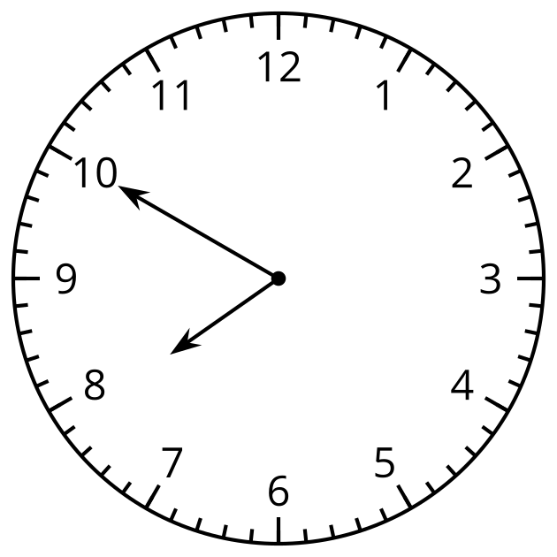
- 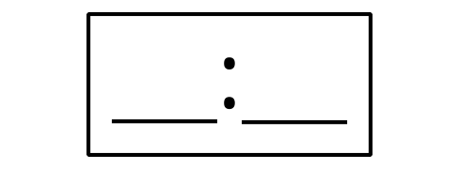

- 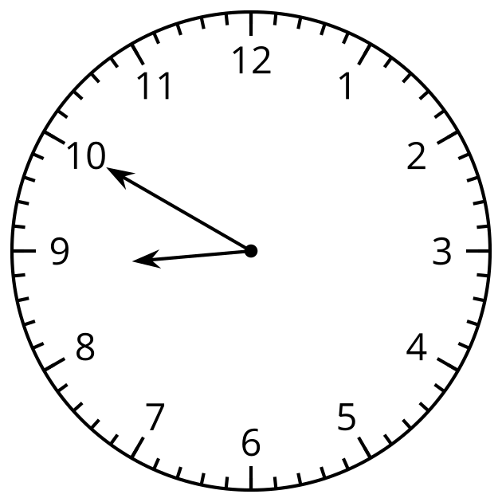
- 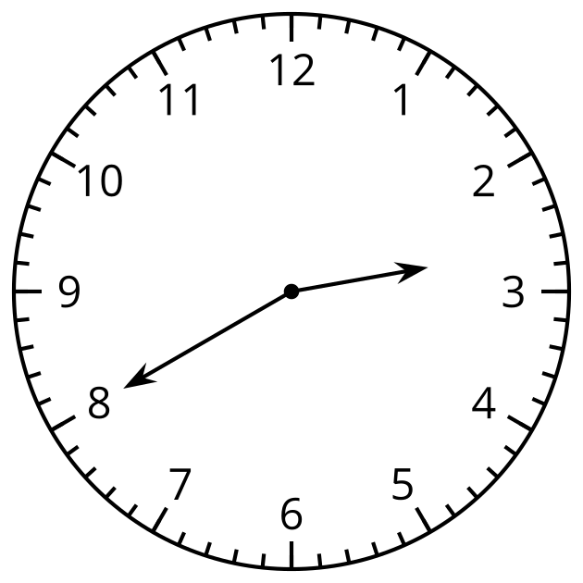

- 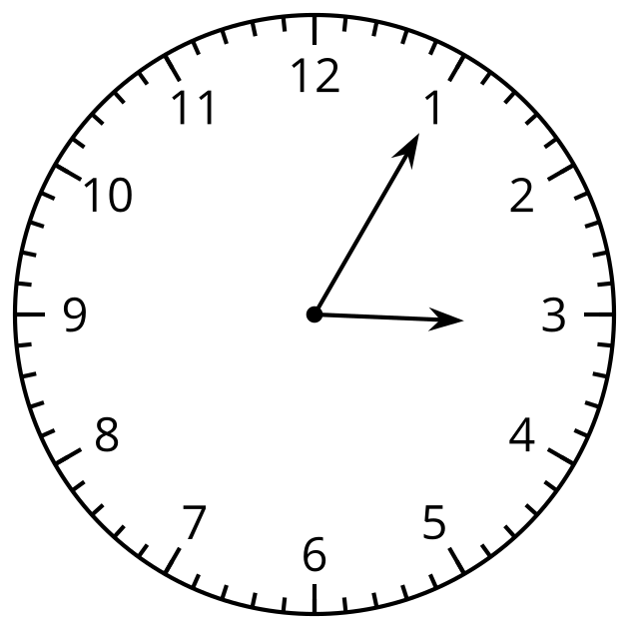
- 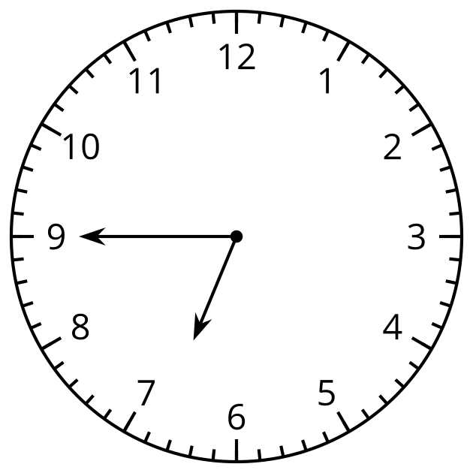

- 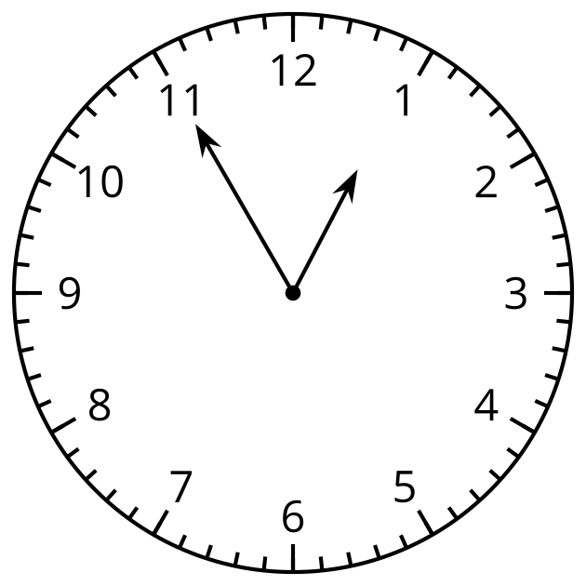
© CC BY 2021 Illustrative Mathematics®

