Lesson 11: Multiplication Strategies on Ungridded Rectangles
- Let’s use different strategies to find the area of ungridded rectangles.

Warm-up: Which One Doesn’t Belong: Multiplication in Many Forms
Which one doesn’t belong?
A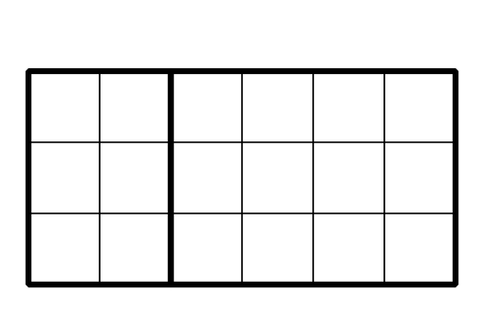
B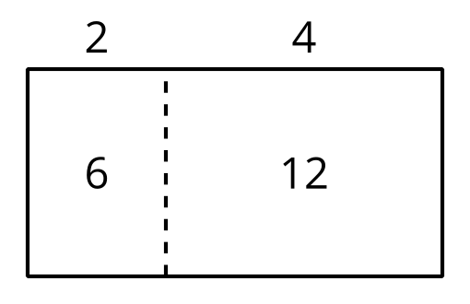
C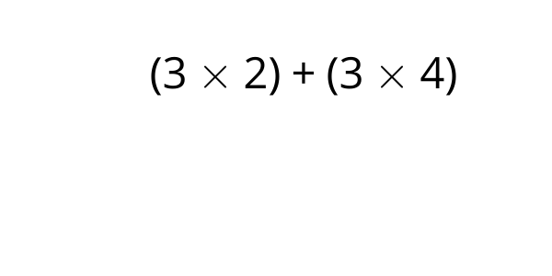
D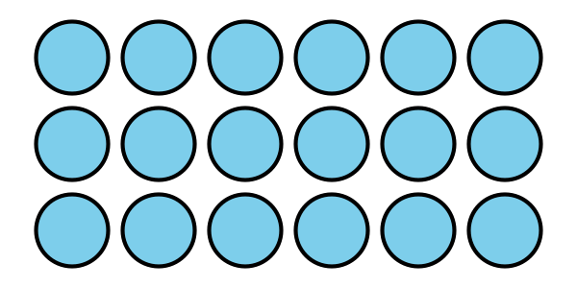

11.1: Mark, then Express
For each rectangle:
- Mark or shade each rectangle to show a strategy for finding its area.
- Write one or more expressions that can represent how you find the area.
A
B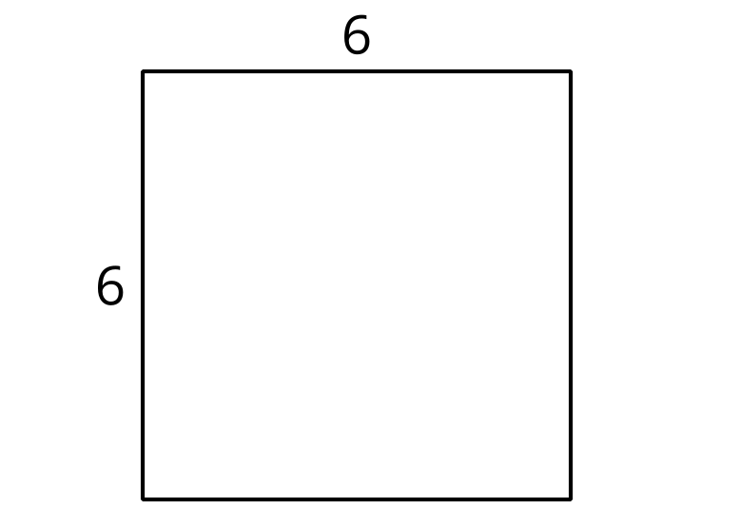
C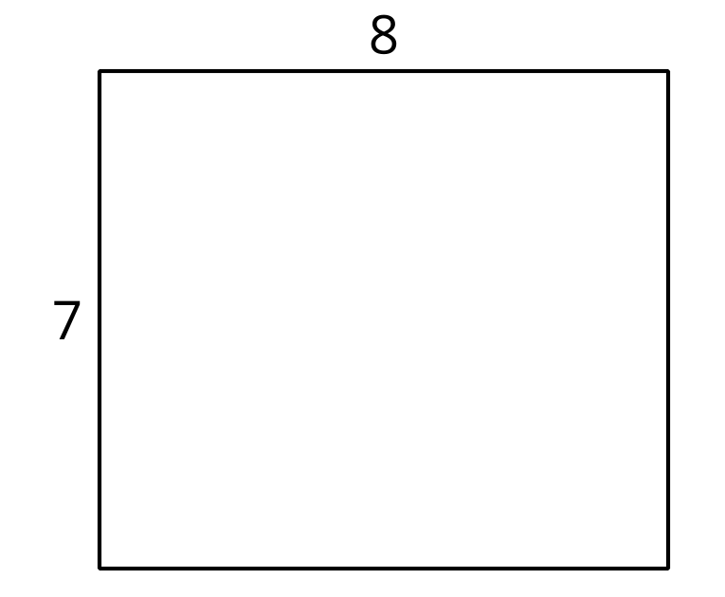

11.2: Card Sort: Different Expressions, Same Rectangle
Your teacher will give you a set of cards with expressions that represent areas of rectangles.
Sort the expressions into groups so that the expressions in each group can represent the area of the same rectangle. Be prepared to explain your reasoning.
You can draw rectangles if you find them helpful.
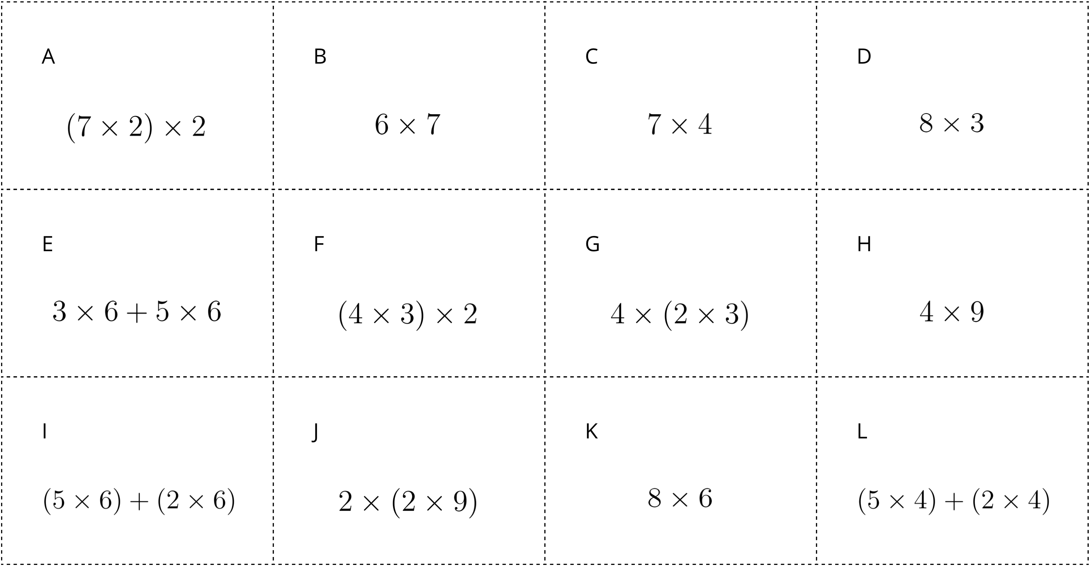

Section Summary
Section Summary
In this section, we learned how multiplication and division are related.
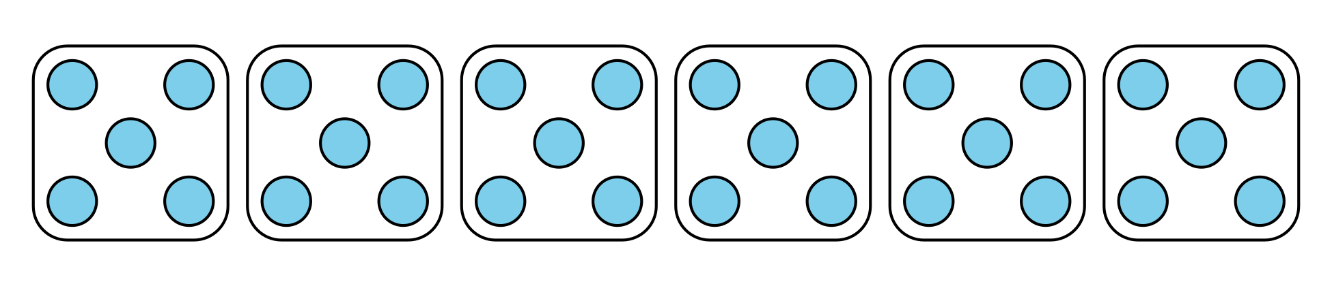
$6×5=?$
$30÷5=?$
$30÷6=?$
We used strategies to multiply and divide and worked towards fluent multiplication and division within 100.
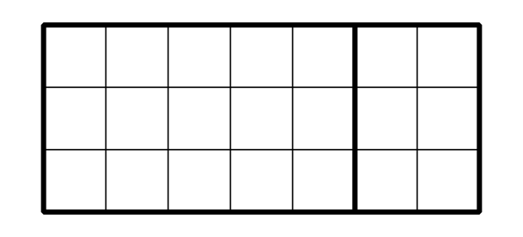
$7×3$
$\left(5×3\right)+\left(2×3\right)$
© CC BY 2021 Illustrative Mathematics®

