Lesson 6: Rectangles and Squares
- Let’s explore what makes a shape a rectangle or a square.

Warm-up: Number Talk: Some Sums
Find the value of each expression mentally.
- $57+10$
- $57+11$
- $57+21$
- $57+42$

6.1: Rectangles and Squares
- These are rectangles.
- 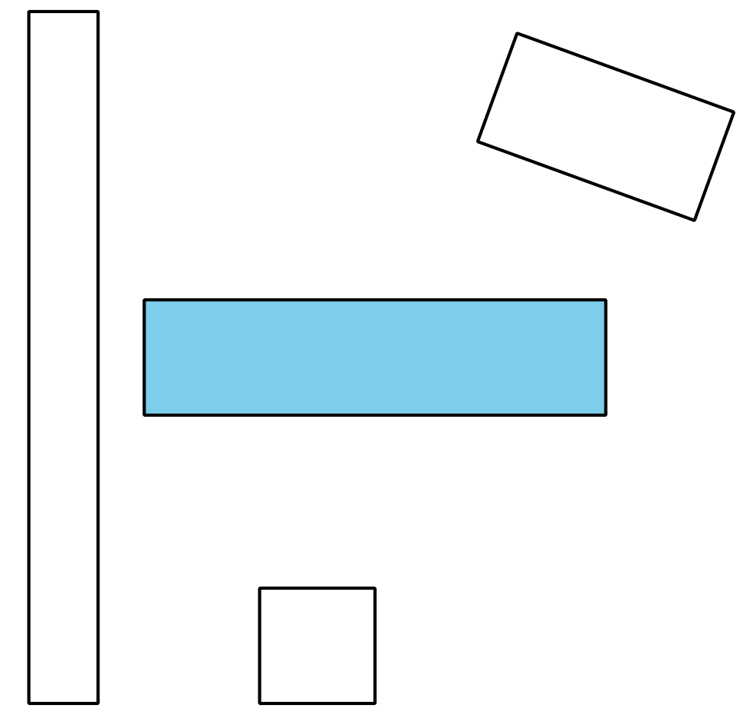
- What is the same about all these rectangles?
- These are not rectangles.
- 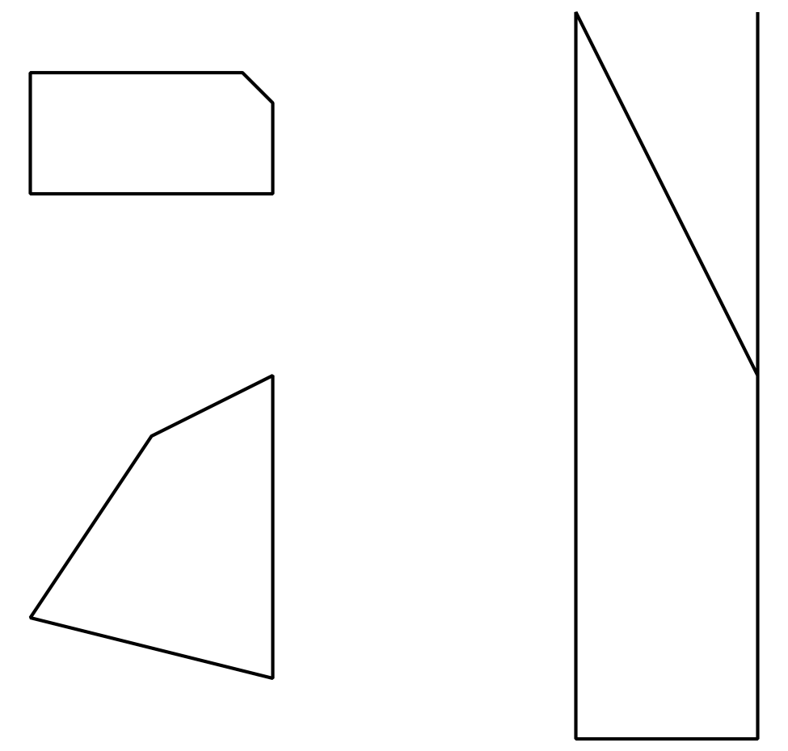
- What makes these shapes different from the rectangles?
- These are squares.
- 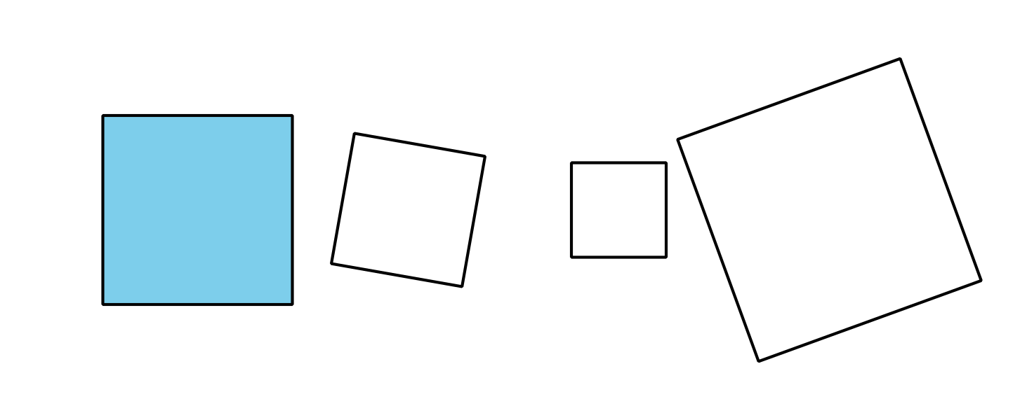
- What is the same about all these squares?
- These are not squares.
- 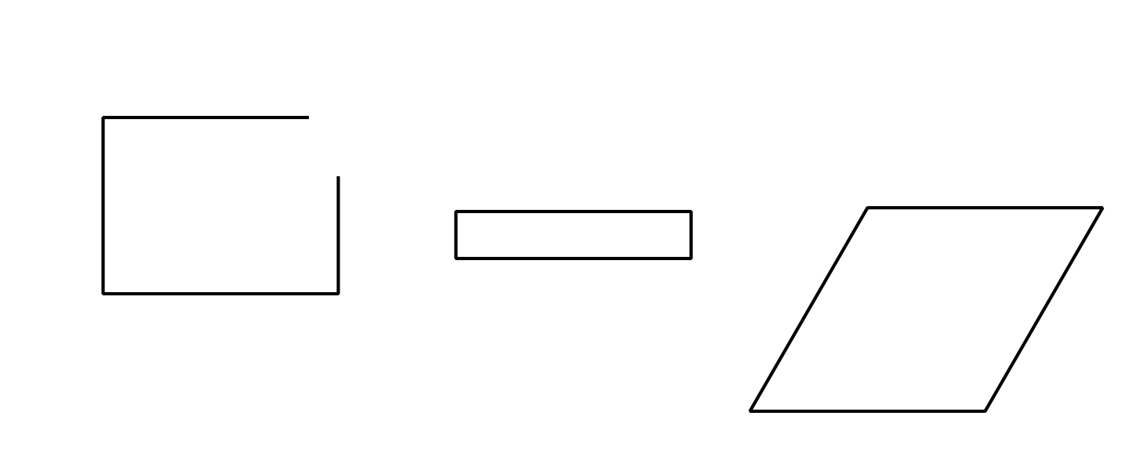
- What makes these shapes different from the squares?

6.2: Draw Rectangles and Squares
- Draw 5 rectangles.
- How do you know these are rectangles?
- Draw 3 shapes that are not rectangles.
- How do you know these are not rectangles?
- Draw 5 squares.
- How do you know these are squares?
- Draw 3 shapes that are not squares.
- How do you know these are not squares?
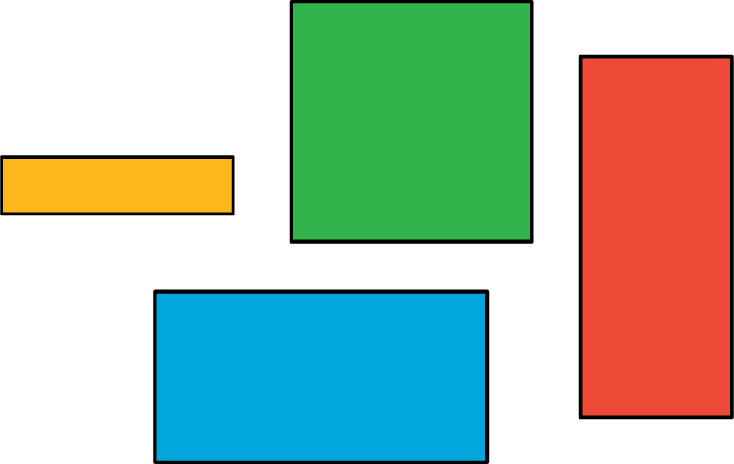
© CC BY 2021 Illustrative Mathematics®

