Lesson 15: Center Day 3
- Let’s use diagrams to make our own story problems and solve them.

Warm-up: Number Talk: Subtract Multiples of 10
Find the value of each expression mentally.
- $25−10$
- $35−10$
- $35−20$
- $35−19$

15.2: Centers: Choice Time
Choose a center.
Target Numbers
Capture Squares
Five in a Row
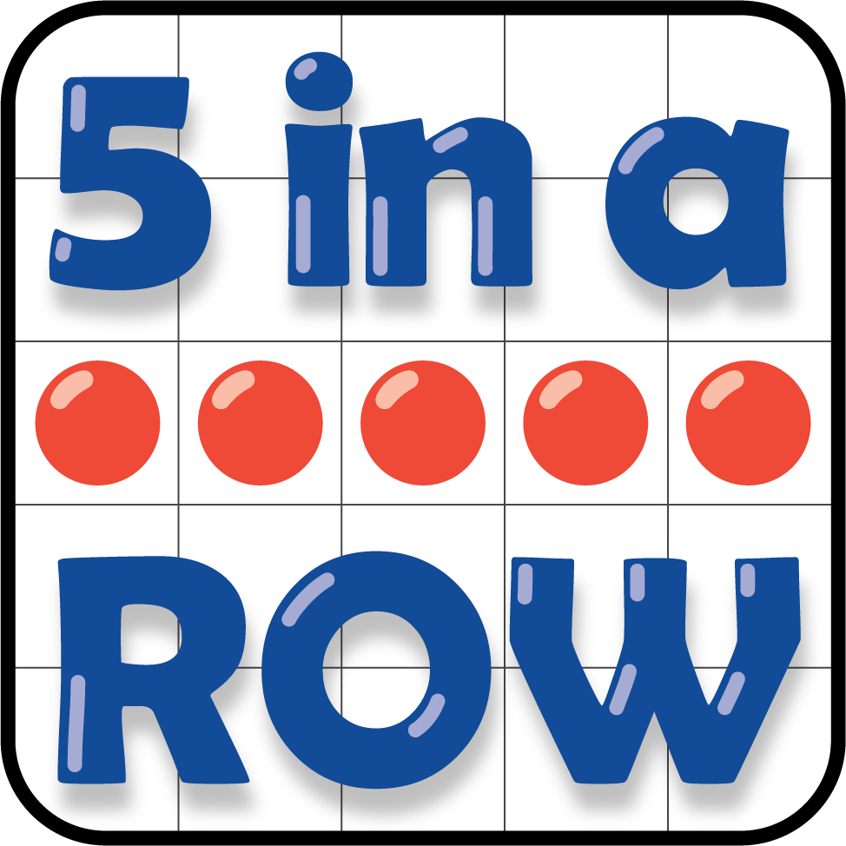
© CC BY 2021 Illustrative Mathematics®

