Lesson 5: Write Division Expressions

Warm-up: Number Talk: What’s the Same?
Find the value of each expression mentally.
- $225−100$
- $227−102$
- $230−105$
- $220−95$

5.1: Card Sort: All about Bugs
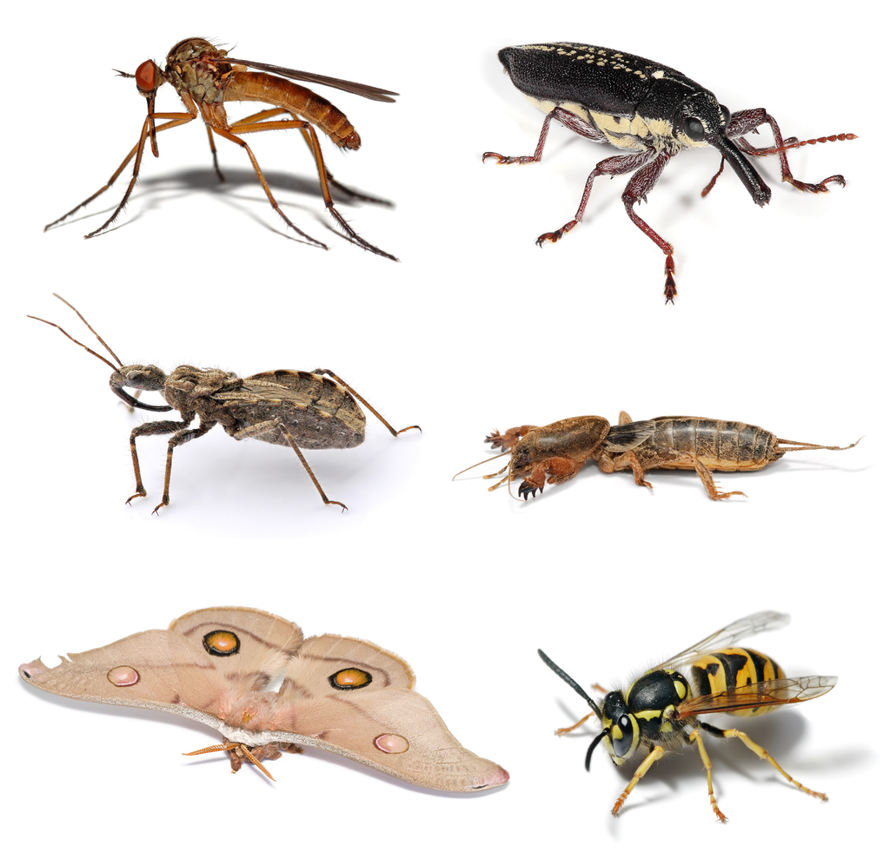
- Your teacher will give you a set of cards that show situations. Sort the cards into 2 categories of your choosing. Be prepared to explain the meaning of your categories.
- A. Mole crickets have special legs for digging. Ten special legs belong to 5 mole crickets. How many special legs does each mole cricket have?
- B. A beetle has a pair of antennae for sensing heat, touch, smell, and more. If there are 8 antennae, how many beetles are there?
- 00
- C. Fourteen antennae belong to a group of bees. If each bee has 2 antennae, how many bees are there?
- D. There are 12 wings. If each dragonfly has 4 wings, how many dragonflies are there?
- 00
- E. Thirty legs belong to 5 ants. If all the ants have the same number of legs, how many legs does each ant have?
- F. There are 50 spots on 5 butterflies. If each butterfly has the same number of spots, how many spots does each butterfly have?
- Write a division expression to represent each situation. Be ready to explain your reasoning.

5.2: Solve a Buggy Problem
Your teacher will assign a problem to your group.
Create a visual display that shows your thinking and your solution to the problem.

Section Summary
Section Summary
In this section, we learned that division is finding the number of groups or finding the size of each group when we put objects into groups of equal size. We represented division situations with drawings and expressions, and solved division problems.
“How many groups?”
“How many in each group?”
Han has 12 colored pencils. He wants to put 2 colored pencils in each box until he’s out of colored pencils. How many boxes does Han need?
Elena has 12 colored pencils. She has 2 boxes and wants to put the same number of colored pencils in each box. How many pencils will be in each box?
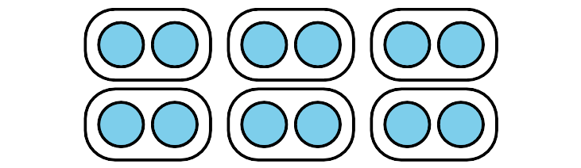
$12÷2$
$12÷2$
© CC BY 2021 Illustrative Mathematics®

