Lesson 8 Practice Problems
- Select all equations for which -3 is a solution.
  - $x^{2}=9$
  - $x^{2}=\text{-}9$
  - $x^{3}=27$
  - $x^{3}=\text{-}27$
  - $\text{-}x^{2}=9$
  - $(\text{-}x)^{2}=9$
  - Use the graph of $y=\sqrt[3]{x}$ to estimate the solution(s) to the following equations.
    - $\sqrt[3]{x}=2$
    - $\sqrt[3]{x}=\text{-}4.5$
    - $\sqrt[3]{x}=3.75$
  - 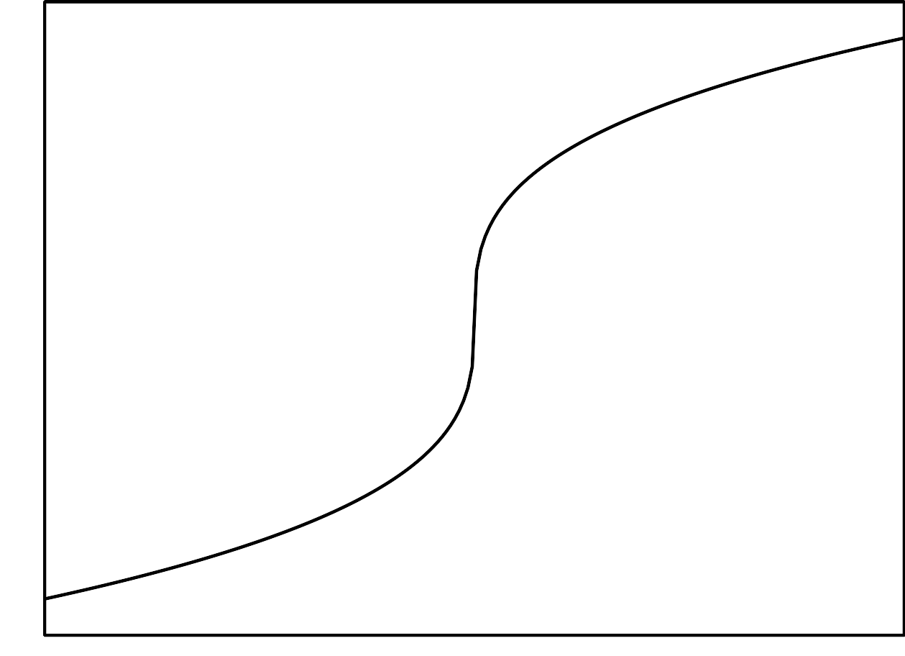
  - Use the meaning of cube roots to find exact solutions to all three equations.
- Which are the solutions to the equation $x^{3}=\text{-}125$?
  - 5
  - -5
  - both 5 and -5
  - The equation has no solutions.
- Complete the table. Use powers of 16 in the top row. Use radicals or rational numbers in the second row.
 | - ${16}^{\text{-}\frac{3}{4}}$ |  | - ${16}^{\text{-}\frac{1}{4}}$
- $\frac{1}{16}$ |  | - $\frac{1}{4}$ |  | - 1
- (From Unit 3, Lesson 5.)
- Which are the solutions to the equation $\sqrt{x}=\text{-}8$?
  - 64 only
  - -64 only
  - 64 and -64
  - This equation has no solutions.
- (From Unit 3, Lesson 6.)
- Find the solution(s) to each equation, or explain why there is no solution.
  - $x^{2}+6=55$
  - $x^{2}+16=0$
  - $x^{2}−3.25=21.75$
- (From Unit 3, Lesson 7.)
© CC BY 2019 by Illustrative Mathematics®

