Lesson 9 Practice Problems
- Here is one way to find $2,​105÷5$ using partial quotients. Show a different way of using partial quotients to divide 2,105 by 5.
- 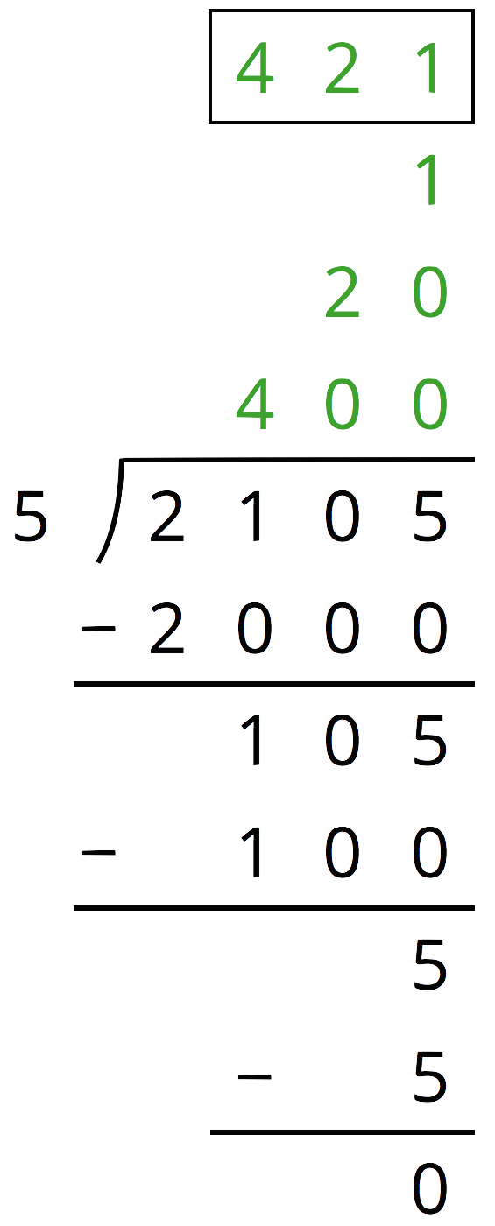
- Andre and Jada both found $657÷3$ using the partial quotients method, but they did the calculations differently, as shown here.
- 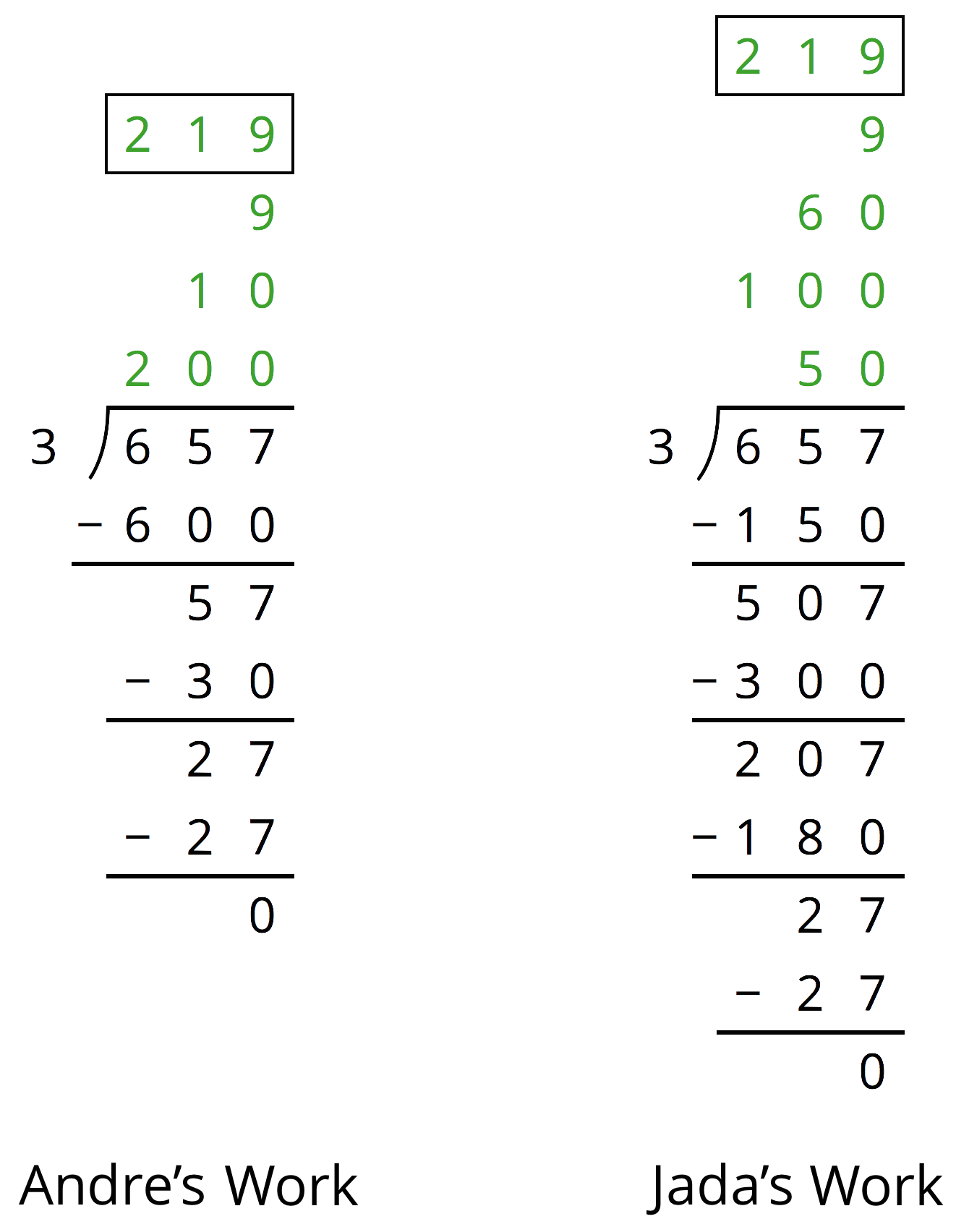
  - How is Jada's work the same as Andre’s work? How is it different?
  - Explain why they have the same answer.
- Which might be a better way to evaluate $1,​150÷46$: drawing base-ten diagrams or using the partial quotients method? Explain your reasoning.
- Here is an incomplete calculation of $534÷6$.
- Write the missing numbers (marked with “?”) that would make the calculation complete.
- 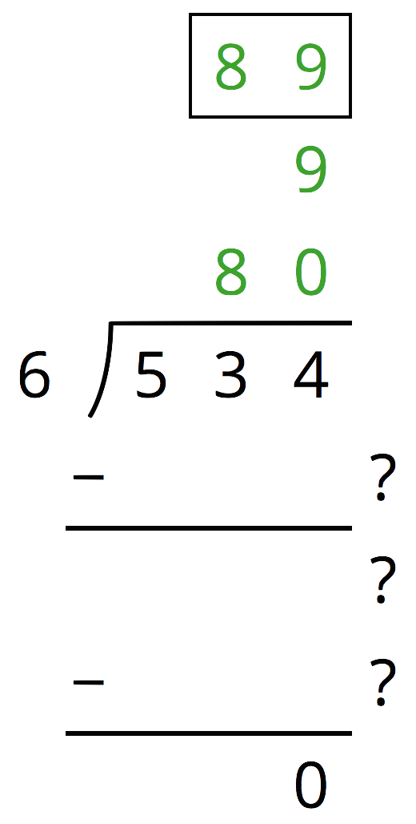
- Use the partial quotients method to find $1,​032÷43$.
- Which of the polygons has the greatest area?
  - A rectangle that is 3.25 inches wide and 6.1 inches long.
  - A square with side length of 4.6 inches.
  - A parallelogram with a base of 5.875 inches and a height of 3.5 inches.
  - A triangle with a base of 7.18 inches and a height of 5.4 inches.
- (From Unit 5, Lesson 8.)
- One micrometer is a millionth of a meter. A certain spider web is 4 micrometers thick. A fiber in a shirt is 1 hundred-thousandth of a meter thick.
  - Which is wider, the spider web or the fiber? Explain your reasoning.
  - How many meters wider?
- (From Unit 5, Lesson 4.)
© CC BY Open Up Resources. Adaptations CC BY IM.

