Unit 5 Lesson 6: Subtracting Rational Numbers

1 Number Talk: Missing Addend (Warm up)

Student Task Statement
Solve each equation mentally. Rewrite each addition equation as a subtraction equation.
$247+c=458$
$c+43.87=58.92$
$\frac{15}{8}+c=\frac{51}{8}$

2 Expressions with Altitude

Student Task Statement
A mountaineer is changing elevations. Write an expression that represents the difference between the final elevation and beginning elevation. Then write the value of the change. The first one is done for you.
beginning  elevation  (feet) | final  elevation  (feet) | difference  between final  and beginning | change
+400 | +900 | $900−400$ | +500
+400 | +50
+400 | -120
-200 | +610
-200 | -50
-200 | -500
-200 | 0

3 Does the Order Matter?

Student Task Statement
- Find the value of each subtraction expression.
- A
- $3−2$
- $5−(\text{-}9)$
- $(\text{-}11)−2$
- $(\text{-}6)−(\text{-}3)$
- $(\text{-}1.2)−(−3.6)$
- $(\text{-}2\frac{1}{2})−(\text{-}3\frac{1}{2})$
- B
- $2−3$
- $(\text{-}9)−5$
- $2−(\text{-}11)$
- $(\text{-}3)−(\text{-}6)$
- $(\text{-}3.6)−(\text{-}1.2)$
- $(\text{-}3\frac{1}{2})−(\text{-}2\frac{1}{2})$
- What do you notice about the expressions in Column A compared to Column B?
- What do you notice about their values?

Activity Synthesis
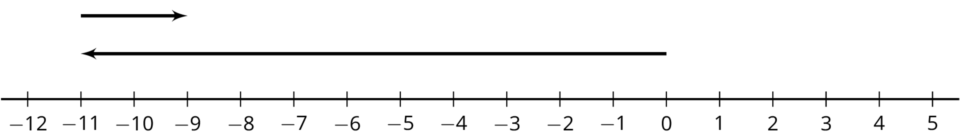
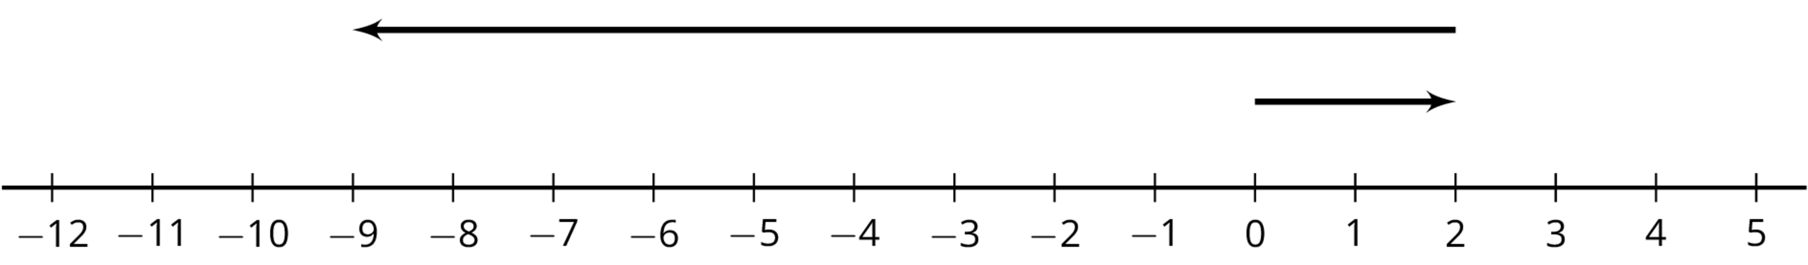
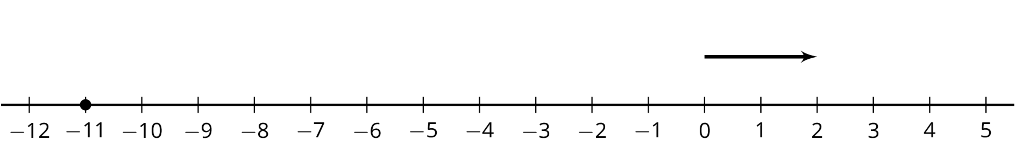
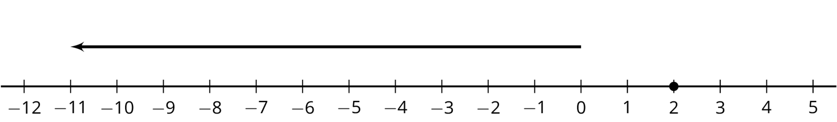
© CC BY Open Up Resources. Adaptations CC BY IM.

