Unit 4 Lesson 18: Two Related Quantities, Part 2

1 Walking to the Library (Warm up)

Student Task Statement
Lin and Jada each walk at a steady rate from school to the library. Lin can walk 13 miles in 5 hours, and Jada can walk 25 miles in 10 hours. They each leave school at 3:00 and walk $3\frac{1}{4}$ miles to the library. What time do they each arrive?

2 The Walk-a-thon

Student Task Statement
Diego, Elena, and Andre participated in a walk-a-thon to raise money for cancer research. They each walked at a constant rate, but their rates were different.
- Complete the table to show how far each participant walked during the walk-a-thon.
- time in hours | - miles walked  by Diego | - miles walked  by Elena | - miles walked  by Andre
- 1
- 2 | - 6
 | - 12 | - 11
- 5 |  |  | - 17.5
- How fast was each participant walking in miles per hour?
- How long did it take each participant to walk one mile?
- Graph the progress of each person in the coordinate plane. Use a different color for each participant.
- 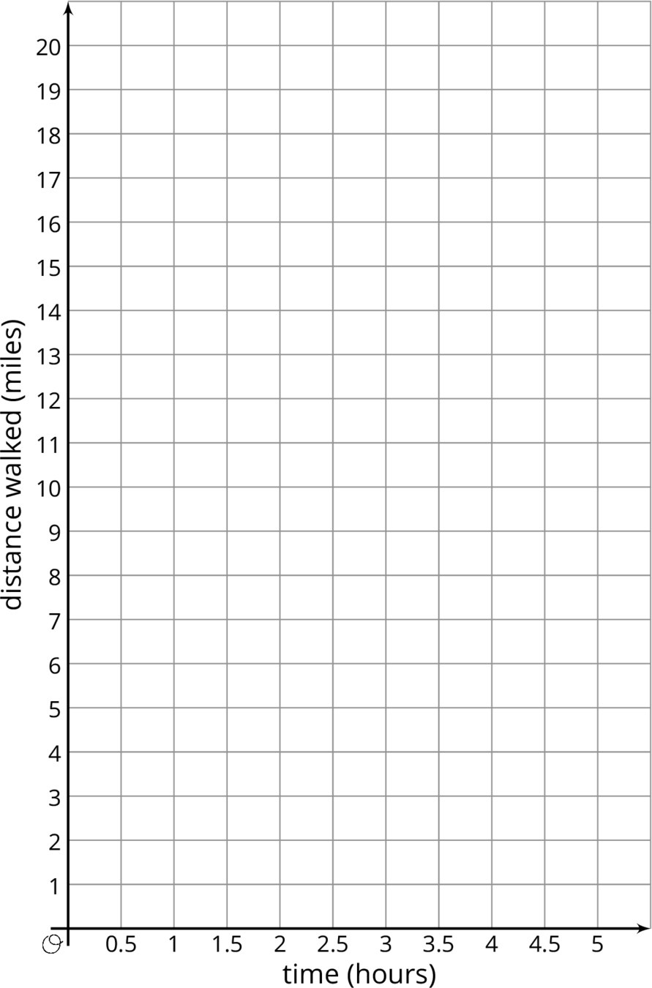
- Diego says that $d=3t$ represents his walk, where $d$ is the distance walked in miles and $t$ is the time in hours.
  - Explain why $d=3t$ relates the distance Diego walked to the time it took.
  - Write two equations that relate distance and time: one for Elena and one for Andre.
- Use the equations you wrote to predict how far each participant would walk, at their same rate, in 8 hours.
- For Diego's equation and the equations you wrote, which is the dependent variable and which is the independent variable?
© CC BY Open Up Resources. Adaptations CC BY IM.

