Lesson 5: Story Problems about Shapes
- Let’s solve story problems and match them to equations.

Warm-up: Notice and Wonder: Questionless Story Problem
What do you notice?
What do you wonder?
Elena used 9 pattern blocks to make a train.
Then she took 3 of the pattern blocks off of the train and put them back in the bucket.

5.1: Match Story Problems to Equations
- Clare made a shape with 7 pattern blocks.
Her little brother came and took 3 of the pattern blocks.
- How many pattern blocks does Clare have now?
- $7=4+3$
- $7−3=4$
- $7+3=10$
- Kiran put together 2 pattern blocks to make a shape.
Jada placed 5 more pattern blocks on the shape.
- How many pattern blocks are in Kiran and Jada’s shape?
- $5−2=3$
- $4=2+2$
- $2+5=7$

5.2: Solve Story Problems
- Andre put together 4 pattern blocks to make a shape.
Then Andre put 4 more pattern blocks on the shape.
- How many pattern blocks are in Andre’s shape?
- _______________
- equation: $8=\underset{_}{}+\underset{_}{}$
- Elena used 9 pattern blocks to make a train.
Then she took 3 of the pattern blocks off of the train and put them back in the bucket.
- How many pattern blocks are in Elena's train now?
- _______________
- equation: $9−3=\underset{_}{}$

5.3: Centers: Choice Time
Choose a center.
Pattern Blocks
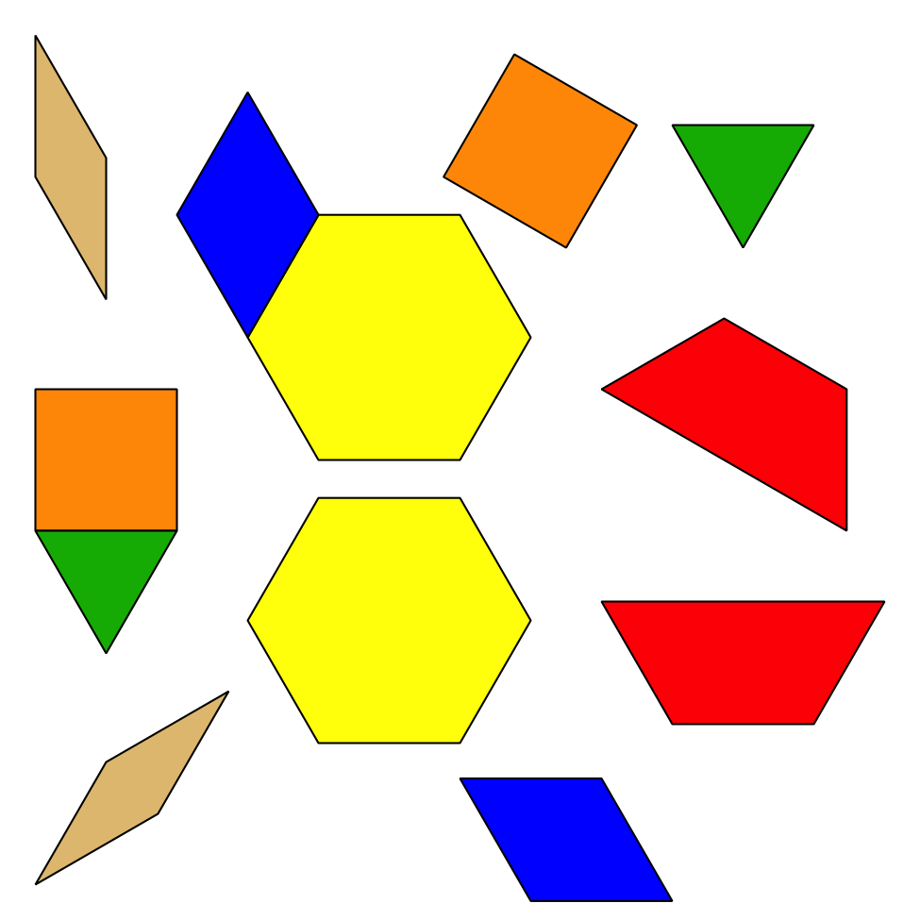
Geoblocks
Grab and Count
Find the Pair
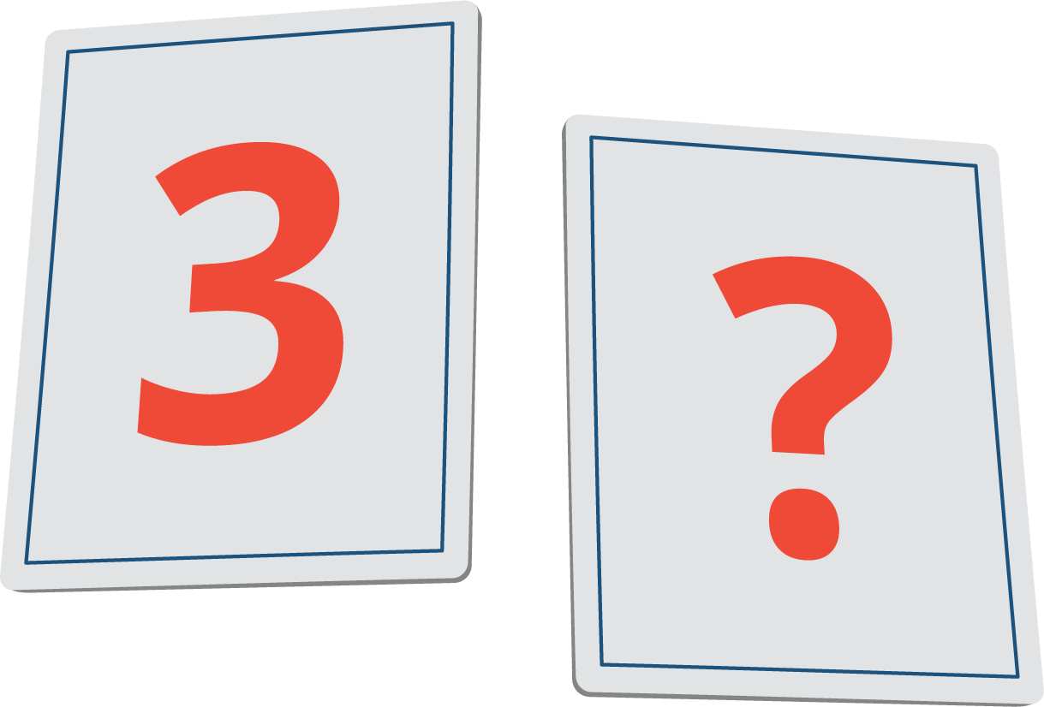
© CC BY 2021 Illustrative Mathematics®

