Lesson 13 Practice Problems
- Find the volume of a pyramid whose base is a square with side lengths of 6 units and height of 8 units.
- A cylinder has radius 9 inches and height 15 inches. A cone has the same radius and height.
  - Find the volume of the cylinder.
  - Find the volume of the cone.
  - What fraction of the cylinder’s volume is the cone’s volume?
- Each solid in the image has height 4 units. The area of each solid’s base is 8 square units. A cross section has been created in each by dilating the base using the apex as a center with scale factor $k=0.25$.
- 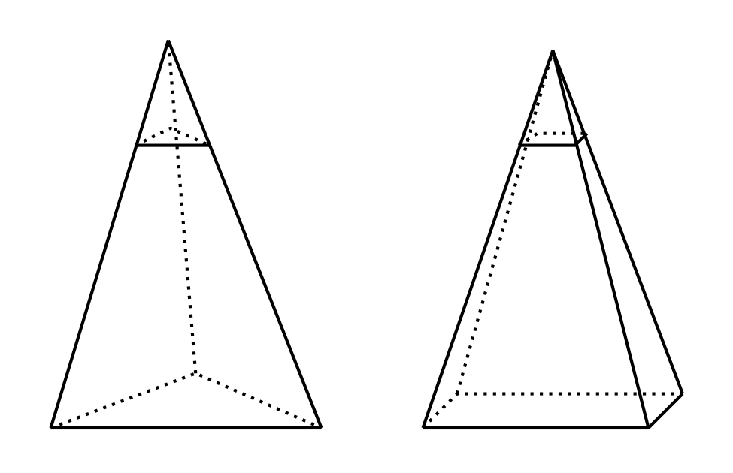
  - Calculate the area of each of the 2 cross sections.
  - Suppose a new cross section was created in each solid, both at the same height, using some scale factor $k$. How would the areas of these 2 cross sections compare? Explain your reasoning.
- Select the most specific and accurate name for the solid in the image.
- 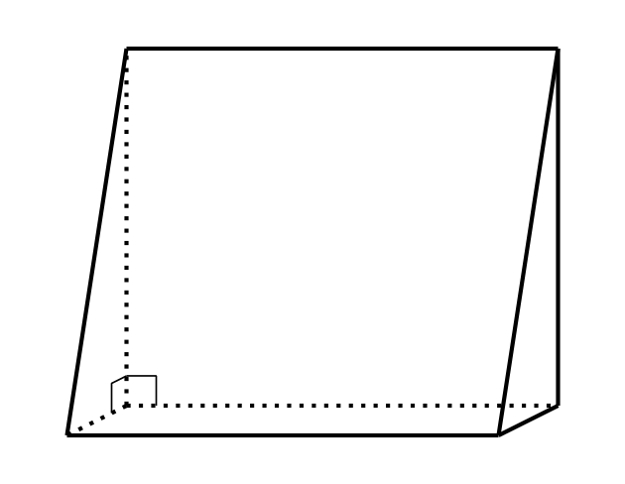
  - triangular pyramid
  - regular prism
  - square prism
  - right triangular prism
- (From Unit 5, Lesson 12.)
- A solid can be constructed with 4 triangles and 1 rectangle. What is the name for this solid?
  - rectangular pyramid
  - triangular pyramid
  - right triangular prism
  - rectangular prism
- (From Unit 5, Lesson 12.)
- Find the volume of the solid produced by rotating this two-dimensional shape using the axis shown.
- 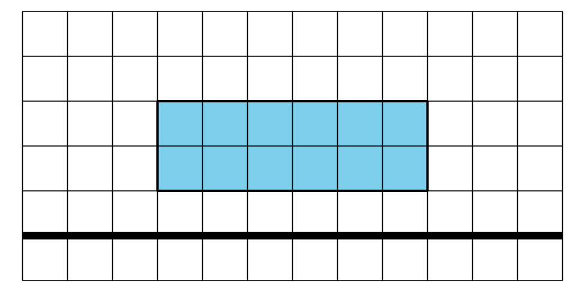
- (From Unit 5, Lesson 11.)
- This zigzag crystal vase has a height of 20 centimeters. The cross sections parallel to the base are always rectangles that are 12 centimeters wide by 6 centimeters long.
- 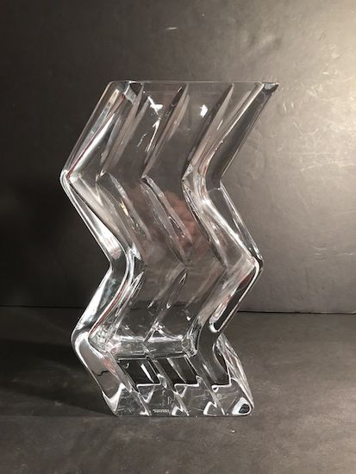
  - If we assume the crystal itself has no thickness, what would be the volume of the vase?
  - The crystal is actually 1 centimeter thick on each of the sides and on the bottom. Approximately how much space is contained within the vase? Explain or show your reasoning.
- (From Unit 5, Lesson 10.)
- A trapezoid has an area of 10 square units. What scale factor would be required to dilate the trapezoid to have an area of 90 square units?
  - 9
  - 6
  - 3
  - $\frac{1}{3}$
- (From Unit 5, Lesson 5.)
© CC BY 2019 by Illustrative Mathematics®

