Unit 1 Lesson 14 Cumulative Practice Problems
- Use the diagram to find the measure of each angle.
  - $m∠ABC$
  - $m∠EBD$
  - $m∠ABE$
- 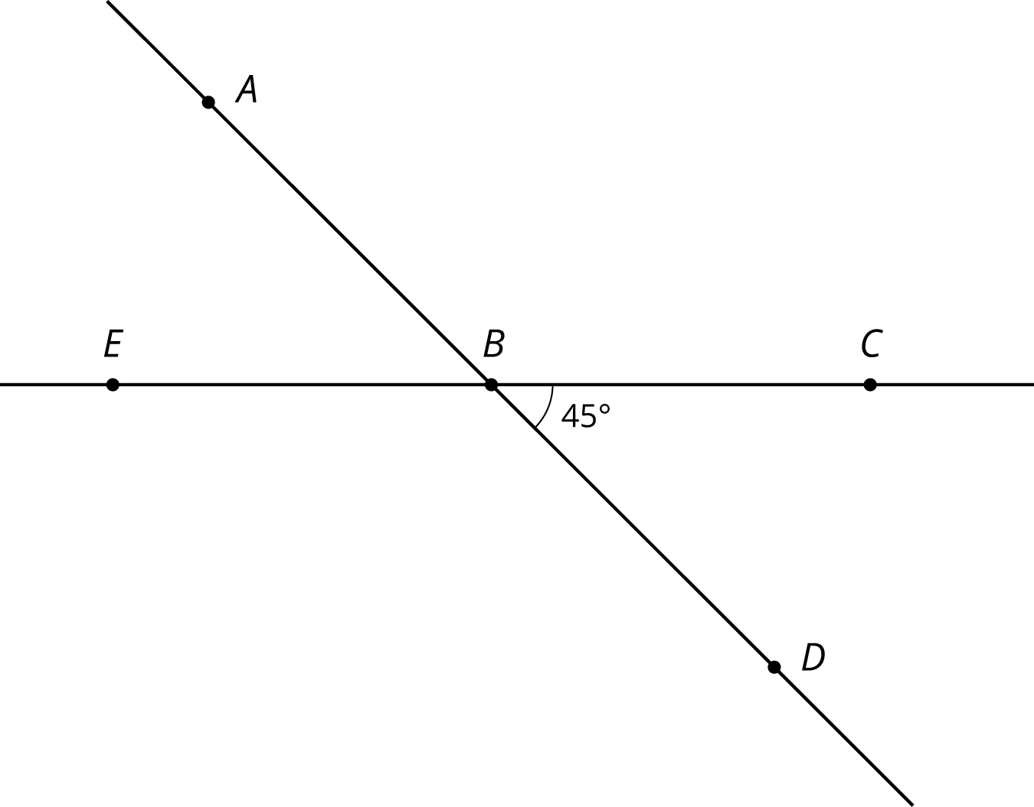
- (From Unit 1, Lesson 9.)
- Lines $k$ and $ℓ$ are parallel, and the measure of angle $ABC$ is 19 degrees.
- 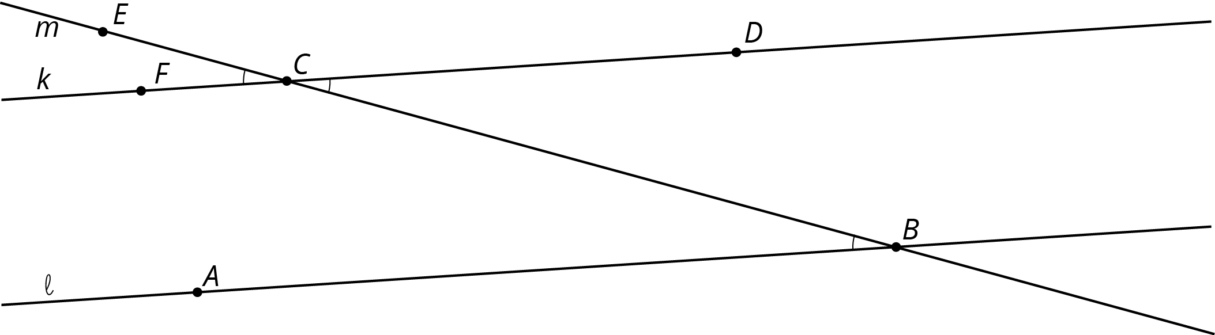
  - Explain why the measure of angle $ECF$ is 19 degrees. If you get stuck, consider translating line $ℓ$ by moving $B$ to $C$.
  - What is the measure of angle $BCD$? Explain.
- The diagram shows three lines with some marked angle measures.
- 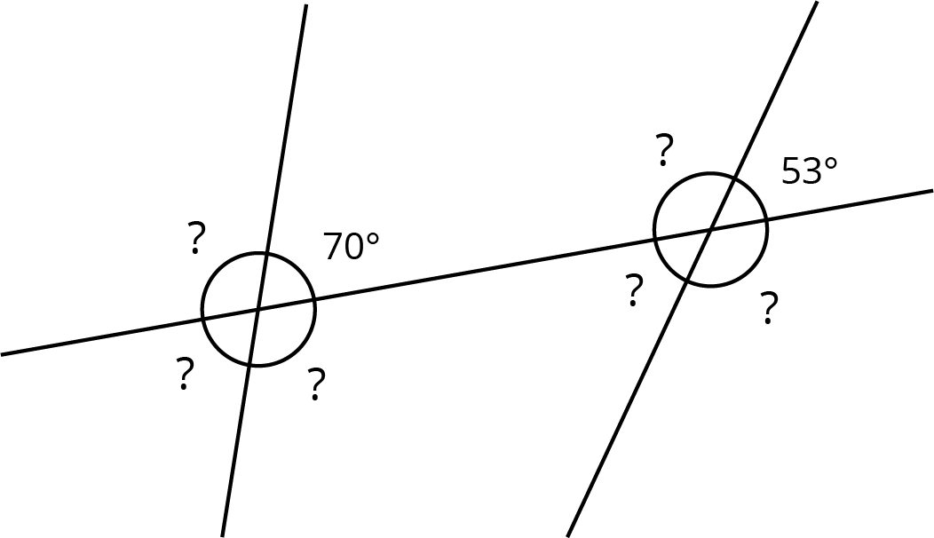
- Find the missing angle measures marked with question marks.
- Lines $s$ and $t$ are parallel. Find the value of $x$.
- 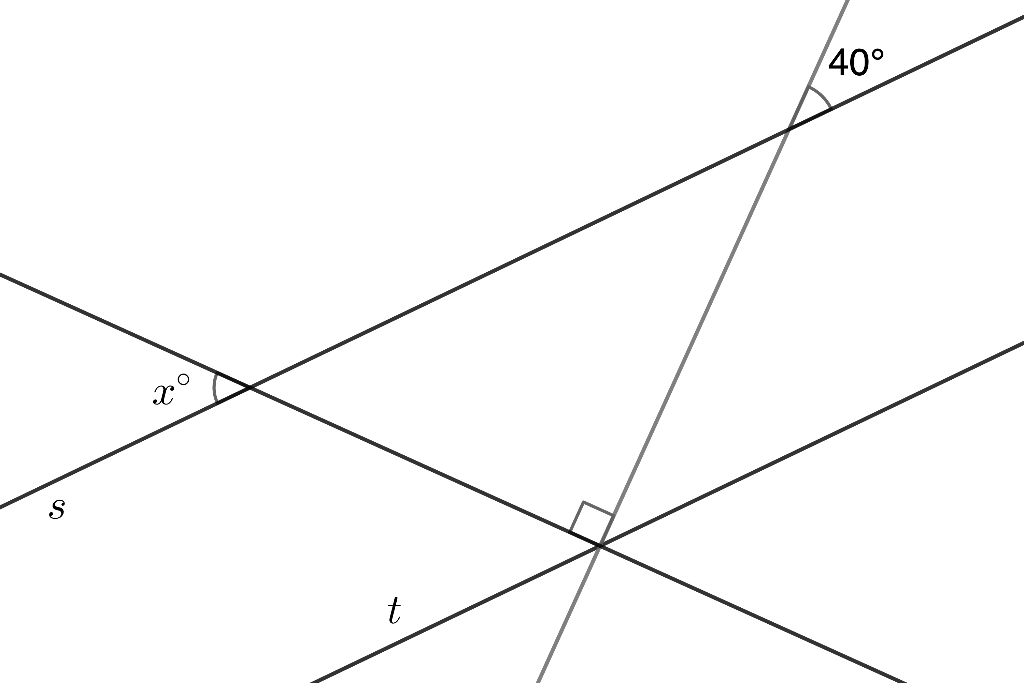
- The two figures are scaled copies of each other.
  - What is the scale factor that takes Figure 1 to Figure 2?
  - What is the scale factor that takes Figure 2 to Figure 1?
- 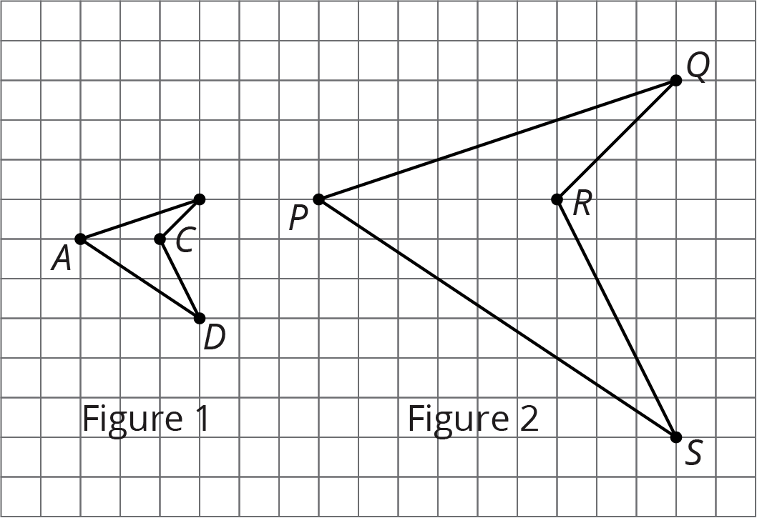
© CC BY Open Up Resources. Adaptations CC BY IM.

