Lesson 8: End Behavior (Part 1)
- Let’s investigate the shape of polynomials.

8.1: Notice and Wonder: A Different View
What do you notice? What do you wonder?

$y=x^{3}+4x^{2}−x−4$
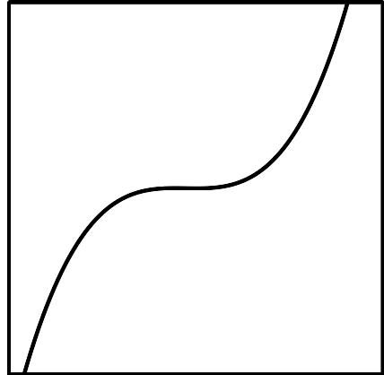

$y=x^{4}−10x^{2}+9$
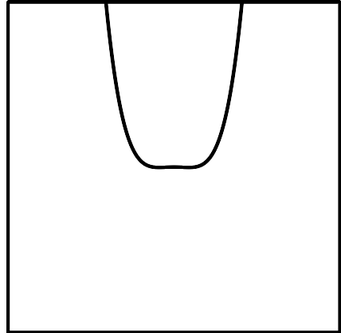

8.2: Polynomial End Behavior
- For your assigned polynomial, complete the column for the different values of $x$. Discuss with your group what you notice.
- $x$ | - $y=x^{2}+1$ | - $y=x^{3}+1$ | - $y=x^{4}+1$ | - $y=x^{5}+1$
- -1000
- -100
- -10
- -1
- 1
- 10
- 100
- 1000
- Sketch what you think the end behavior of your polynomial looks like, then check your work using graphing technology.

Are you ready for more?
Mai is studying the function $p(x)=\text{-}\frac{1}{100}x^{3}+25,​422x^{2}+8x+26$. She makes a table of values for $p$ with $x=±1,±5,±10,±20$ and thinks that this function has large positive output values in both directions on the $x$-axis. Do you agree with Mai? Explain your reasoning.

8.3: Two Polynomial Equations
Consider the polynomial $y=2x^{5}−5x^{4}−30x^{3}+5x^{2}+88x+60$.
- Identify the degree of the polynomial.
- Which of the 6 terms, $2x^{5}$, $5x^{4}$, $30x^{3}$, $5x^{2}$, $88x$, or $60$, is greatest when:
  - $x=0$
  - $x=1$
  - $x=3$
  - $x=5$
- Describe the end behavior of the polynomial.

Lesson 8 Summary
We know that if the expression for a polynomial function $f$ written in factored form has the factor $(x−a)$, then $a$ is a zero of $f$ (that is,$f(a)=0$) and the point $(a,0)$ is on the graph of the function. But what about other values of $x$? In particular, as we consider values of $x$ that get larger and larger in either the negative or positive direction, what happens to the values of $f(x)$?
The answer to this question depends on the degree of the polynomial, because any negative real number raised to an even power results in a positive number. For example, if we graph $y=x^{2}$, $y=x^{3}$ and $y=x^{4}$ and zoom out, we see the following:

$y=x^{2}$
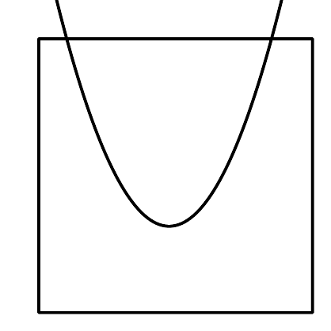

$y=x^{3}$
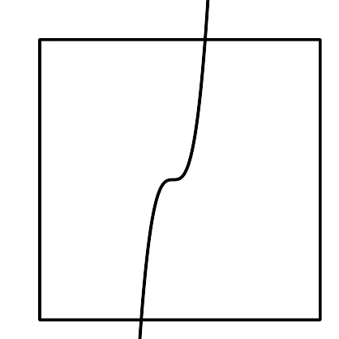

$y=x^{4}$
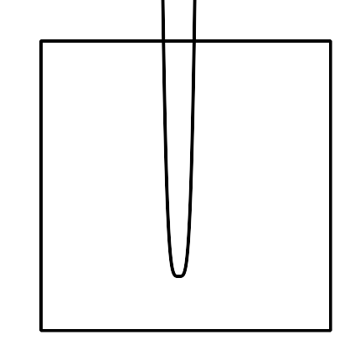
For both $y=x^{2}$ and $y=x^{4}$, large positive values of $x$ or large negative values of $x$ each result in large positive values of $y$. But for $y=x^{3}$, large positive values of $x$ result in large positive values of $y$, while large negative values of $x$ result in large negative values of $y$.
Consider the polynomial $P(x)=x^{4}−30x^{3}−20x^{2}+1000$. The leading term, $x^{4}$, almost seems smaller than the other 3 terms. For certain values of $x$, this is even true. But, for values of $x$ far away from zero, the leading term will always have the greatest value. Can you see why?
$x$ | $x^{4}$ | $\text{-}30x^{3}$ | $\text{-}20x^{2}$ | $1000$ | $P(x)$
-500 | 62,500,000,000 | 3,750,000,000 | -5,000,000 | 1,000 | 66,245,001,000
-100 | 100,000,000 | 30,000,000 | -200,000 | 1,000 | 129,801,000
-10 | 10,000 | 30,000 | -2,000 | 1,000 | 39,000
0 | 0 | 0 | 0 | 1,000 | 1000
10 | 10,000 | -30,000 | -2,000 | 1,000 | -21,000
100 | 100,000,000 | -30,000,000 | -200,000 | 1,000 | 69,801,000
500 | 62,500,000,000 | -3,750,000,000 | -5,000,000 | 1,000 | 58,745,001,000
The value of the leading term $x^{4}$ determines the end behavior of the function, that is, how the outputs of the function change as we look at input values farther and farther from 0. In the case of $P(x)$, as $x$ gets larger and larger in the positive and negative directions, the output of the function gets larger and larger in the positive direction.
© CC BY 2019 by Illustrative Mathematics®

