Unit 8 Lesson 16: Parts to Make 5

WU How Many Do You See: Add and Subtract (Warm up)

Student Task Statement
How many do you see?
How do you see them?
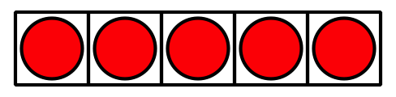
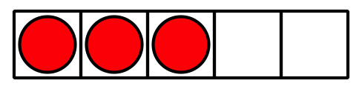
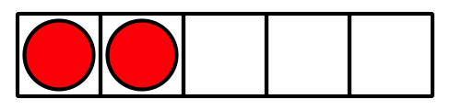
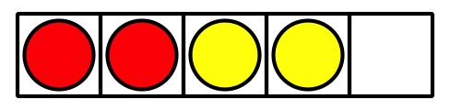

1 Revisit Shake and Spill, Cover

Student Task Statement
Put 3, 4, or 5 counters in the cup.
Shake and spill the counters.
Hide some of the counters under the cup.
Figure out how many of the counters are hidden.
Write an expression.

2 Missing Value (Optional)

Student Task Statement
Fill in the missing part of each equation.
$3−\underset{_}{}=2$
$2+\underset{_}{}=2$
$5−\underset{_}{}=2$
$1+\underset{_}{}=2$
$5−\underset{_}{}=3$
$2+\underset{_}{}=3$
$4−\underset{_}{}=3$
$0+\underset{_}{}=3$
$5−\underset{_}{}=4$
$3+\underset{_}{}=4$
$4−\underset{_}{}=4$
$2+\underset{_}{}=4$
$1+\underset{_}{}=5$
$4+\underset{_}{}=5$
$5−\underset{_}{}=5$
$3+\underset{_}{}=5$

3 Centers: Choice Time

Student Task Statement
Choose a center.
5-frames
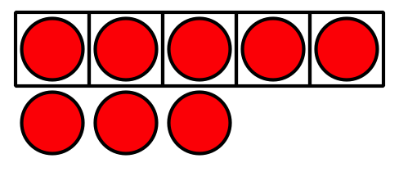
Roll and Add
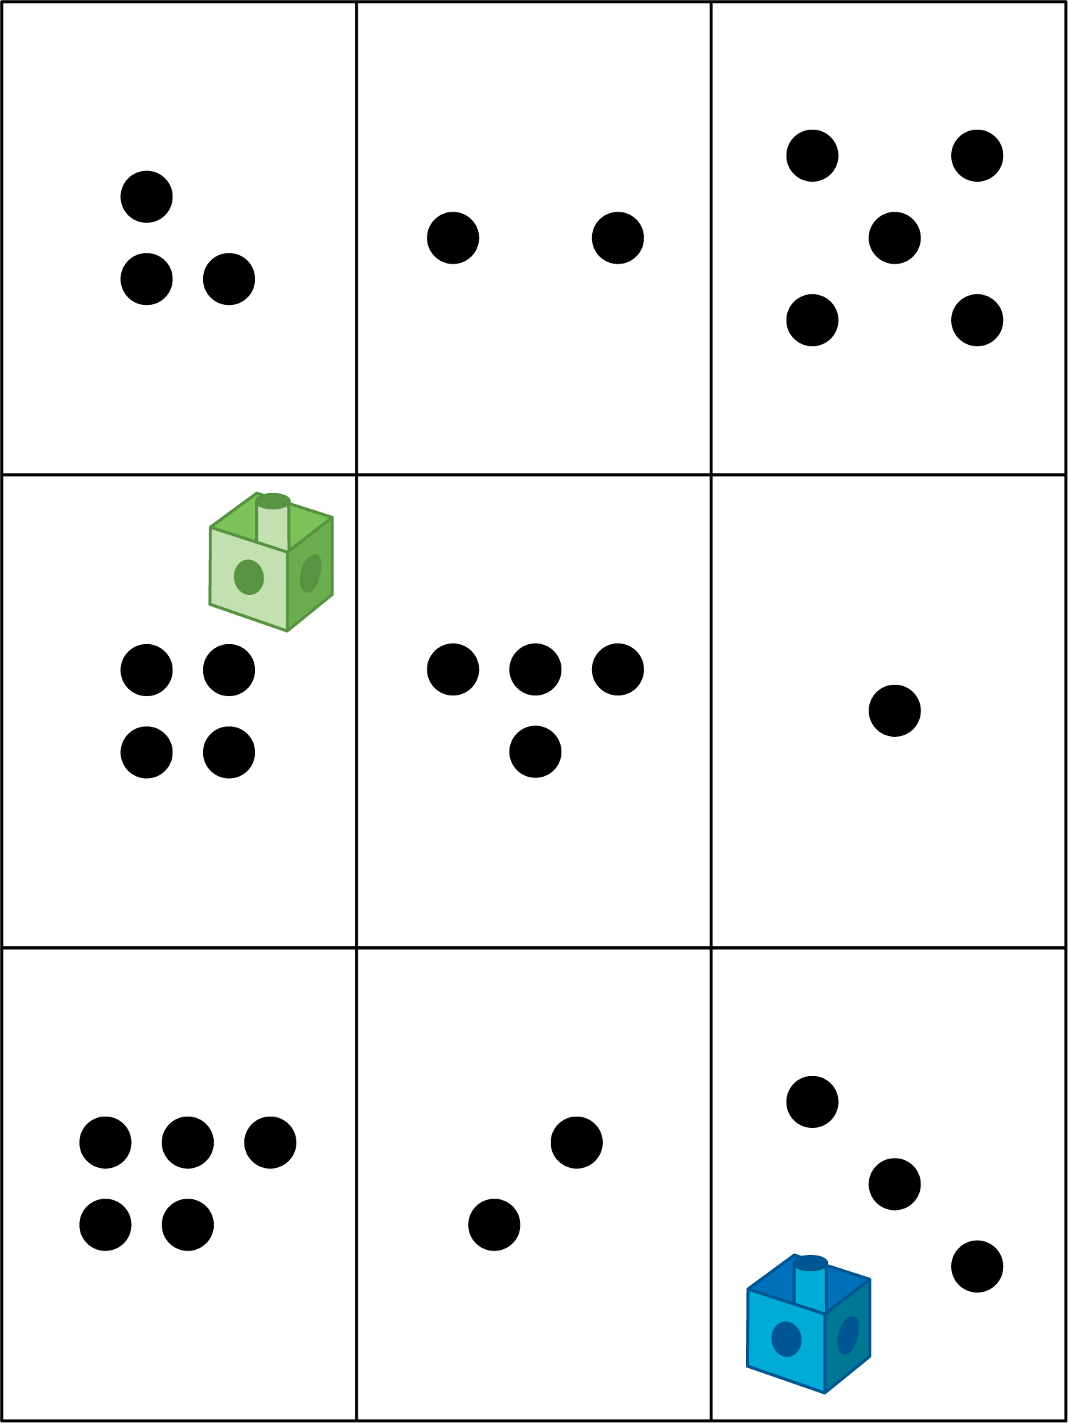
Bingo
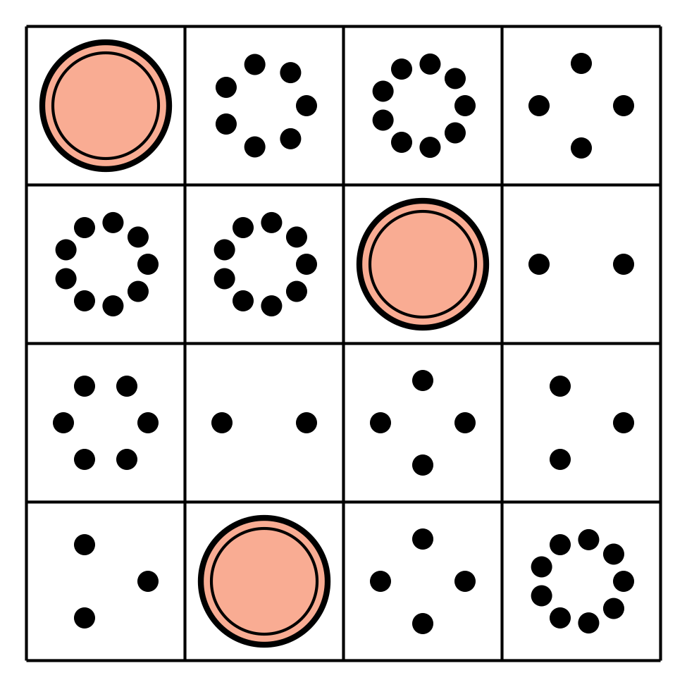
Geoblocks
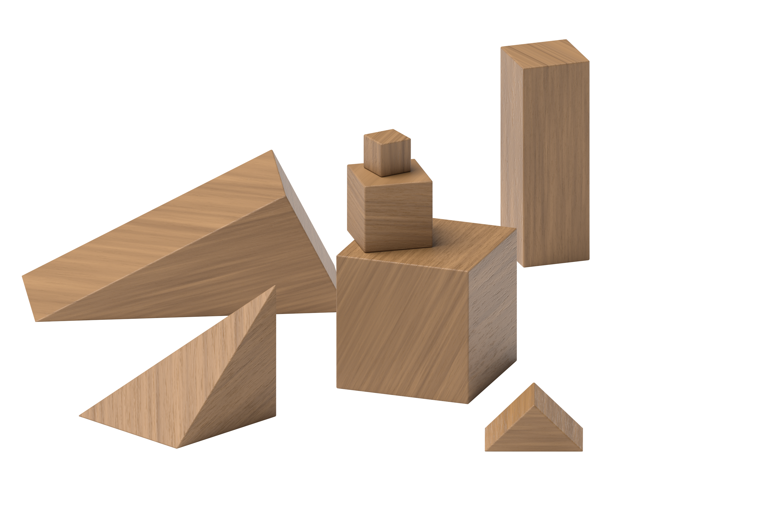
Find the Value of Expressions
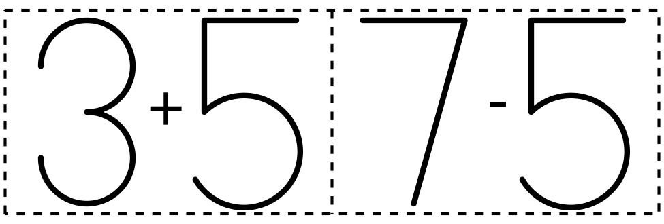
© CC BY 2021 Illustrative Mathematics®

