Lesson 13: Is It a.m. or p.m.?
- Let’s read and write times using a.m. or p.m.

13.1: What is the Time of Day?
- Use the materials your teacher gives you to create your own representation for the hours in a day.
  - Circle and label when you eat breakfast, lunch, and dinner on the diagram.
  - Shade in when you might be sleeping.
- Fill in the blank with a.m. or p.m. to show the time of day for each activity. Explain your thinking to your partner.
  - Diego goes to baseball practice at 3:00 __________.
  - Mai eats breakfast at 7:00 __________.
  - Tyler eats lunch at 12:00 __________.
  - Elena walks her dog at 2:00 __________.
  - Han gets on the bus to go to school at 8:00 __________.
  - The second-grade class has a snack at 10:00 __________.

13.2: Tell Time with a.m. and p.m.
- Label each activity with a.m. or p.m.
- Draw a line to the time when the activity could take place.
- Draw the hands on the clock to show the time.
activity
do homework ____________
get ready for bed ____________
eat lunch ____________
on the way to school ____________
in bed sleeping ____________
time
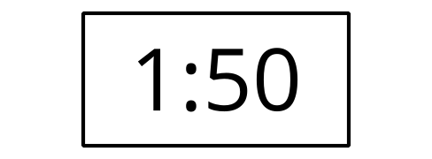
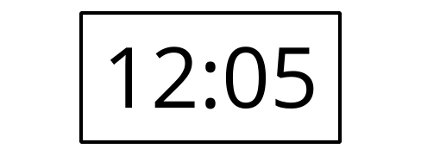
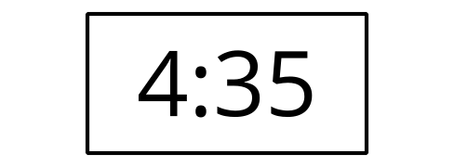
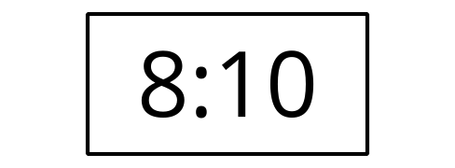
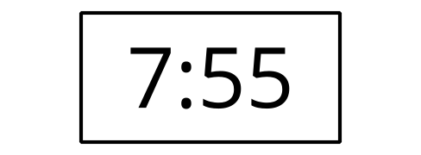
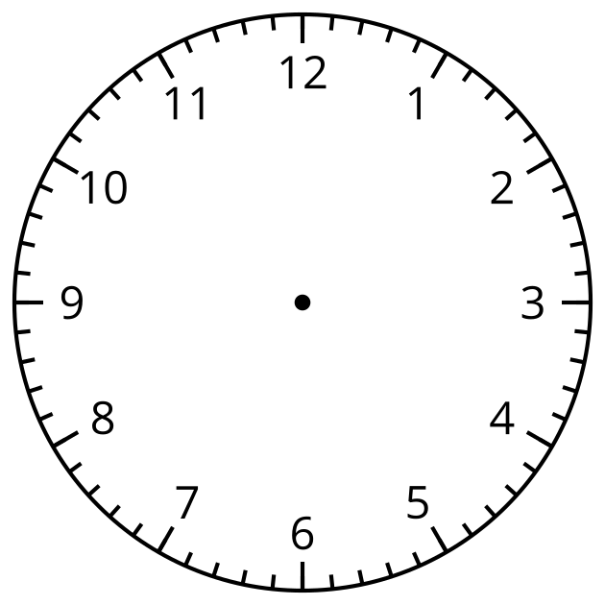

Section Summary
Section Summary
In this section, we learned to read clocks to tell and write time to the nearest 5 minutes. By counting by 5 starting at the number 1, we can tell the time in hours and minutes. We can also use half past, quarter past, or quarter till to tell time when the minute hand is in certain positions. To show the time of day, we use a.m. and p.m. when we tell and write time.
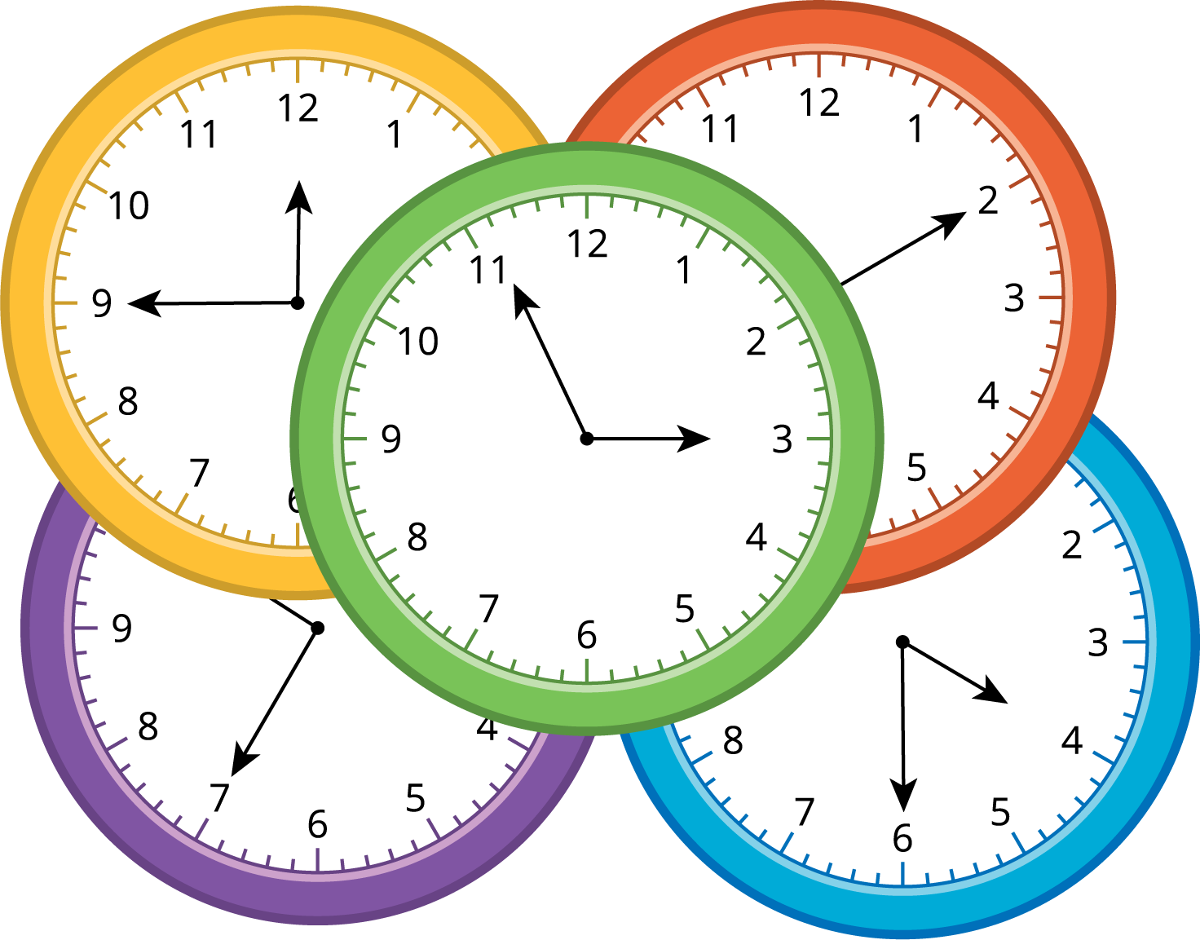
© CC BY 2021 Illustrative Mathematics®

