Unit 8 Lesson 5: Patterns with Even and Odd Numbers

WU How Many Do You See: Even or Odd (Warm up)

Student Task Statement
How many do you see? How do you see them?
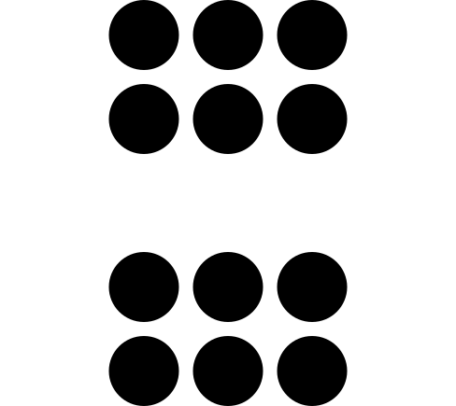

1 Even and Odd Round-about

Images for Launch
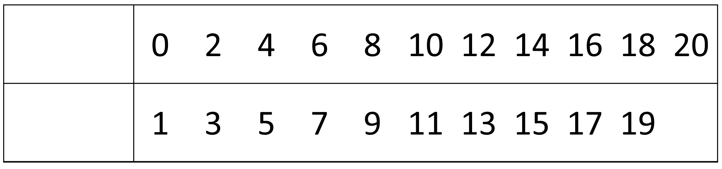

Student Task Statement
What did you notice? What do you wonder?

Activity Synthesis
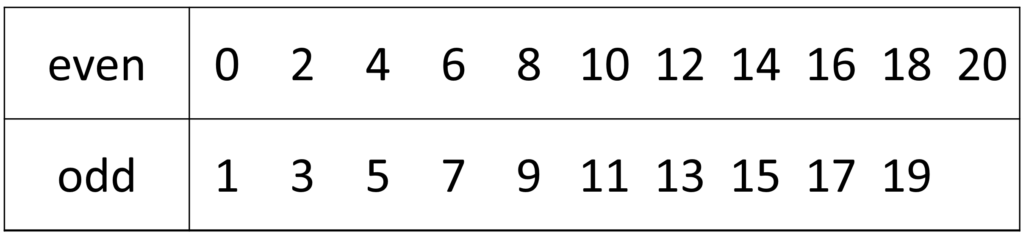

2 Presto Chango

Images for Launch

Student Task Statement
- In the first column of your recording sheet, decide whether each student has an even or odd number of counters. Show your reasoning and circle your choice.
- Complete the gray column. Does adding 1 change whether the number of counters is even or odd? Explain.
- Complete the last column. Does adding 2 change whether the number of counters is even or odd? Explain.
© CC BY 2021 Illustrative Mathematics®

