Lesson 16: Our Market’s Inventory

Warm-up: Notice and Wonder: The Shopping Cart
What do you notice? What do you wonder?
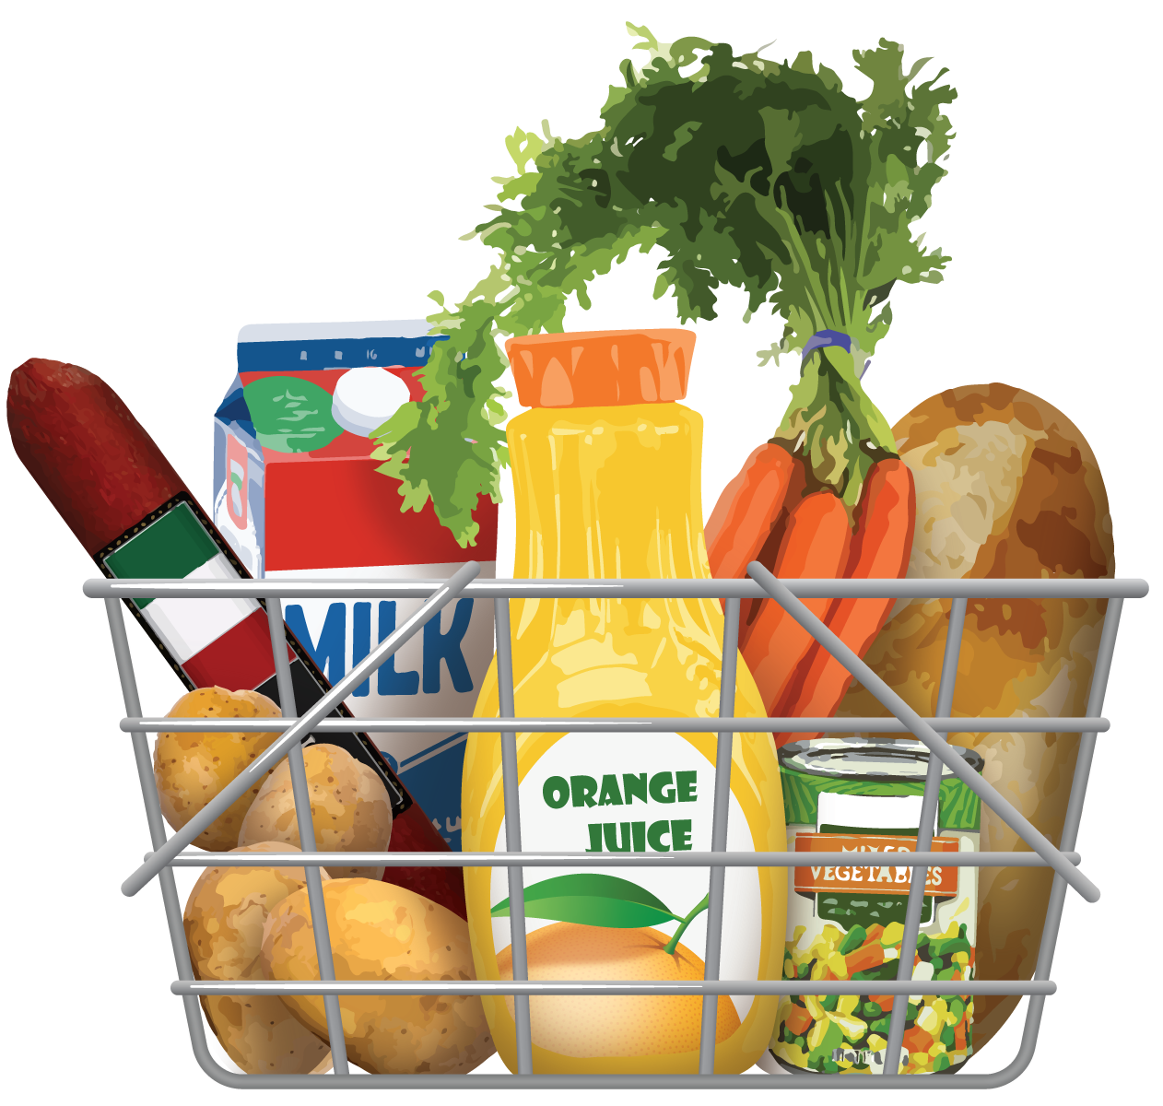

16.1: 100 Items
You sell 3 kinds of items in a store. At the beginning of each day you have:
- a total of 100 items
- less than 10 of one of the items
- more than 10 for the other 2
- Choose 3 items to sell at your market. Write the names of the items in the first row.
- Fill in the second row to show how much of each item you begin the day with.
- Share your store set-up with your partner pair. Discuss:
  - the amount you have for each item
  - how you know that you have a total of 100 items at your store
names | item 1: | item 2: | item 3:
amount at the beginning of the day
sales activity
amount at the end of the day

16.2: Buyers and Sellers
- At your table, take turns rolling a number cube. Each person should roll three times. Record each roll.
  - Roll 1: _____________
  - Roll 2: _____________
  - Roll 3: _____________
- Buyers: You will buy a certain amount of each item. Use the numbers you rolled to make:
  - two-digit numbers
  - one-digit numbers
- Sellers: After a sale, update the total number of items you have sold on your inventory sheet next to “sales activity.”

16.3: Sales Reports
- Fill out the inventory sheet with the information from your sales from the previous activity.
 | - item 1 | - item 2 | - item 3 | - totals
- starting amount
- number of items sold
- number of items left
- restock amount
- Summarize the activity of your store.
© CC BY 2021 Illustrative Mathematics®

