Lesson 4: Compare and Order Decimals
- Let’s put some decimals in order.

Warm-up: Estimation Exploration
The person in the image is 1.7 meters tall.
Estimate the wingspan of the eagle in meters.
Record an estimate that is:
too low | about right | too high

4.1: All in Order
- Order the numbers from least to greatest. Use the number line if it is helpful.
- 1.08
- 0.08
- 0.80
- 0.9
- 0.45
- 0.54
- Order the numbers from greatest to least. Use the number line if it is helpful.
- 1.25
- 0.95
- 0.4
- 0.09
- 12.05
- 0.25

4.2: 400-Meter Dash in a Flash
The table shows eight of the top runners in the Women’s 400-Meter event. Their best running times, listed here, put the runners in the world’s top 25 for this event.
48.37
49.3
48.7
49.26
49.07
49.28
48.83
49.05
The names in the table are arranged by the runners’ best time. The fastest runner is at the top.
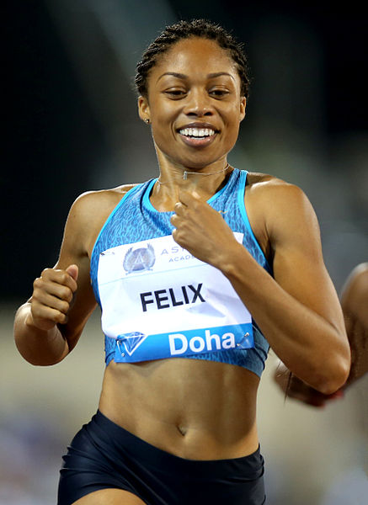
runner | best time (seconds) | year achieved
Shaunea Miller-Uibo (Bahamas) |  | 2019
Sanya Richards (U.S.A.) |  | 2006
Valerie Brisco-Hooks (U.S.A.) |  | 1984
Chandra Cheesborough (U.S.A.) |  | 1984
Tonique Williams-Darling (Bahamas) |  | 2004
Allyson Felix (U.S.A.) |  | 2015
Pauline Davis (Bahamas) |  | 1996
Lorraine Fenton (Jamaica) |  | 2002
- Put the times in order, from least to greatest, to match the times with the runners.
- How many seconds did it take Sanya Richards to run 400 meters?
- What is Allyson Felix’s best time?
© CC BY 2021 Illustrative Mathematics®

