Unit 8 Lesson 3: What Are Probabilities?

1 Which Game Would You Choose? (Warm up)

Student Task Statement
Which game would you choose to play? Explain your reasoning.
Game 1: You flip a coin and win if it lands showing heads.
Game 2: You roll a standard number cube and win if it lands showing a number that is divisible by 3.

2 What’s Possible?

Student Task Statement
- For each situation, list the sample space and tell how many outcomes there are.
  - Han rolls a standard number cube once.
  - Clare spins this spinner once.
  - 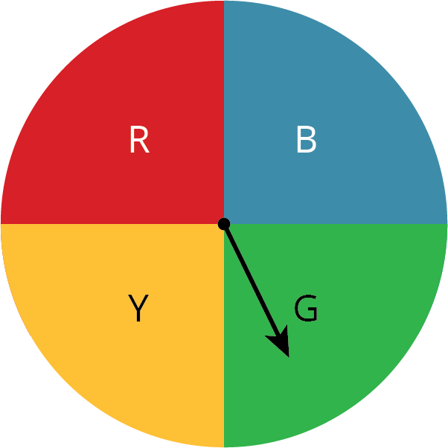
  - Kiran selects a letter at random from the word “MATH.”
  - Mai selects a letter at random from the alphabet.
  - Noah picks a card at random from a stack that has cards numbered 5 through 20.
- Next, compare the likelihood of these outcomes. Be prepared to explain your reasoning.
  - Is Clare more likely to have the spinner stop on the red or blue section?
  - Is Kiran or Mai more likely to get the letter T?
  - Is Han or Noah more likely to get a number that is greater than 5?
- Suppose you have a spinner that is evenly divided showing all the days of the week. You also have a bag of papers that list the months of the year. Are you more likely to spin the current day of the week or pull out the paper with the current month?

3 What’s in the Bag?

Student Task Statement
Your teacher will give your group a bag of paper slips with something printed on them. Repeat these steps until everyone in your group has had a turn.
- As a group, guess what is printed on the papers in the bag and record your guess in the table.
- Without looking in the bag, one person takes out one of the papers and shows it to the group.
- Everyone in the group records what is printed on the paper.
- The person who took out the paper puts it back into the bag, shakes the bag to mix up the papers, and passes the bag to the next person in the group.
 | Guess the  sample space. | What is printed  on the paper?
person 1
person 2
person 3
person 4
- How was guessing the sample space the fourth time different from the first?
- What could you do to get a better guess of the sample space?
- Look at all the papers in the bag. Were any of your guesses correct?
- Are all of the possible outcomes equally likely? Explain.
- Use the sample space to determine the probability that a fifth person would get the same outcome as person 1.
© CC BY Open Up Resources. Adaptations CC BY IM.

