Lesson 9: Compare Capacity
- Let’s compare objects to see which one holds more.

9.3: Centers: Choice Time
Choose a center.
Counting Collections
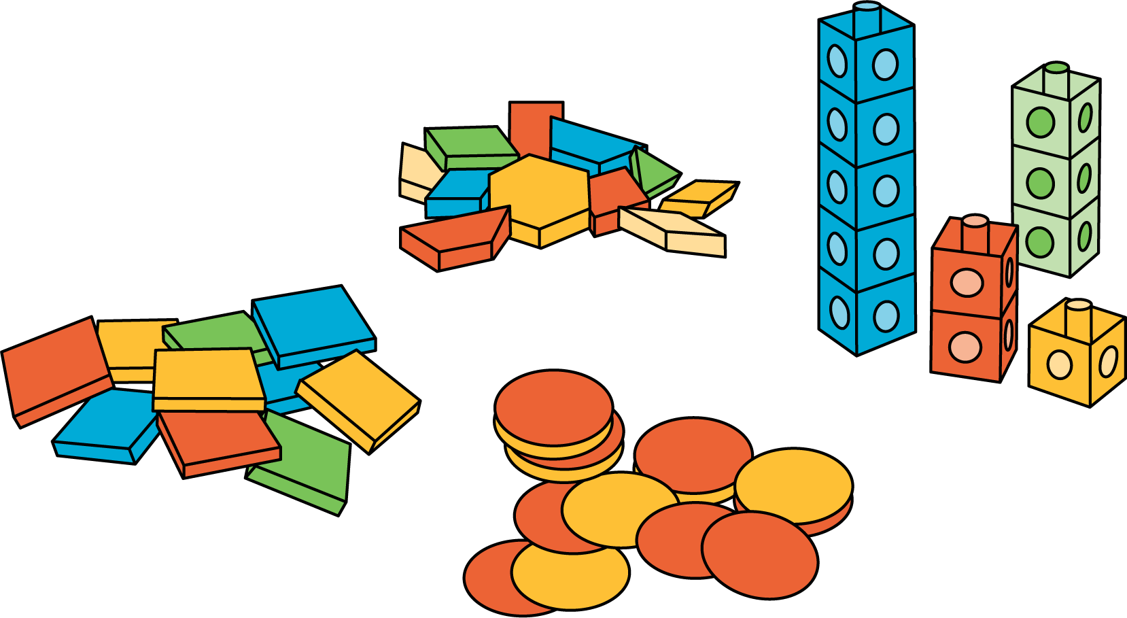
Match Mine
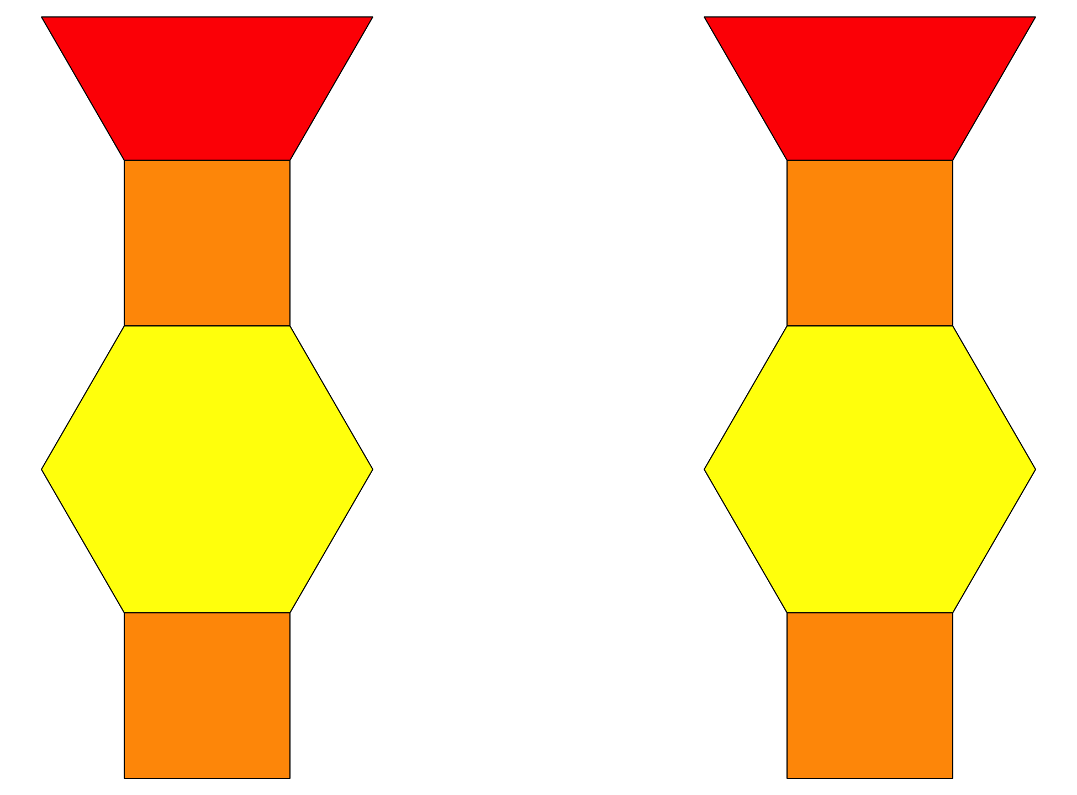
Shake and Spill
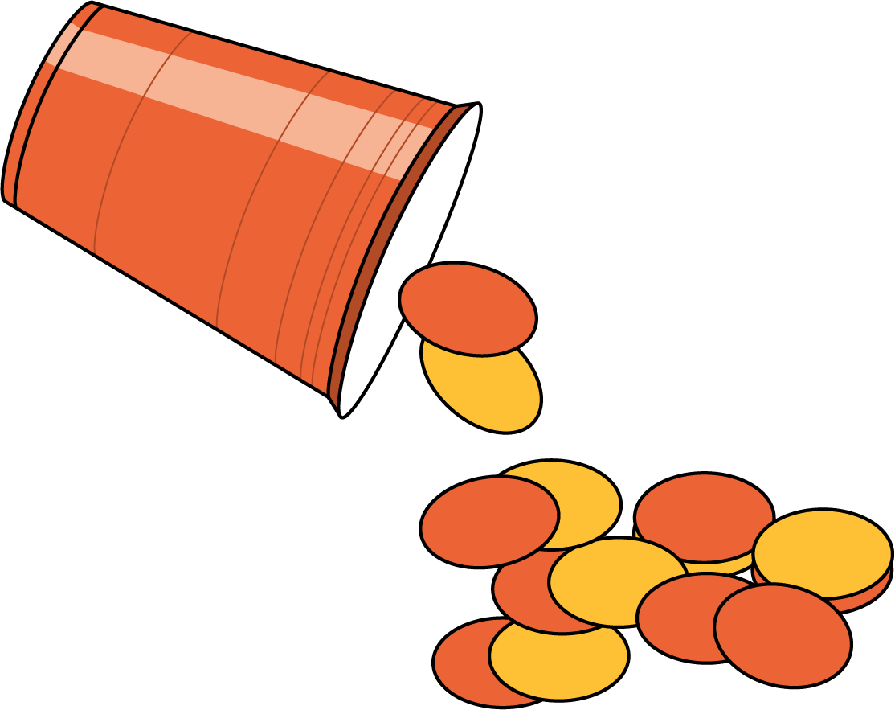
© CC BY 2021 Illustrative Mathematics®

