Lesson 17 Practice Problems
- The washer in the image has an inner diameter of $\frac{1}{4}$ inch. The outer diameter measures $\frac{3}{4}$ inch, and the washer is $\frac{1}{4}$ inch thick. The density of the metal the washers are made of is 0.285 pounds per cubic inch.
- 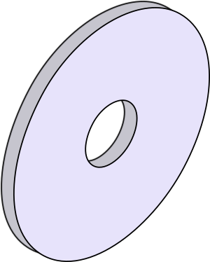
- How much do 5 washers weigh, in pounds? Round your answer to the nearest hundredth.
- Assume that a cell is a sphere with radius ${10}^{\text{-}3}$ or 0.001 centimeter, and that a cell’s density is 1.1 grams per cubic centimeter.
  - Koalas weigh 6 kilograms on average. How many cells are in the average koala?
  - Hippos weigh 1,400 kilograms on average. How many cells are in the average hippo?
- The density of water is 1 gram per cm³. An object floats in water if its density is less than water’s density, and it sinks if its density is greater than water’s. Will a toy in the shape of a rectangular prism that is 1 centimeter by 2 centimeter by 2 centimeter with mass 3 grams sink or float? Explain your reasoning.
- A cube and a sphere both have volume 512 cubic units. Which solid has a greater surface area? Explain your reasoning.
- (From Unit 5, Lesson 16.)
- Give the dimensions of 2 solids with equal surface area and different volume.
- (From Unit 5, Lesson 16.)
- A right cone has a base with diameter 10 units. The volume of the cone is $100π$ cubic units. What is the length of a segment drawn from the apex to the edge of the circular base?
  - 5 units
  - 12 units
  - 13 units
  - 15 units
- (From Unit 5, Lesson 15.)
- A pyramid has a height of 4 inches and a volume of 40 cubic inches. Select all figures that could be the base for this pyramid.
  - a 5 inch by 2 inch rectangle
  - a 3 inch by 10 inch rectangle
  - a triangle with height 10 inches and base 3 inches
  - a right triangle with one side 5 inches and the hypotenuse 13 inches
  - a heart with area 30 square inches
- (From Unit 5, Lesson 14.)
- Select all solids for which the formula $V=Bh$ applies.
  - a triangular prism
  - a triangular pyramid
  - a square pyramid
  - a rectangular prism
  - a cone
  - a cylinder
- (From Unit 5, Lesson 9.)
- Two distinct lines, $ℓ$ and $m$, are each perpendicular to the same line $n$. A fourth distinct line, $k$, is also perpendicular to line $n$. Does line $k$ intersect line $ℓ$ or line $m$? Explain how you know.
- (From Unit 1, Lesson 6.)
© CC BY 2019 by Illustrative Mathematics®

