Unit 8 Lesson 20: More or Less than 10?

WU Estimation Exploration: Close to 10 (Warm up)

Student Task Statement
Record an estimate that is:
too low | about right | too high

1 Use 10 to Estimate

Student Task Statement
Write “more” or “fewer” to finish each sentence.
- I think there are ______________________ than 10 pencils.
- How many pencils are there? __________
- I think there are ______________________ than 10 pencils.
- How many pencils are there? __________
- I think there are ______________________ than 10 pencils.
- 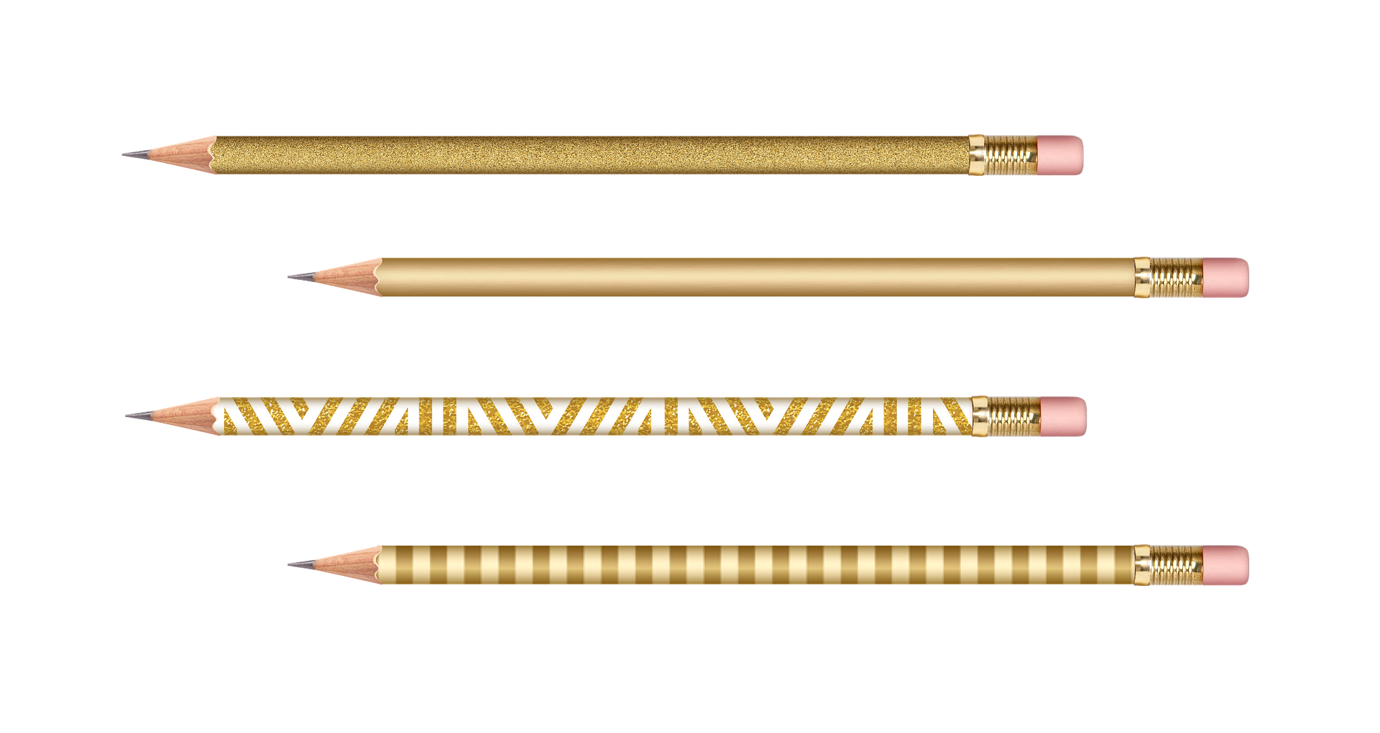
- How many pencils are there? __________
- I think there are ______________________ than 10 pencils.
- How many pencils are there? __________
- I think there are ______________________ than 10 pencils.
- How many pencils are there? __________

Activity Synthesis

2 Could She Be Right?

Student Task Statement
- Elena says there are about 11 snowflakes.
Do you think she could be right?
Why or why not?
- 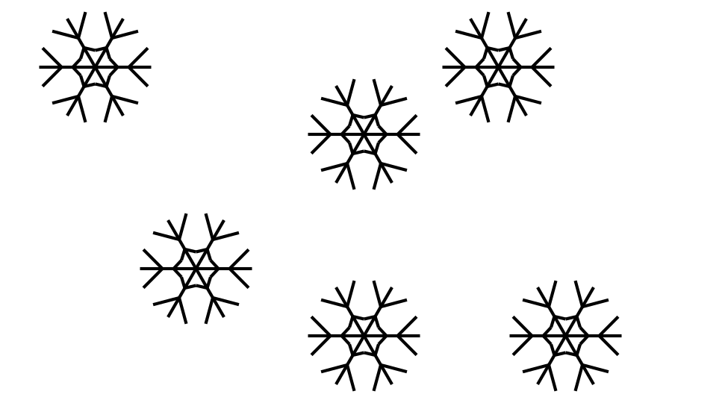
- Elena says there are about 8 flowers.
Do you think she could be right?
Why or why not?
- 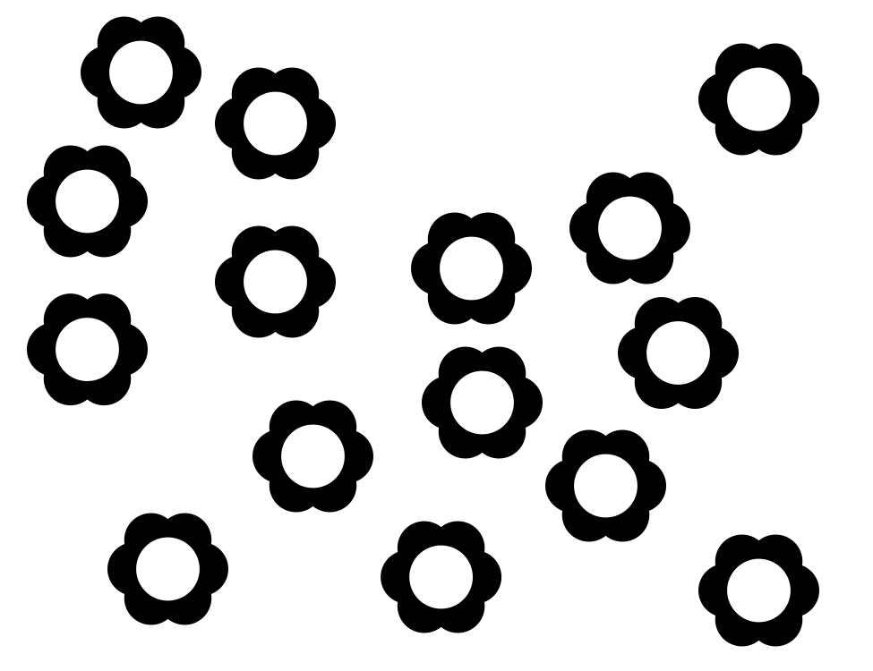
- Elena says there are about 11 suns.
Do you think she could be right?
Why or why not?
- 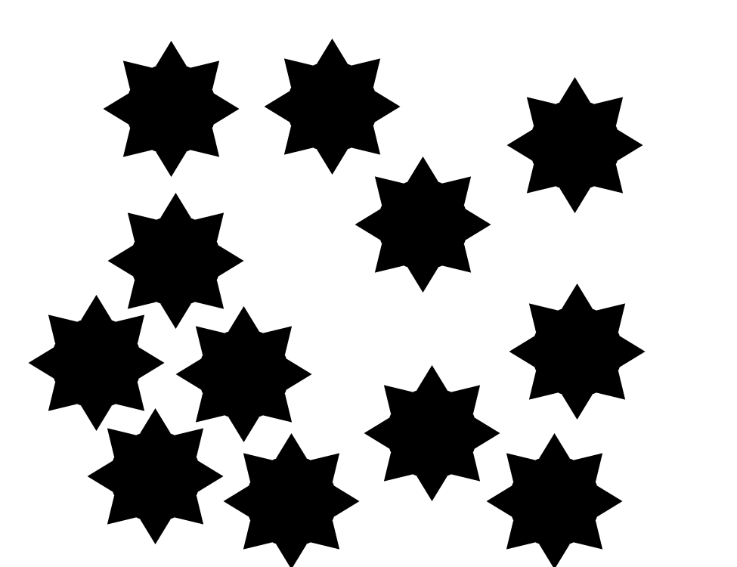
Synthesis:
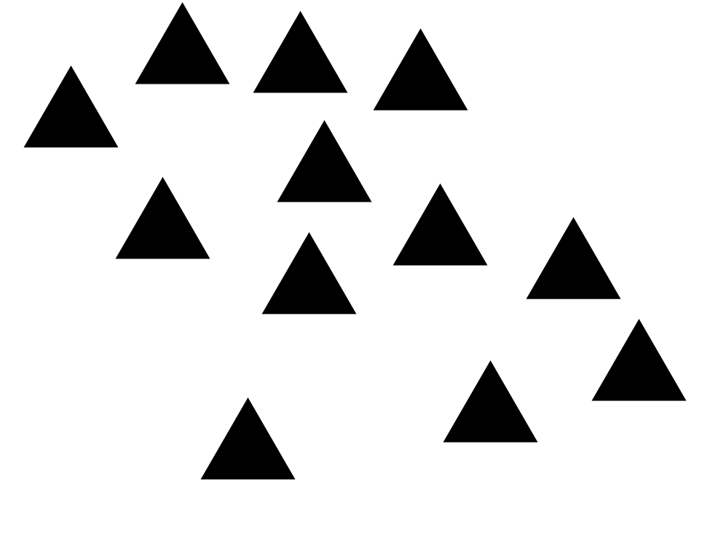

3 Centers: Choice Time

Student Task Statement
Choose a center.
Shake and Spill
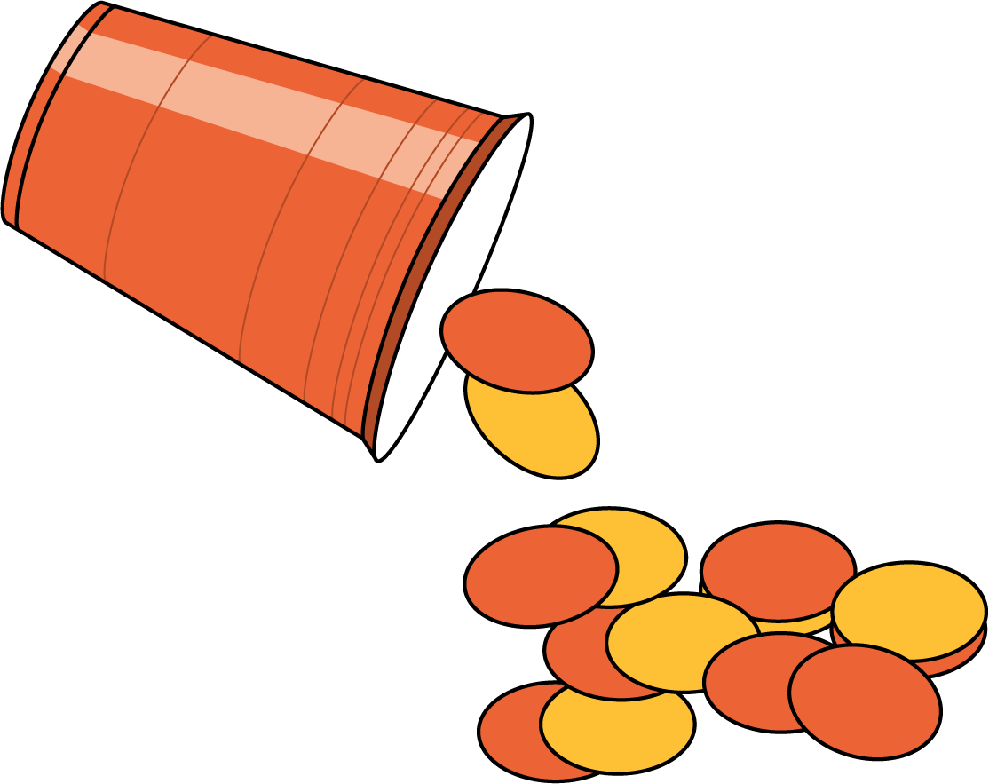
Number Race
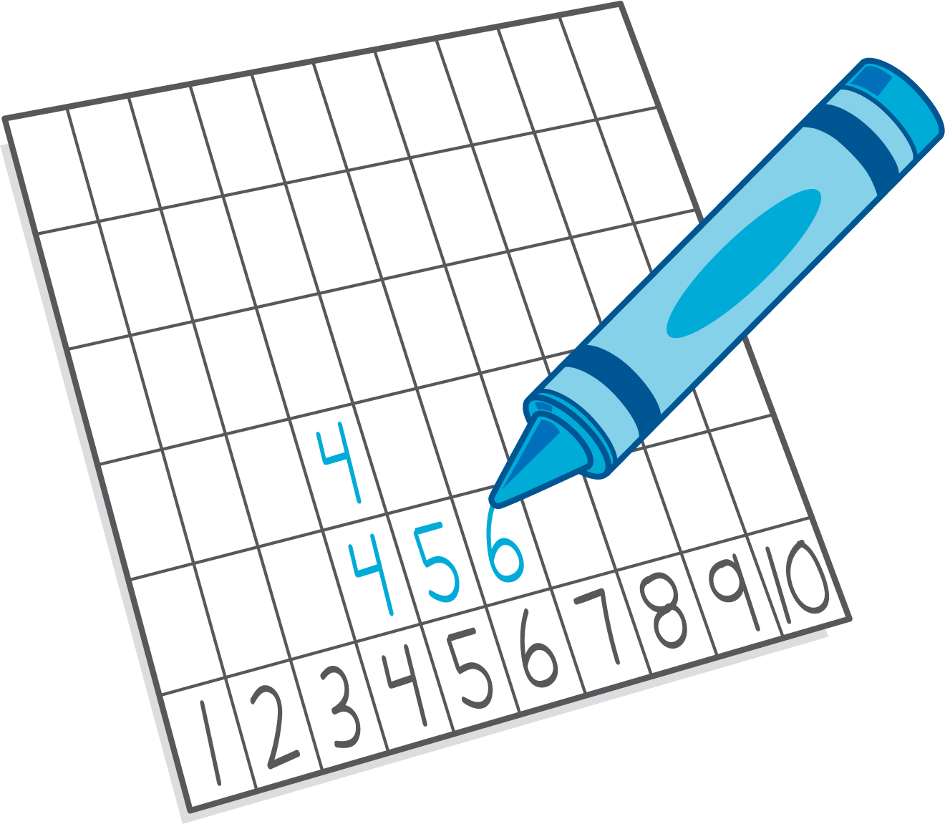
Grab and Count
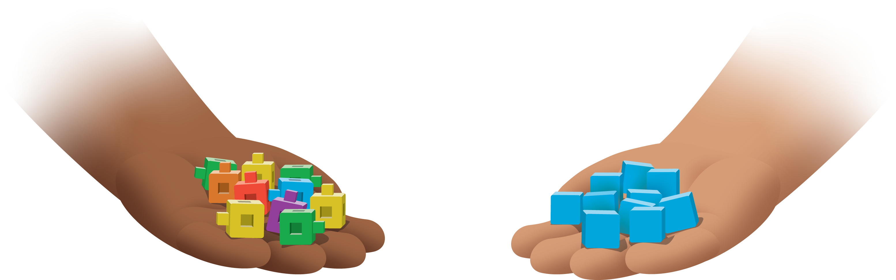
What's Behind My Back?
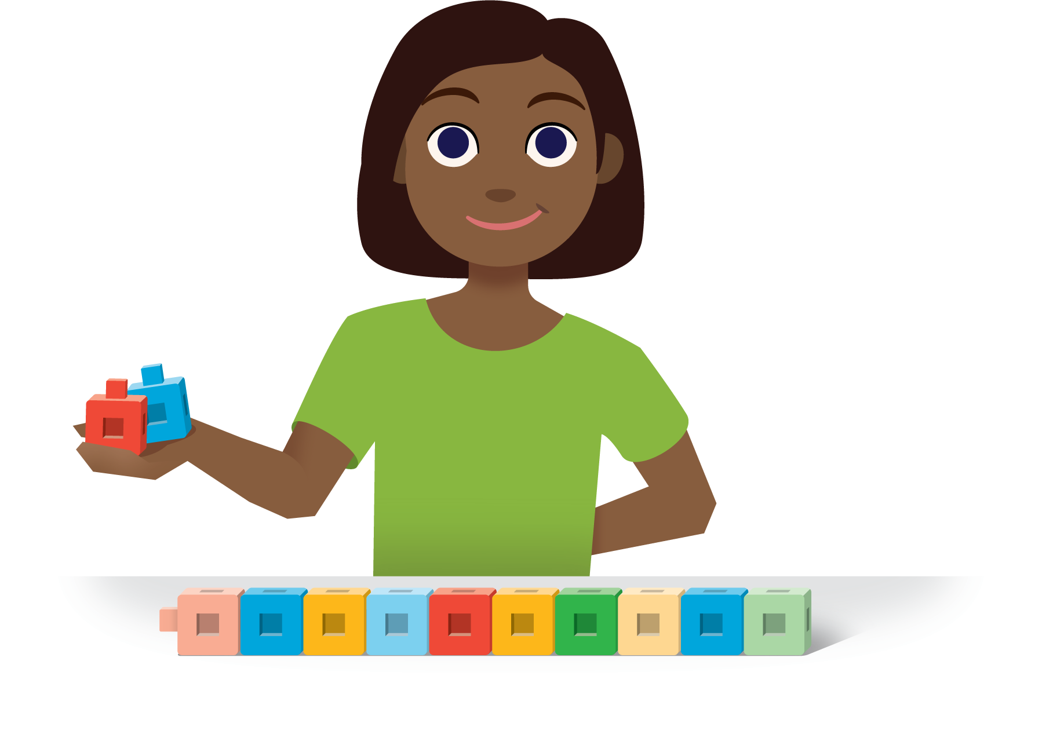
Pattern Blocks
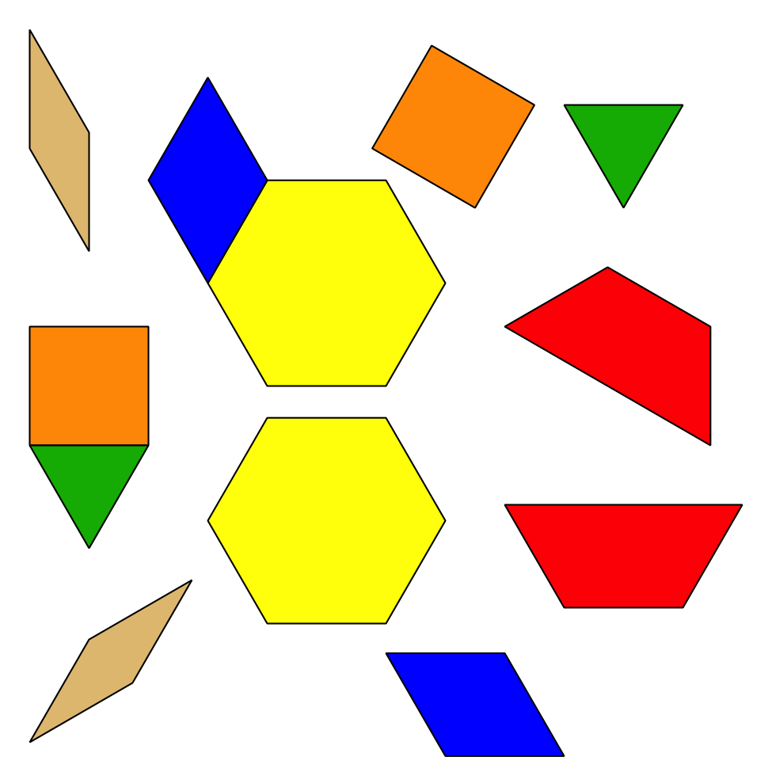
© CC BY 2021 Illustrative Mathematics®

