Unit 5 Lesson 4: Center Day 1

WU Notice and Wonder: Marbles (Warm up)

Student Task Statement
What do you notice?
What do you wonder?
Kiran and Priya each have some marbles.
Kiran has 14 marbles.
Priya has 23 marbles.

1 Introduce Number Puzzles, Within 100 without Composing

Student Task Statement

2 Centers: Choice Time

Student Task Statement
Choose a center.
Number Puzzles
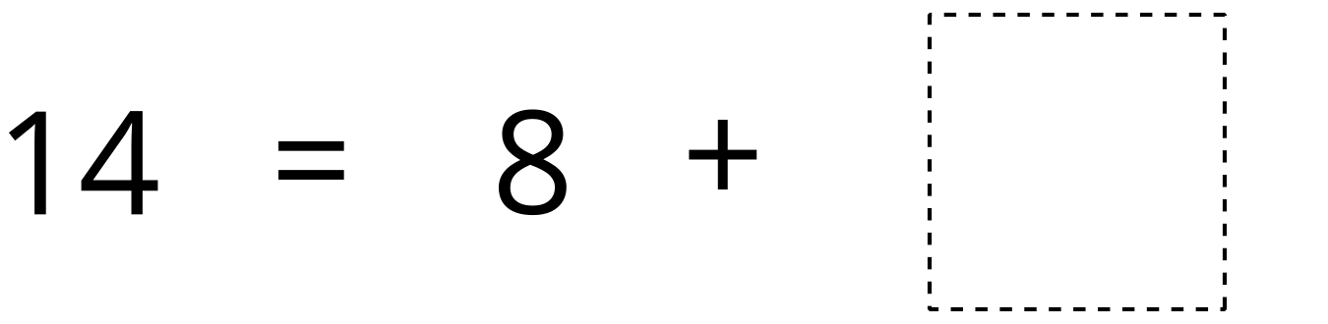
Five in a Row
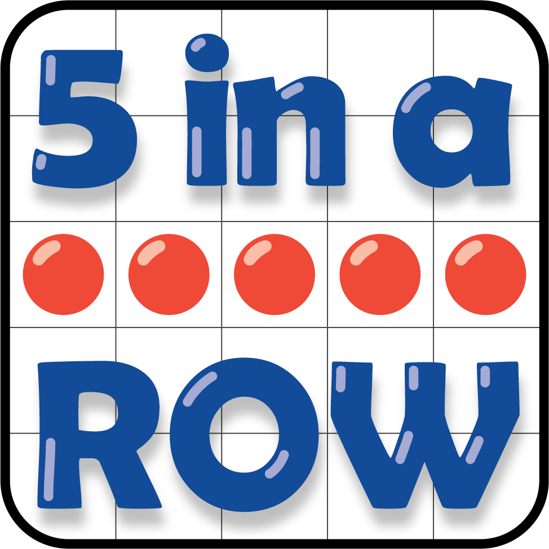
Greatest of Them All
© CC BY 2021 Illustrative Mathematics®

