Unit 8 Lesson 9: A Sum of Equal Addends

WU Estimation Exploration: How Many Waffles? (Warm up)

Images for Launch
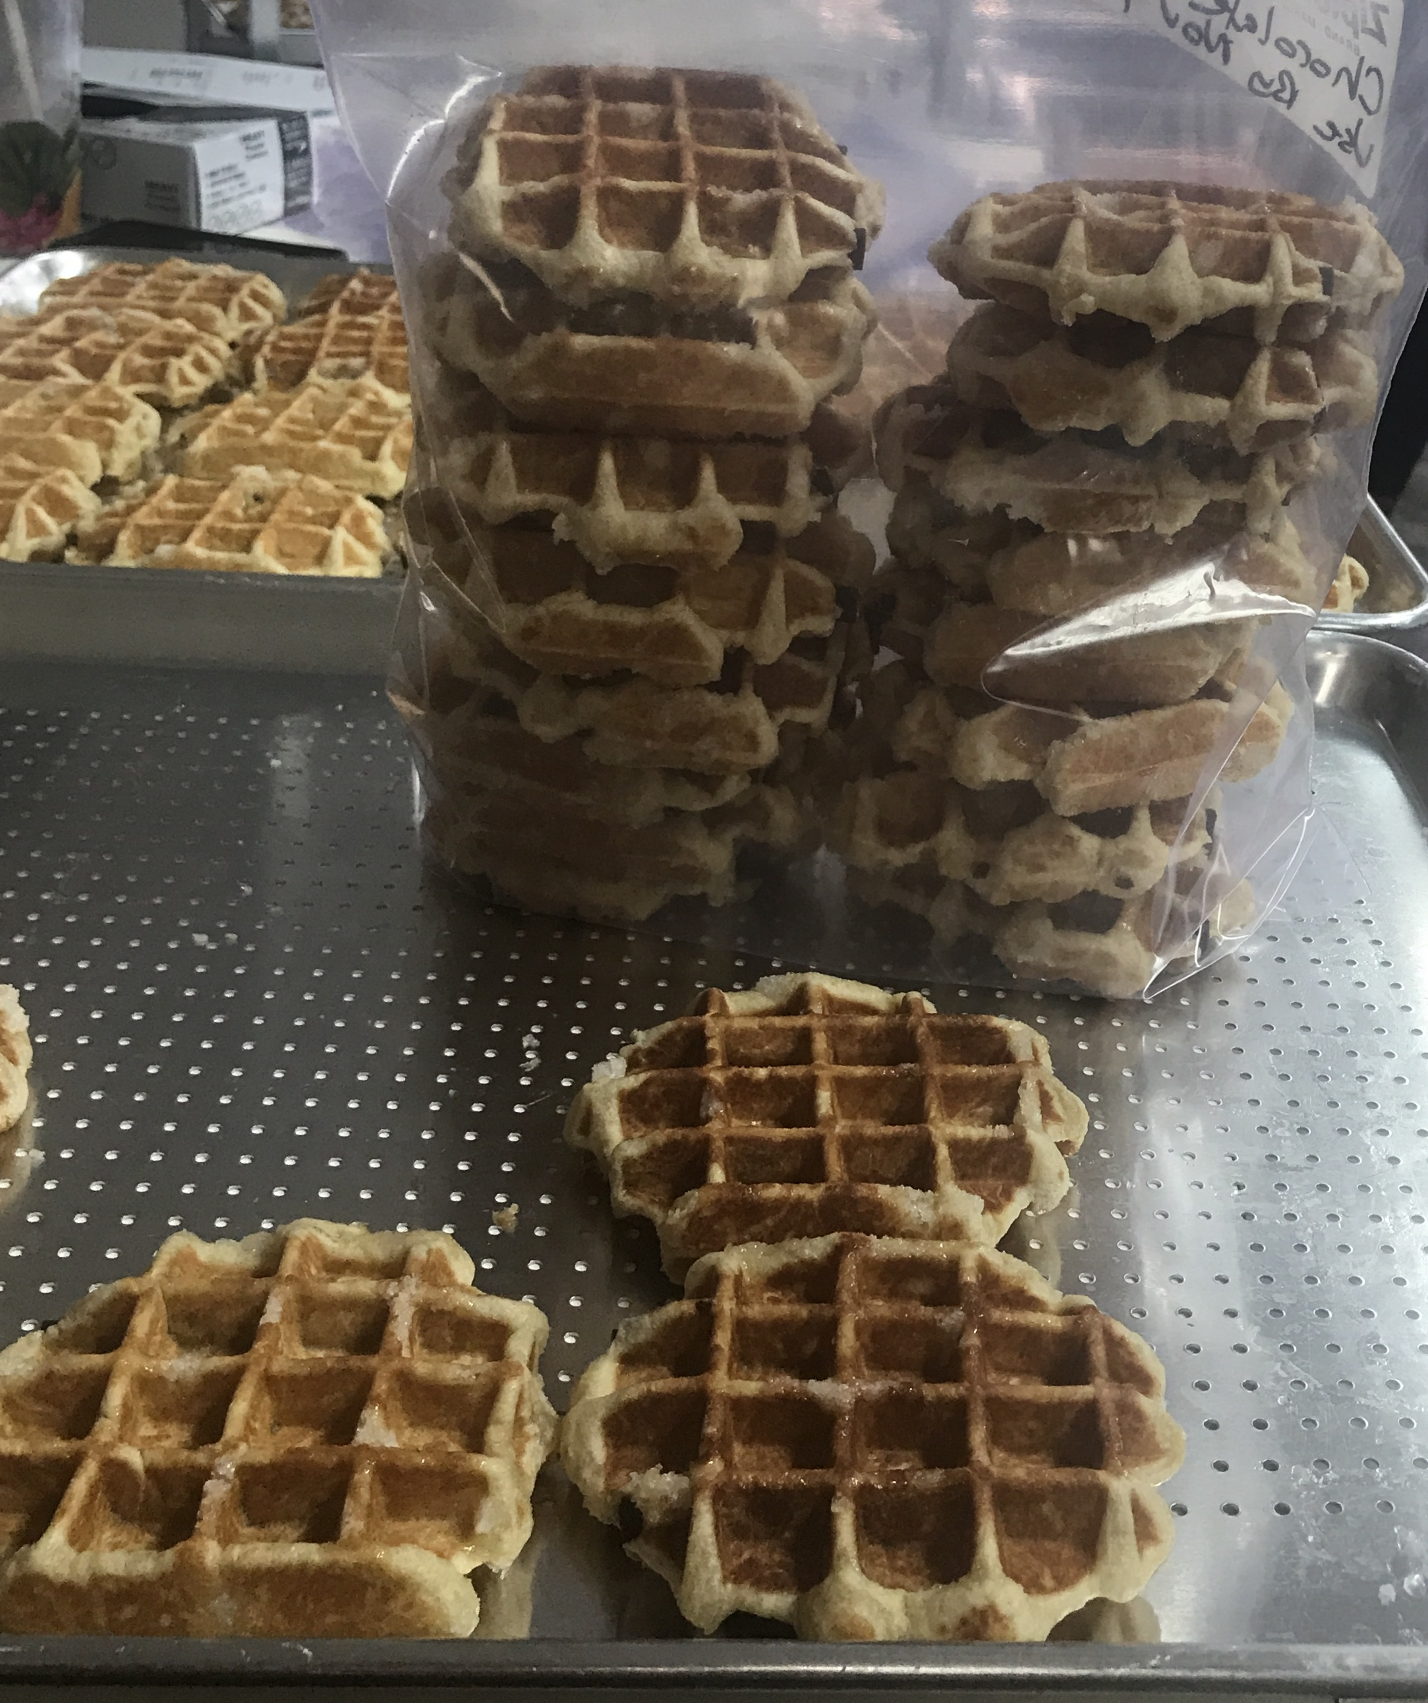

Student Task Statement
How many waffles are on the tray?
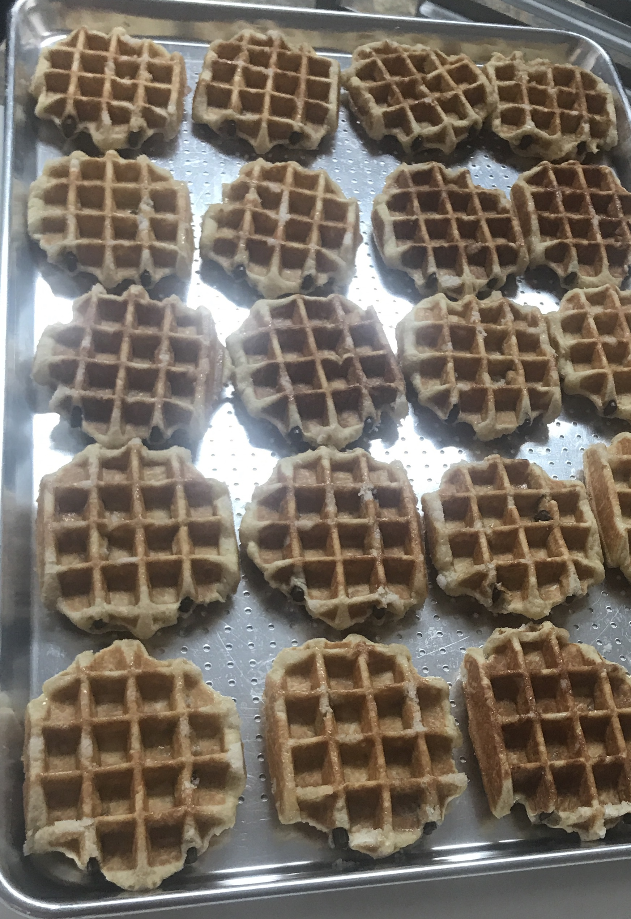
Record an estimate that is:
too low | about right | too high

1 Sums of Rows and Sums of Columns

Student Task Statement
Mai and Diego represented the same array with different expressions.
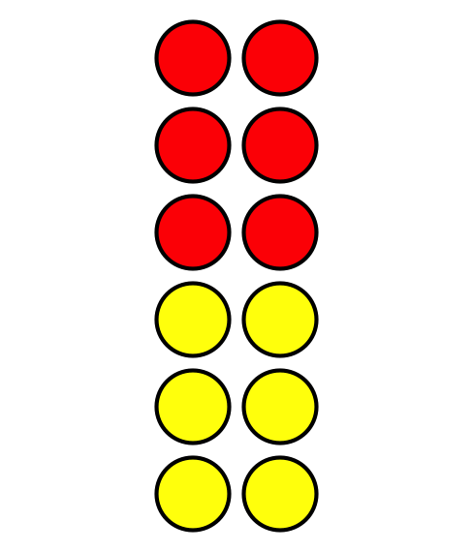
Diego’s expression
$2+2+2+2+2+2$
Mai’s expression
$6+6$
Who do you agree with?
Show your thinking using diagrams, symbols, or other representations.

Activity Synthesis
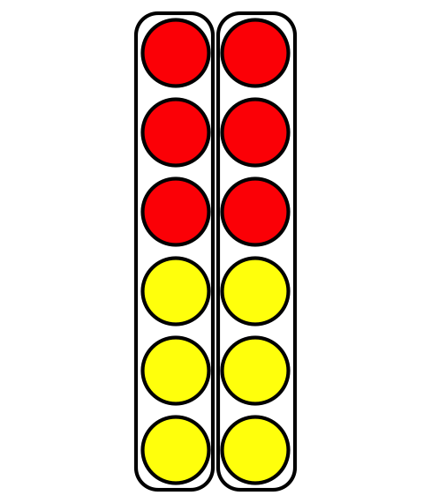
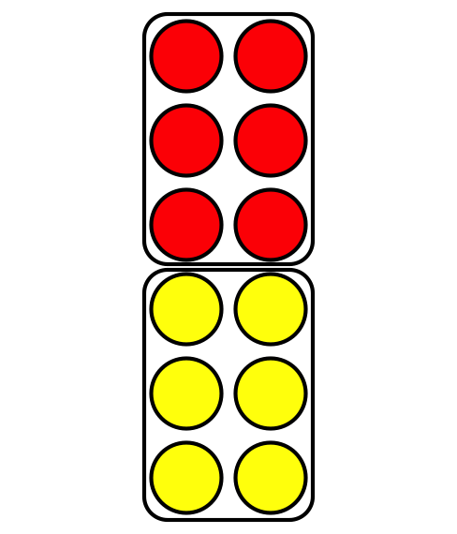

2 Card Sort: Arrays and Expressions

Student Task Statement
Your teacher will give you a set of cards that show arrays, expressions and a total number. Find the cards that match.

3 Add It All Up

Student Task Statement

  - How many counters are there in all?
  - 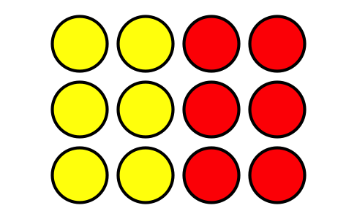
  - Explain how you found the total number of counters.
  - Circle 2 expressions that represent the array.
  - $3+3+3+3$
  - $3+3+3$
  - $4+3$
  - $4+4+4$
  - $4+4+4+4$

  - How many counters are there in all?
  - 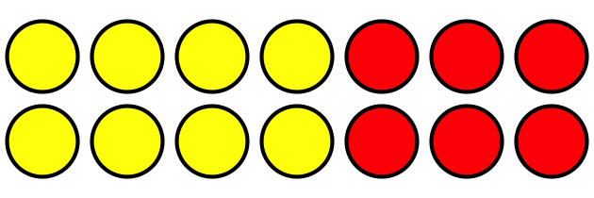
  - Explain how you found the total number of counters.
  - Circle 2 expressions that represent the array.
  - $2+2+2+2+2+2+2$
  - $6+6$
  - $7+7$
  - $2+2+2+2+2$

Images for Activity Synthesis
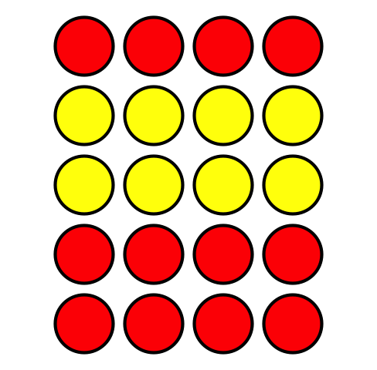
© CC BY 2021 Illustrative Mathematics®

