Lesson 8: Beyond 100,000
- Let’s read, write, and represent numbers beyond 100,000.

Warm-up: How Many Do You See?
How many do you see? How do you see them?
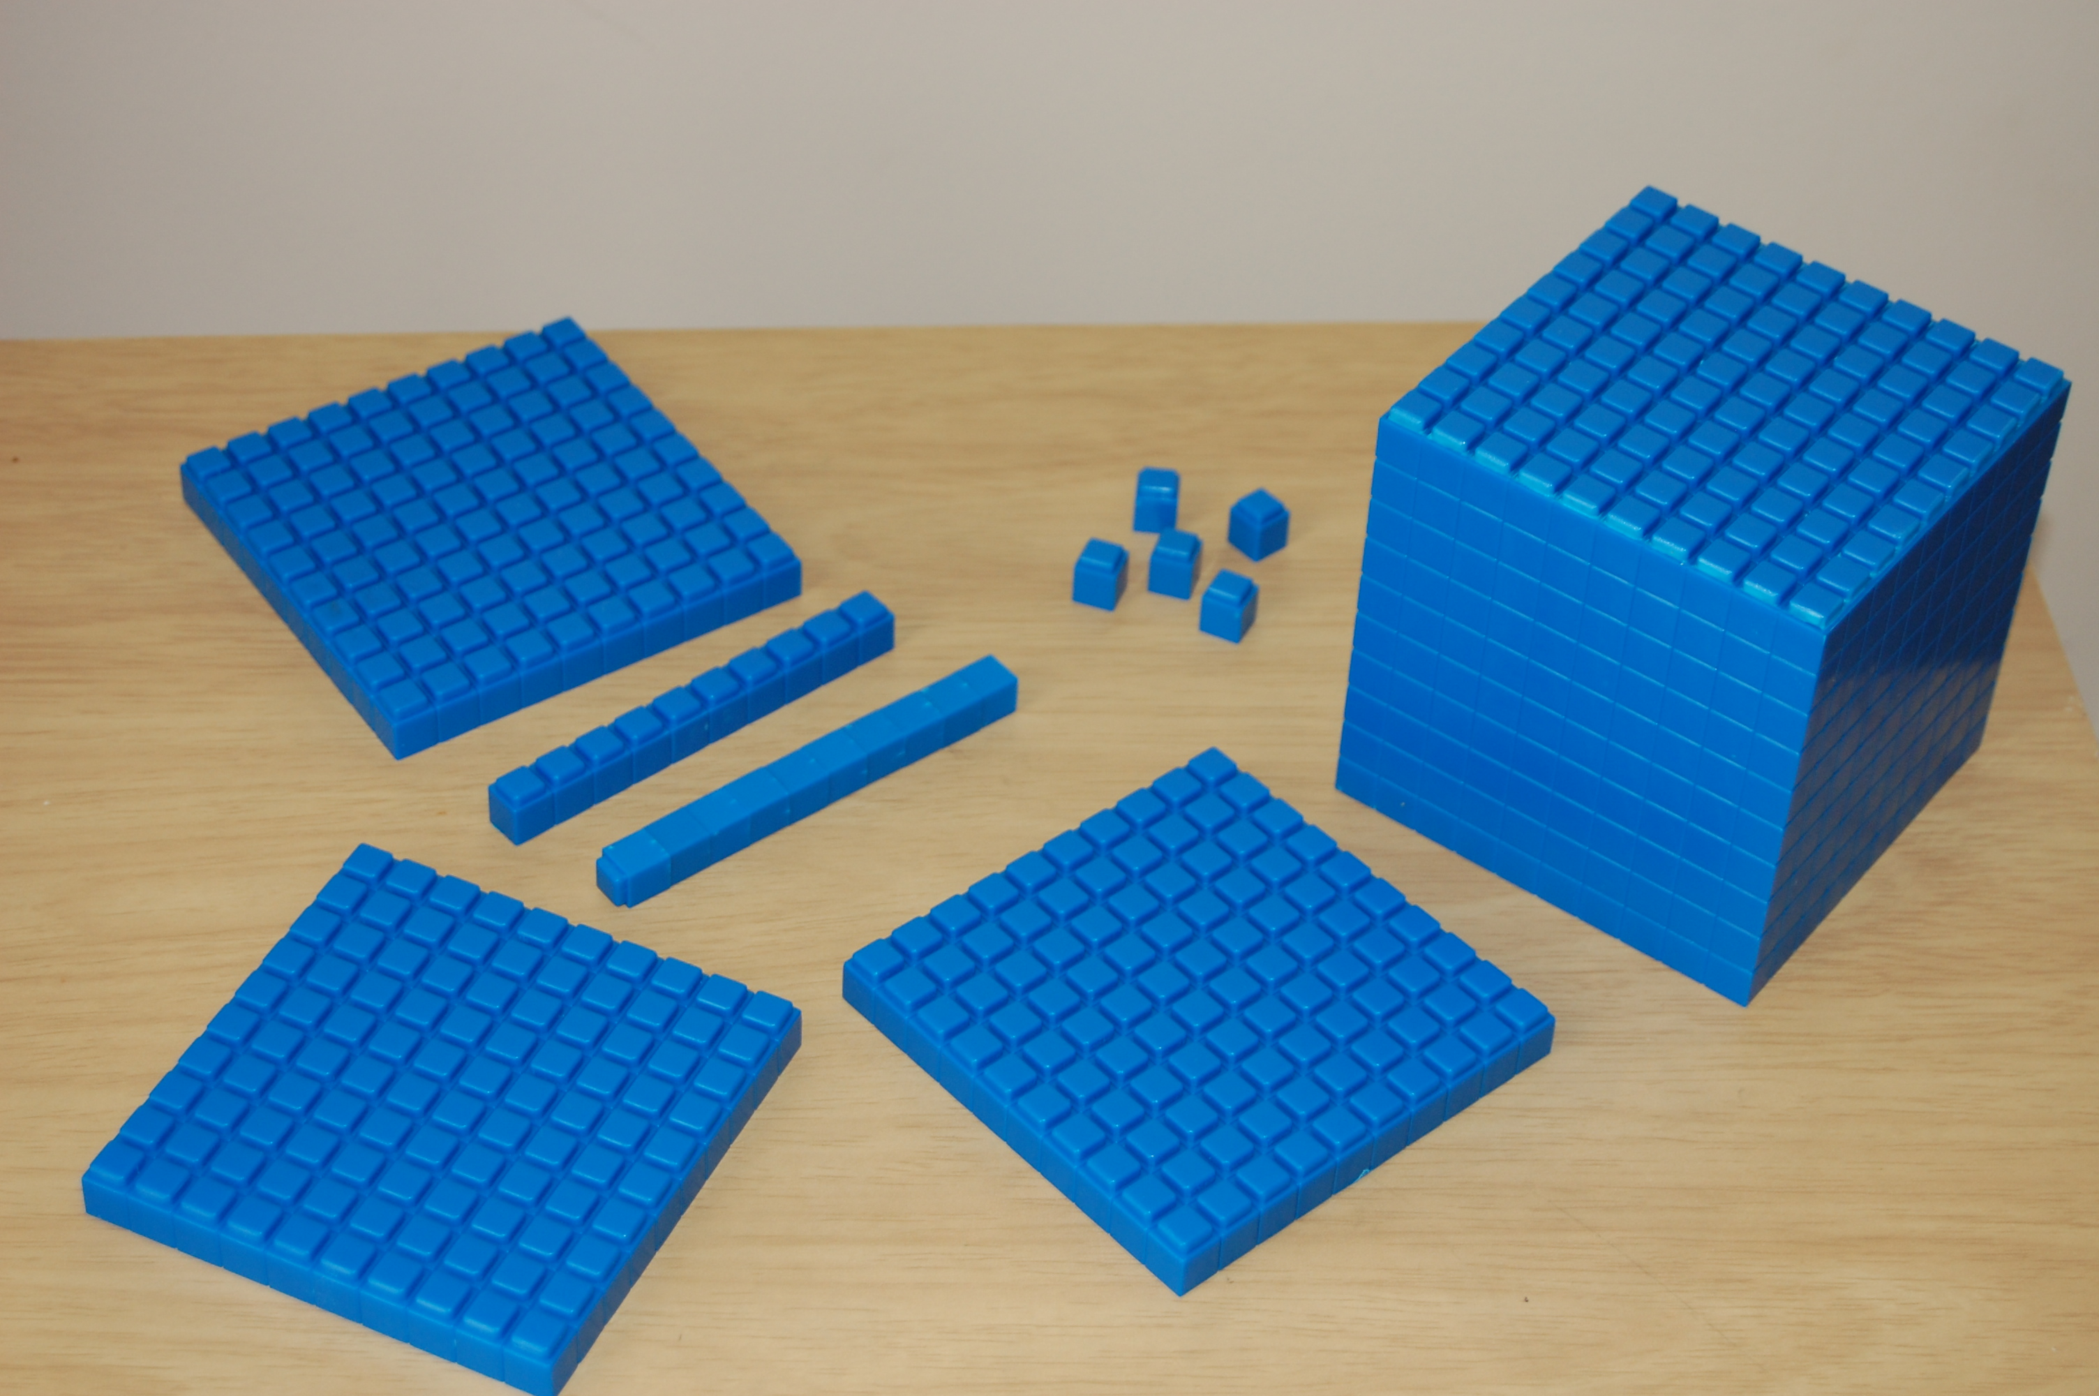

8.1: Lin’s Representation
- Use base-ten blocks or draw a base-ten diagram to represent 15,710.
- Lin is using blocks like these to represent 15,710. She decided to change the value of the small cube to represent 10.
- 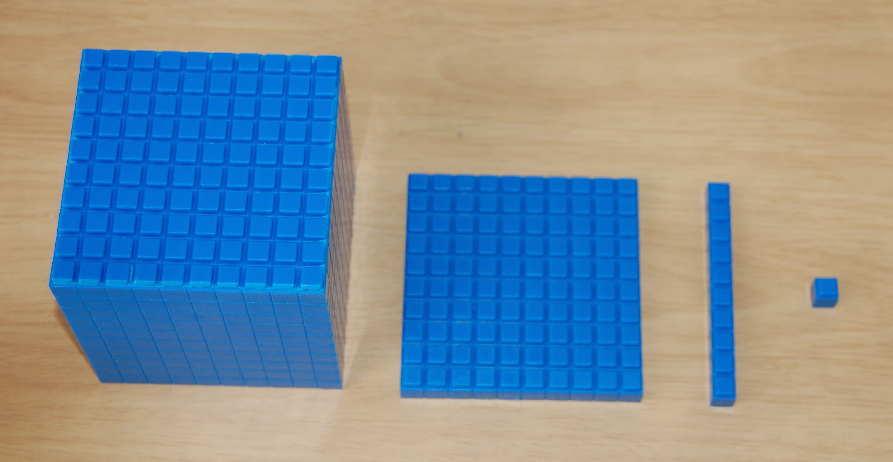
- What is the value of each block if the value of the small cube is 10?
  - Small cube: 10
  - Long rectangular block: __________
  - Large square block: __________
  - Large cube: __________
- Use Lin’s strategy to represent 15,710.
- Use Lin’s strategy to represent each number.
  - 23,000
  - 58,100
  - 69,470
- Using her strategy, which base-ten blocks would be used to represent 100,000?

8.2: What Number is Represented?
- A small cube represents 1. What value do the blocks in the picture represent?
- A small cube is now worth 10. What is the new value that the blocks in the picture represent?
- Write two statements comparing the numbers in the previous problems.

8.3: Build Hundred-thousands
- To represent large numbers, Lin changed the value of the small cube to 10. She used the following blocks to represent her first number.
- 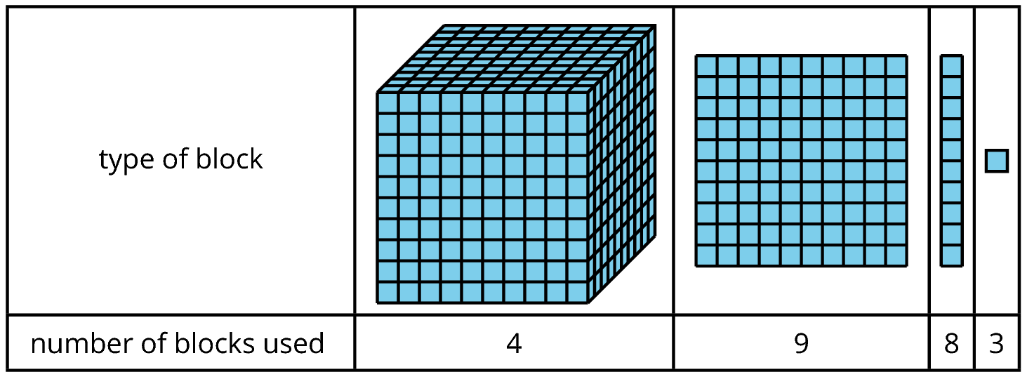
  - What number did Lin represent? Show or explain your reasoning.
  - Write an equation to represent the value of the blocks.
- She used more blocks to represent another number.
- 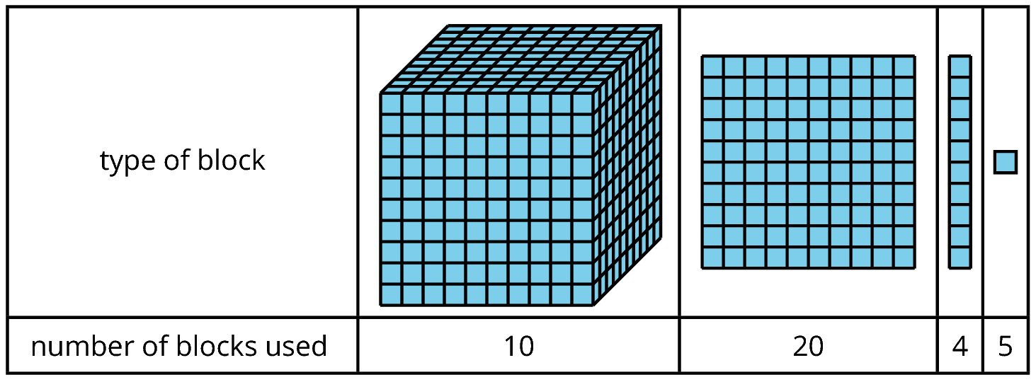
  - What number did Lin represent? Show or explain your reasoning.
  - Write an equation to represent the value of the blocks.
© CC BY 2021 Illustrative Mathematics®

