Lesson 15: Lots of Fruit
- Let’s make up story problems and solve them.

Warm-up: Notice and Wonder: Fruit Stand
What do you notice?
What do you wonder?

15.1: Fruit Story Problems
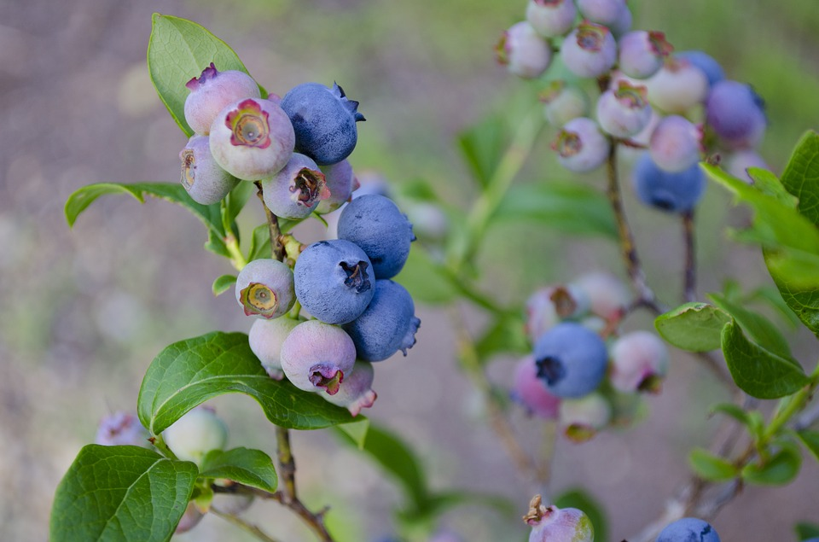
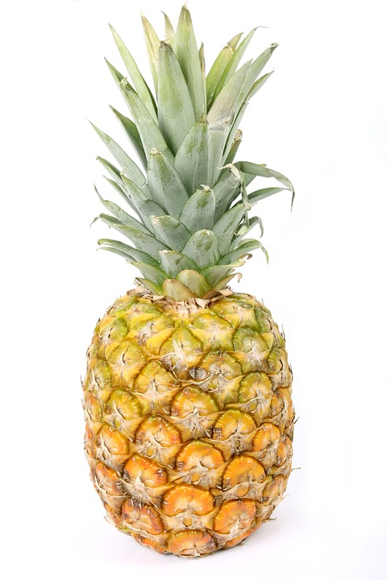
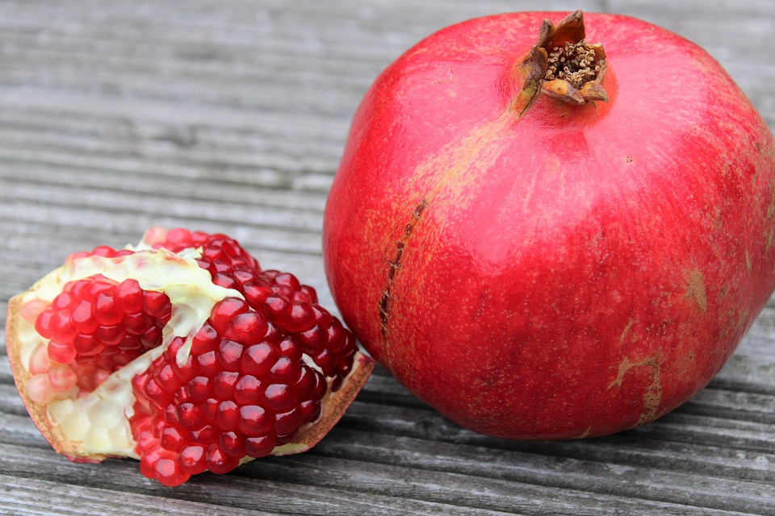
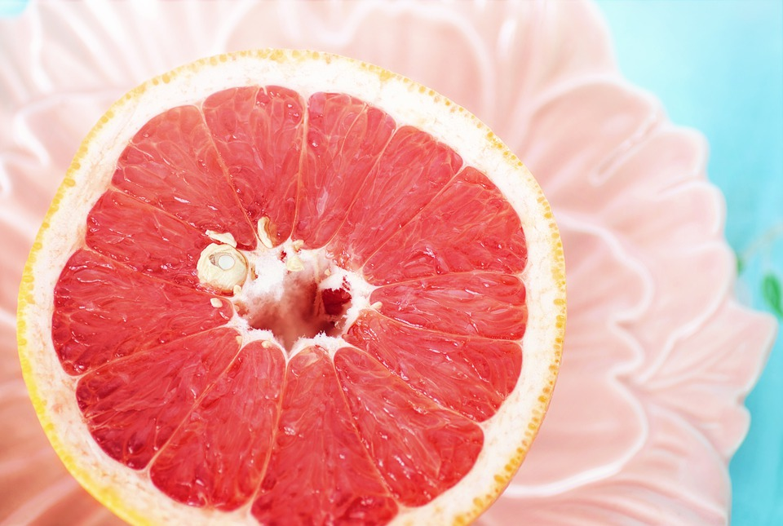
Solve the story problem.
Show your thinking using objects, drawings, numbers, or words.

15.2: All the Solutions
Show your thinking using drawings, numbers, words, or objects.
© CC BY 2021 Illustrative Mathematics®

