Lesson 6: Compose and Decompose 10 with Pattern Blocks
- Let’s find different ways to make 10 using our pattern blocks.

6.1: Diego’s Shape
Diego built a shape with 10 pattern blocks.
He only used squares and triangles.
How many square pattern blocks did Diego use?
Then how many triangle pattern blocks did Diego use?
Expression: _________________________________

Section Summary
Section Summary
In this section, we put together pattern blocks to fill in puzzles and make shapes.
We wrote numbers to show how many pattern blocks we used and figured out which pattern blocks we used more of.
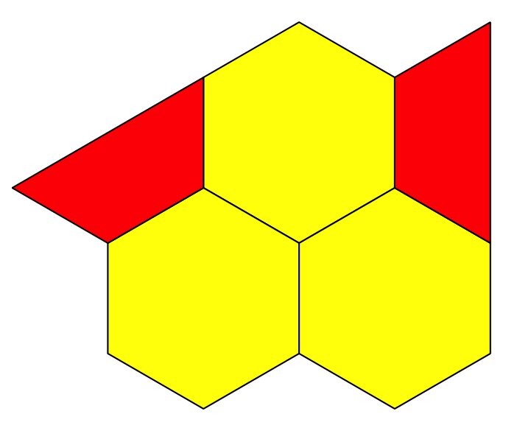
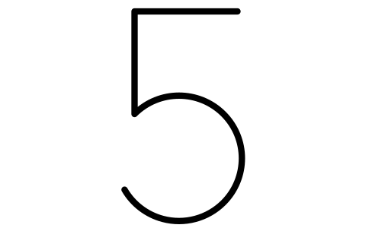
There are more
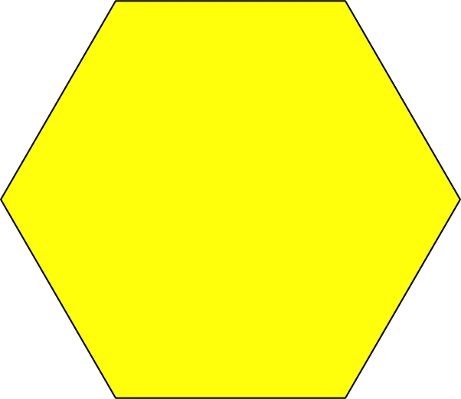
than
yellow hexagons
red trapezoids.
There are fewer
than
red trapezoids
yellow hexagons.
We matched equations to pattern block shapes and to story problems.
$5+2=7$
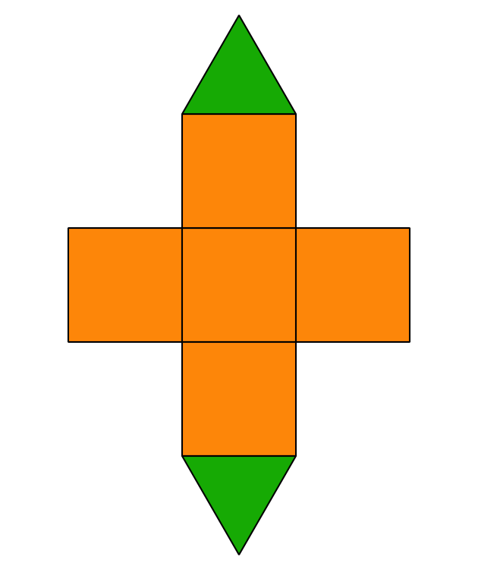
Kiran put together 5 pattern blocks to make a shape.
Jada put 2 more pattern blocks on Kiran’s shape.
How many pattern blocks are in Kiran and Jada’s shape?
We showed many different ways to make 10 using different types of pattern blocks.
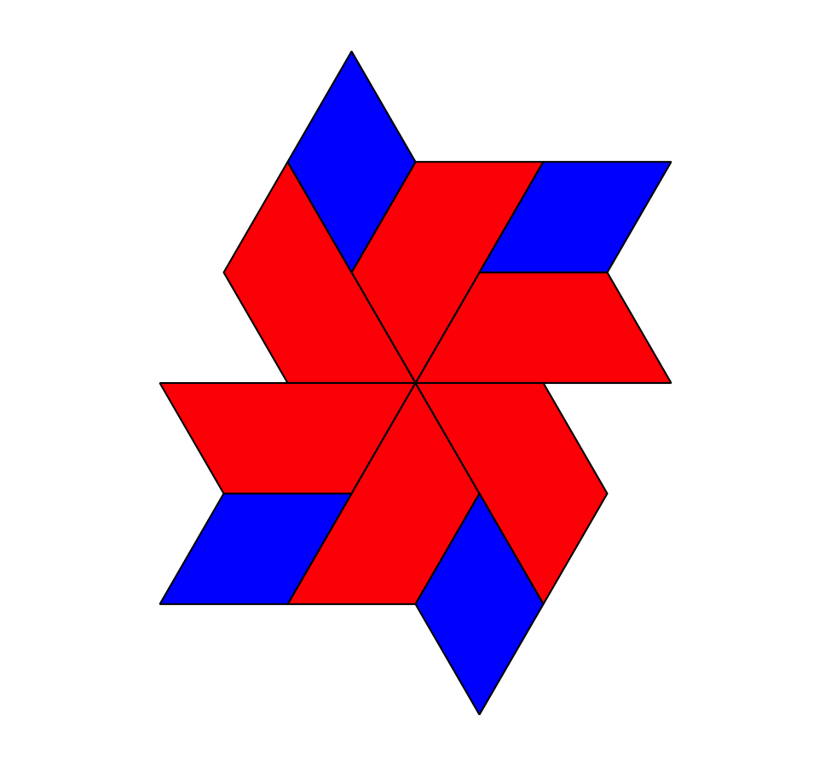
$4+6=10$
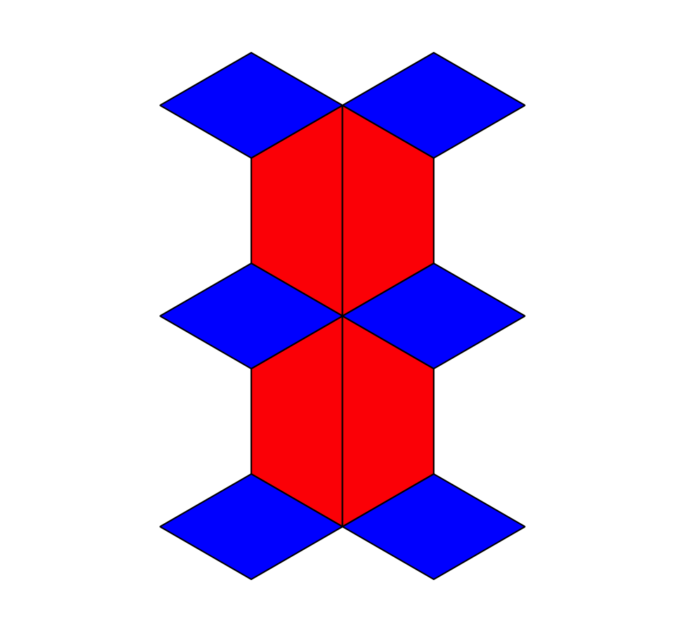
$10=6+4$
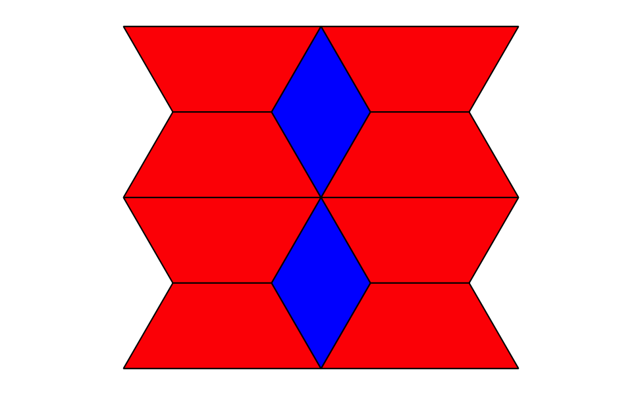
$2+8=10$
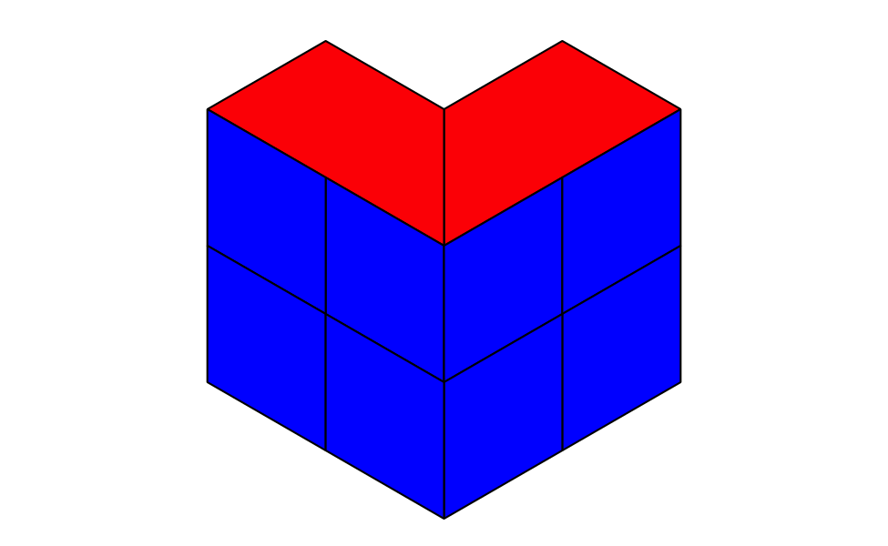
$10=8+2$
© CC BY 2021 Illustrative Mathematics®

